AIM

DO.070 User Guide

Allegion

Oracle iSupplier & Supply Chain Collaborative Planning Portals

Supplier Owned Managed Inventory (SOMI) Process

Author: Alberto A. Pagaza

Creation Date: March 14, 2018

Last Updated: July 31, 2019

Document Ref: DO070-ISUPCPP-USER-GUIDE

Version:  1

1. **Title, Subject, Last Updated Date, Reference Number**, **and** **Version** are marked by a Word Bookmark so that they can be easily reproduced in the header and footer of documents. When you change any of these values, be careful not to accidentally delete the bookmark. **You can make bookmarks visible by selecting Tools->Options…View and checking the Bookmarks option in the Show region.**

**Approvals:**

|  |  |
| --- | --- |
| <Approver 1> |  |
| <Approver 2> |  |

1. To add additional approval lines, press [Tab] from the last cell in the table above.

 Copy Number _____

1. You can delete any elements of this cover page that you do not need for your document. For example, Copy Number is only required if this is a controlled document and you need to track each copy that you distribute.

## Document Control

**Change Record**

1

| Date | Author | Version | Change Reference |
| --- | --- | --- | --- |
|  |  |  |  |
| 14-Mar-18 | Alberto Pagaza | Draft 1a | No Previous Document |
| 22-Mar-18 | Alberto Pagaza | 1 | Draft 1A |
|  |  |  |  |
|  |  |  |  |

**Reviewers**

| Name | Position |
| --- | --- |
|  |  |
|  |  |
|  |  |
|  |  |
|  |  |

**Distribution**

| Copy No. | Name | Location |
| --- | --- | --- |
|  |  |  |
|  | Library Master | Project Library |
|  |  | Project Manager |
|  |  |  |
|  |  |  |

1. The copy numbers referenced above should be written into the **Copy Number** space on the cover of each distributed copy. If the document is not controlled, you can delete this table, the Note To Holders, and the **Copy Number** label from the cover page.

**Note To Holders:**

If you receive an electronic copy of this document and print it out, please write your name on the equivalent of the cover page, for document control purposes.

If you receive a hard copy of this document, please write your name on the front cover, for document control purposes.

# Preface

1. Provide a brief introductory sentence for the Preface.
2. If you change the main headings for this Preface, then be sure to update the bullet list below.
3. To update the cross-references in the bullet list:  
     
   1. Choose Insert > Cross-Reference.  
     
   2. Select the correct heading, and click OK.

T

his document is intended to be a reference material for all users that access and uses iSupplier & Supply Chain Collaborative Planning Portals that are used for the SOMI Process with Allegion.

Topics discussed are:

1. Supply Chain Collaborative Planning Portal for SOMI Process
2. iSupplier Portal for SOMI Process

## How The Manual Is Organized

This manual is divided in 2 sections:

1. Supply Chain Collaborative Planning
2. iSupplier Portal

#### Supply Chain Collaborative Planning

Oracle Supply Chain Collaborative Planning Portal is a tool that provides suppliers Advance Vendor Managed Inventory (VMI) and Consigned Inventory (CI) Support to automate replenishment and hence reduce inventory holding costs. This is a collaborative tool that allows suppliers to plan and replenish VMI-CI items and also view forecast information.

#### iSupplier Portal

Oracle iSupplier Portal is a tool that suppliers can use to find out up to date information abouot purchase orders, receipts, invoices, payments, shipments and other tasks directly form Allegion’s Oracle System. This is a collaborative tool that allows immediate access to inventory atransactions, purchase order information and where available, invoice information.

### Audience

1. Identify the audience of the guide.

Oracle iSupplier and Supply Chain Collaborative Portal is a collaborative application enabling secure tansactions between buyers and suppliers using the Internet. Using both portals. Suppliers can monitor and respond to events in the SOMI Process cycle.

This guide contains information on how to use the Oracle iSupplier and Supply Chain Collaborative Portal application. This guide assumes you have a working knowledge of the principles and customary practices of your business area.

### How to Use This Manual

This guide is organized to help you learn, use and understand Oracle iSupplier Portal for Allegion’s SOMI Process.

* Chapter 1 contains an introduction to Oracle Collaborative Planning and its SOMI functionality
* Chapter 2 contains an introduction to Oracle iSupplier and its SOMI functionality

Important Note:

Supplier related data (i.e. pricing, parts, lead times, etc) contained within these training documents had been altered and is not reflective of current negotiated agreements.

1. Describe how the manual should be used. For example, should the user read it entirely before beginning to use the system (conceptually written information)? Or can the user find task topics to refer to as needed (task-oriented information)?

### Related Documents

Oracle Collaborative Planning and iSupplier shares business and setup information with other Oracle Applications Products. Therefore, you may want to refer to other user’s guides when you use Oracle Collaborative Planning and iSupplier.

1. List related documentation, such as product user manuals.

### Your Comments are Welcome

Allegion values and appreciates your comments as a user and reader of this manual. As we write, revise, and evaluate our documentation, your comments are the most valuable input we receive. If you would like to contact us regarding comments and suggestions on future releases of SOMI Process, please use the following address or telephone numbers:

<Company Long Name><Contact Address>  
<Contact Phone Number> Email: <Contact Email>

Contents

Document Control iii

Preface 1

How The Manual Is Organized 2

Audience 2

How to Use This Manual 2

Related Documents 3

Your Comments are Welcome 3

Chapter *1* Oracle Supply Chain Collaborative Planning Portal 5

Overview of Oracle Collaborative Planning 6

Chapter Topics 7

Navigating the Supplier Collaborative Planning Portal 7

Supplier Replenishes inventory from VMI-CI Workbench 10

Reviewing the overall forecast information 14

Reference Documents 16

Chapter *2* Oracle iSupplier Portal 17

Overview of Oracle iSupplier Portal 18

Chapter Topics 18

Navigating the iSuppliers Portal 18

Reviewing Purchase Orders 21

Purchase Order Changes 24

Create an ASN for a Purchase Order Shipment 25

View Purchase Order Receipts 29

Reference Documents 32

Appendix A 33

Open and Closed Issues for this Deliverable 34

Open Issues 34

Closed Issues 34

1. To update the table of contents, put the cursor anywhere in the table and press [F9]. To change the number of levels displayed, select the menu option Insert‑>Index and Tables, make sure the Table of Contents tab is active, and change the Number of Levels to a new value.

# Chapter *1* Oracle Supply Chain Collaborative Planning Portal

T

his Chapter we will discuss Supply Chain Collaborative Planning Portal and it’s SOMI Functionality and operation.

1. Use this section to divide your document into chapters.   
     
   The chapter number above is a Word Sequence field that automatically updates to reflect the correct chapter number when you have multiple chapters in your document.   
     
   Also consider dividing your document into sections by inserting a section break before each chapter. You can also include the current chapter number in captions and page numbers using by inserting a field (Insert->Field…) with the contents:  
     
    Seq Chapter \c  
     
   For more information, search for “Sequence” in Word for Windows help.

## Overview of Oracle Collaborative Planning

Oracle Collaborative Planning provides advanced capabilities for commiunitating planning, and optimizing supply and demand information for trading partners across the supply chain. Oracle Collaborative Planning enables you to reduce inventory levels, improve visibility across your supply chain, increase the speed of information and materials, and promise delivery more accurately.

The following image depicts how Oracle Collaborative Planning works between Manufacturers, Customers and Suppliers:

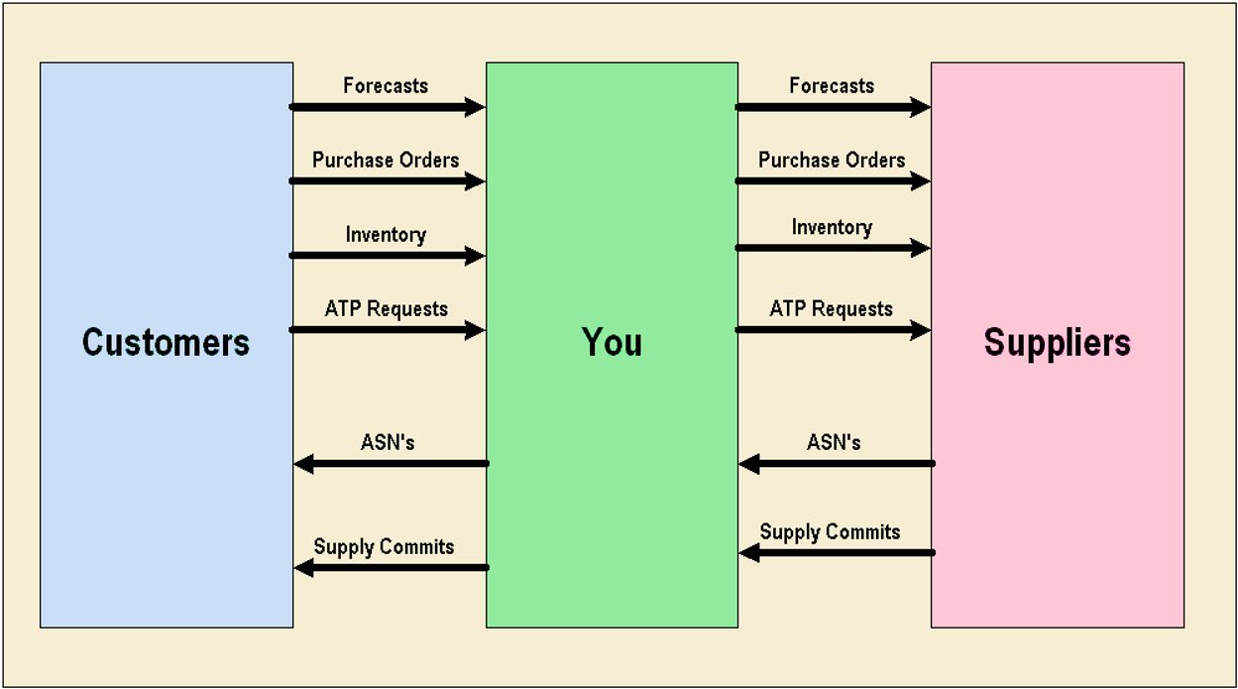

Oracle Collaborative Planning integrates with Oracle Advanced Supplpy Chain Planning, Oracle Demand Planning, and Oracle iSupplier Portal for a complete supply chain solution. You also can integrate Oracle Collaborative Planning with legacy ERP systems or use it as a standalone product.

Through integration, Oracle Collaborative Planning enables youy to:

* Use data collections to acquire setup data from ERP legacy systems (items, customers, suppliers in Oracle Collaborative Planning
* Receive supply commits from Oracle Collaborative Planning to Oracle Advanced Supply Chain Planning
* Publish sales forecasts from Oracle Demand Planning to your customers in Oracle Collaborative Planning

### Chapter Topics

#### Topics

This Chapter covers the following functional areas:

1. Navigating the supplier Collaborative Planning Portal
2. Release Replenishment Orders From VMI Workbench
3. Review the overall forecast information

### Navigating the Supplier Collaborative Planning Portal

###### Login to Supplier Collaborative Planning portal

Description of the login process.

1

2

3

1. Click in the **username** field and enter your unique user name
2. Click in the **password** field and enter the password provided to you
3. Click the **Login** Button

If it is the first time you log in to Oracle Collaborative portal you may be asked to change your password.

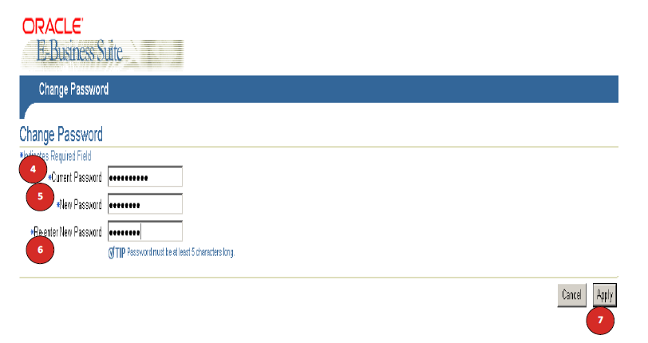

1. Click in the **Current Password** field and enter your current Password.
2. Click in the **New Password** field and enter your new password
3. Click in the **Re-enter New Password** field and enter your new password again
4. Click the **Apply** button.

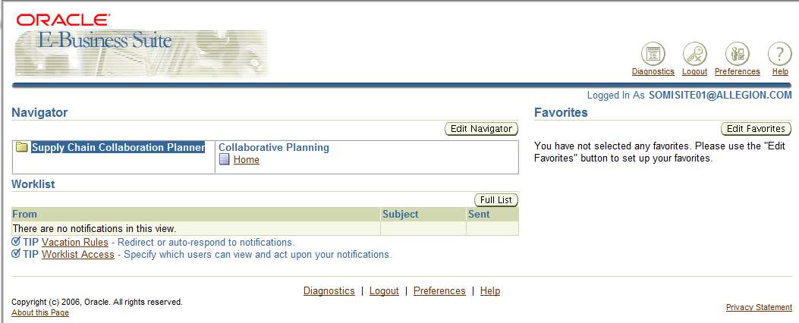

1. Click in the **Supply Chain Collaboration Planner** link
2. Click on the **Home** link

Please review the attached video for more information on the steps to follow.

 **TIP**: On Your initial login to the system, you will be prompted to change your password. This step will only be performed on the initial login and will not need to be performed again. Please use 8 characters, Use one Capital leter, no repeating characters allowed (i.e. aa, 11, 22, etc).

Login Video Instructions



#### Collaborative Planning Main Screen Description

Descpription of the Main Page.

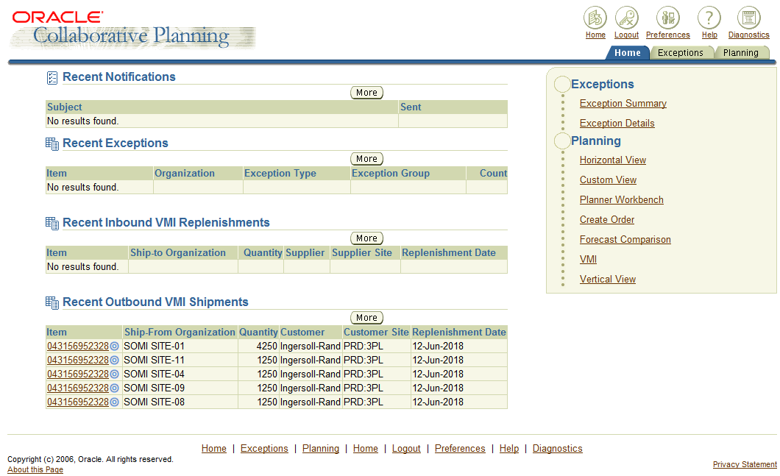

1

2

3

4

5

6

7

1. Navigation Tabs
2. Navigation Menu
3. Recent notifications Section (Click on More for quick access to the notification page )
4. Recent Exception Section ( Click on More for quick access to the Recent Exceptions page)
5. Recent Inbound VMI Replenishments (Click on More for quick access to that page)
6. Recent Outbount VMI Shipments (Click on More for quick access to that page)
7. “More” button access to their respective pages.

It is important to mention that when you access through the More buttons the information is filtered specifically for each one of the sections mentioned before, the most importan link will be for Recent Outbound Shipments wich will only show the Replenishment releases fort your specific user/company.

### Supplier Replenishes inventory from VMI-CI Workbench

In this section, the supplier will evaluate and replenish inventory levels for items. This will provide a quick visual guide to see how many items need replenishment.

This will also indicate if the shipped quantity has been received by inventory organization or not.

***Navigation Path***

**Supplier collaborative Planning Instance -> Supply Chain Collaboration Planning -> Collaborative Planning: Home -> VMI**

***Alternative Paths:***

1. **Click on Planning Tab, VMI Link**
2. **Click on the “More” button of the Recent Outbount VMI Shipments.**

Watch the attached video for navigation demonstration.



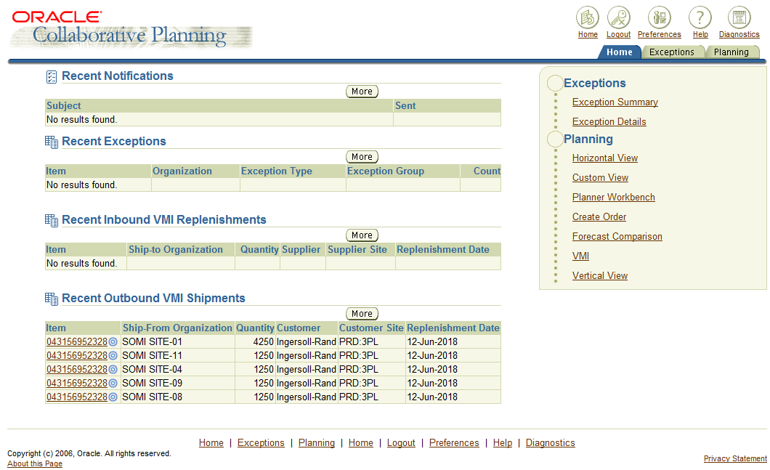

1. Select the **VMI** link on the home page

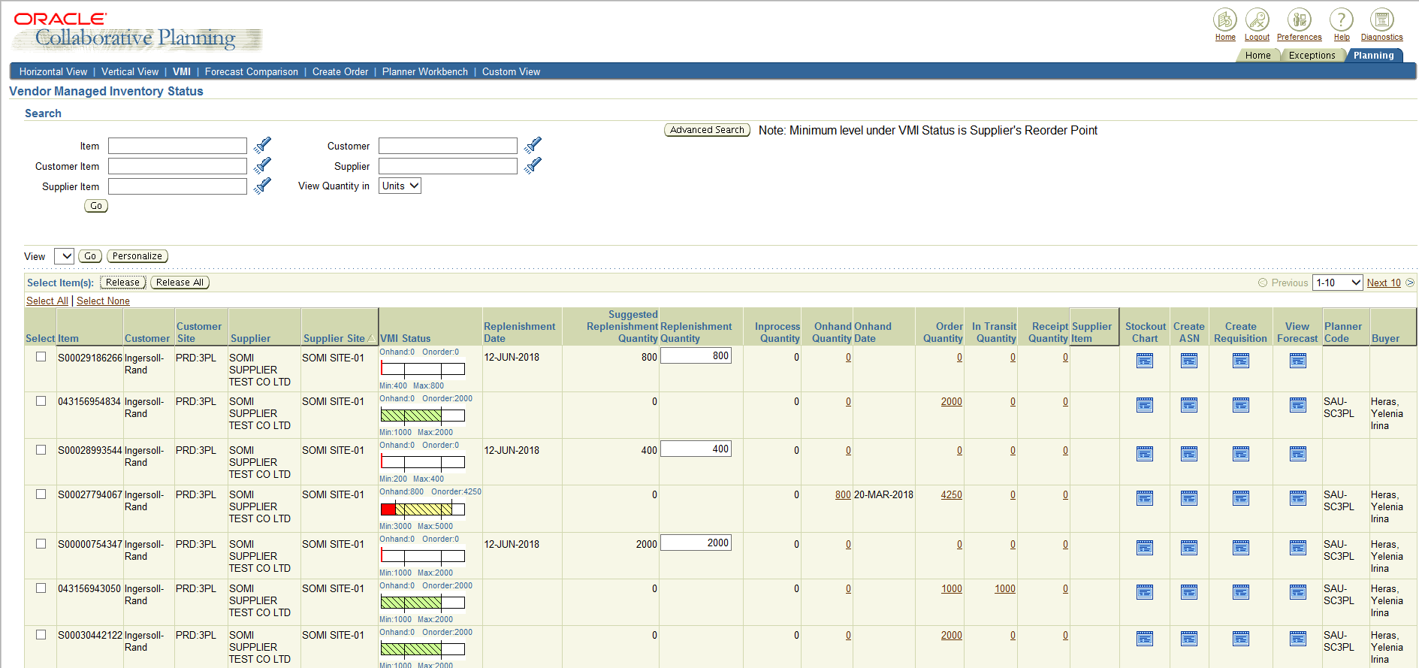

1. Click in the replenishment Quantity field to omdocate the quantity to be released.

This replenishment defaults to replenish up to the Maximum inventory level. This

amount should be changed to reflect the actual amount of inventory which will be

replenished.

Note: Scroll to the Right for additional details

The VMI status field will show the status of the current on hand quantity.

· The hash marks represent the lines which are on order but have not been

received. Once it is received, the lines will be solid color.

· The red color indicates that the inventory levels are below the minimum on hand.

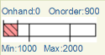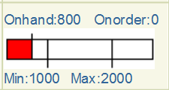2

· The green represents that this will be within the inventory levels.

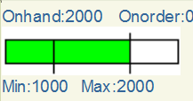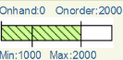

· A yellow color indicates that inventory levels are over the maximum quantity, which can occur if order multipliers calculate out to be over the maximum quantity.

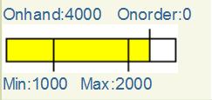

3

1. For this example we will be releasing 800 pieces so the replenishment quantity field is updated. Click on the Release button to release the replenishment Quantity

* Leave the quantity
* Select the line
* And Click on the Release Button

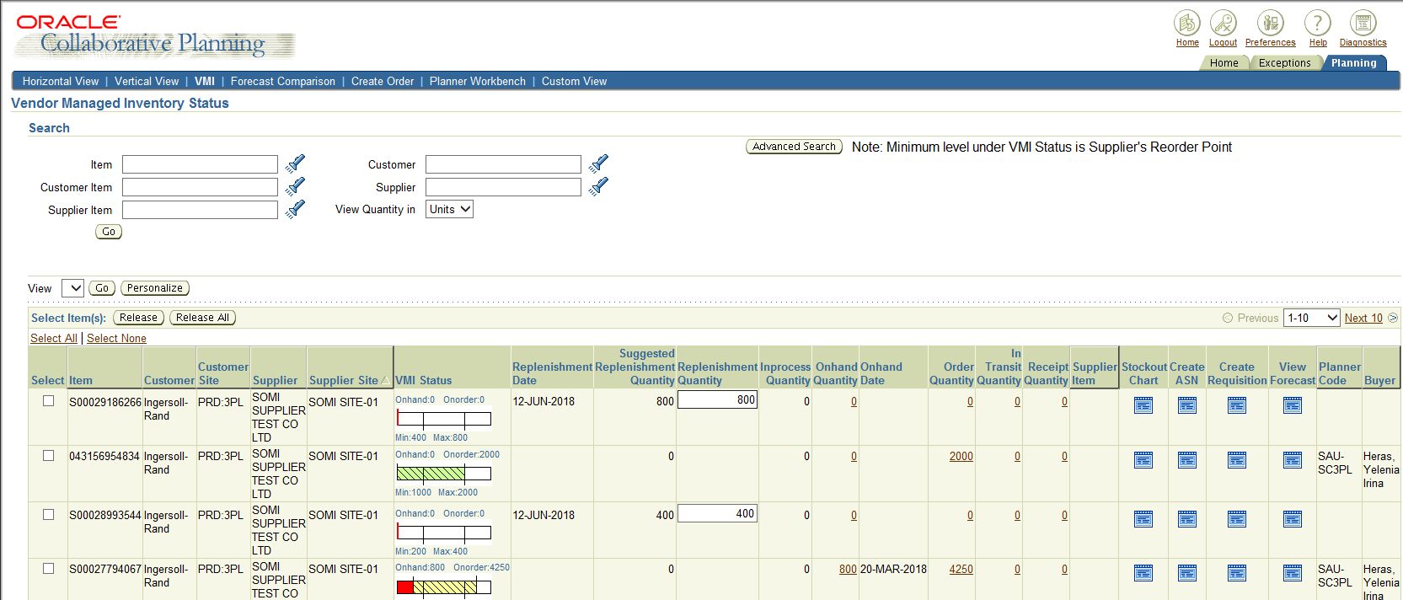

1. The 800 pieces will show as Inprocess Quantity until de purchase order is created. The Order Quantity column will show prevous orders wich where on order.

The Replenishment Quantity field will remain open for additional replenishment to allw you to replenish to the maximum Amount.

Important Note:

The in transit quantity column displayts current in-transit shipment information that VMI supplier is responsible for managing. For items that are planned in units, this column displays the replenishment quantity in units.

All supplies (PO+ Requisitions + ASN + Shipments) will be considered whose expected receipt date is less than the replenishment time fence end date. Where the replenishment time fence en date of item is (SYSDATE + processing lead time + intransit lead time).

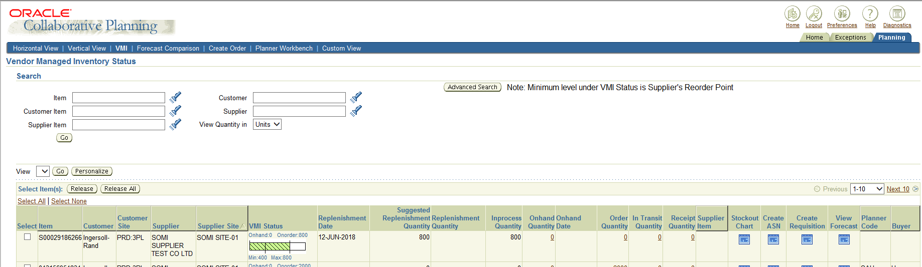The purchase order may take some time to appear, due that the requisition needs to get imported into the transactional database as well needs to go thrugh Allegion’s Approval Workflow, once the requisition is approved, the PO is created, and as the requisition it also needs to undergo through the approval process.

Please review the attached videos on how to release replenishment orders.

 

#### Review Release Replenishment order information.

While still on the VMI Workbench page you can still review the information on the released replenished orders created as well see about other usefull information for you to consider while collaborating with Allegion.

It is important to consider the different columns in the workbench to understand what we are looking at.

4

3

1

2

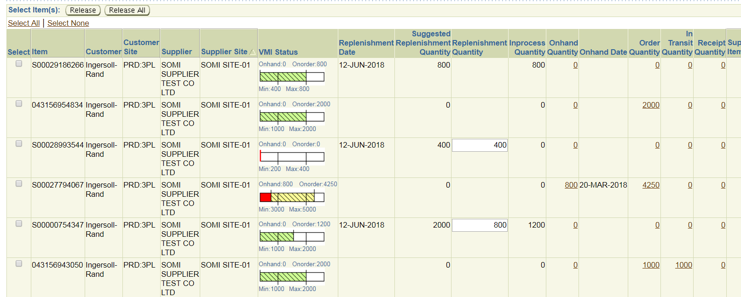

7

5

6

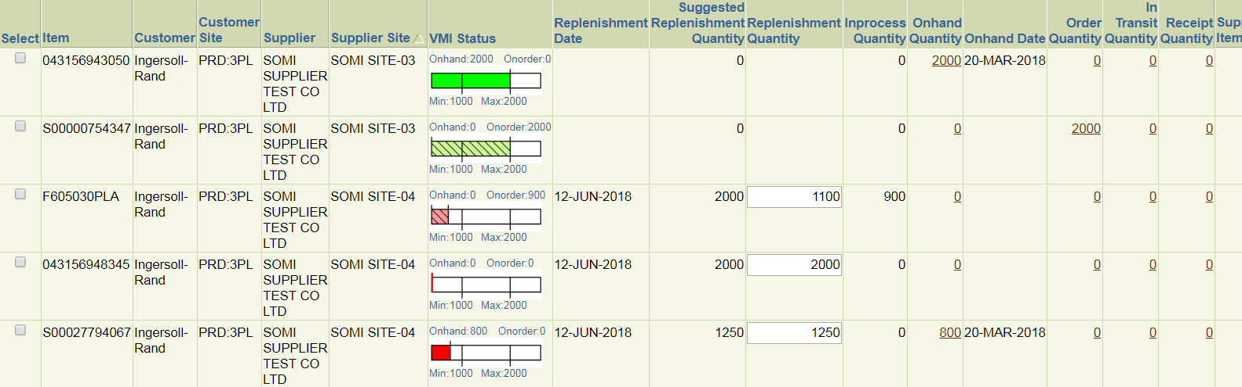

8

Let’s talk about the main columns and the information shown.

1. Suggested Replenisment Quantity: The quantity suggested by the VMI Engine according to Minimum and Maximum suggested levels
2. Replenishment Quantity: The quantity that is suggested to be released and can be modified
3. In process Quantity: The Quantity that has already been released and is waiting for a Requisition/PO Creation in the transactional database (EBS)
4. On hand Quantity: Shows the quantity in pieces available for comsumption from the warehouse.
5. On Hand Date: The date when the last shipment receipt took place.
6. Order Quantity: Once the release quantity has been turned into a Requisition / Purchase order for replenishment this column gets updated.
7. In transit Quantity: When an ASN is created in the iSupplier Portal and refreshed back to the Collaborative Planning portal, this quantity indicates the quantity in transit.
8. Click on the Order quantity to reveal the document information for that specific line. In the screenshot below we can see that a Requisition has been created for that specific line, for some other lines you will se a Purchase order

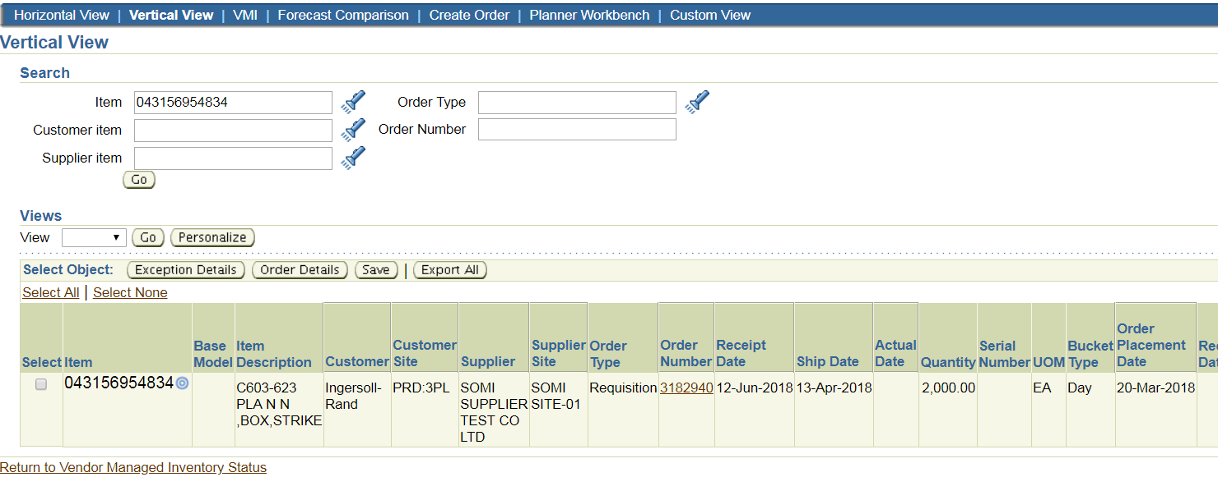

### 

### Reviewing the overall forecast information

In this section we will discuss the way to review the information of the release replenishment orders and how to quicly understand all the information available in the portal.

***Navigation Path***

**Supplier Collaborative Planning Instance -> Supply Chain Collaboration Planning -> Collaborative Planning: Home -> Vertical view**

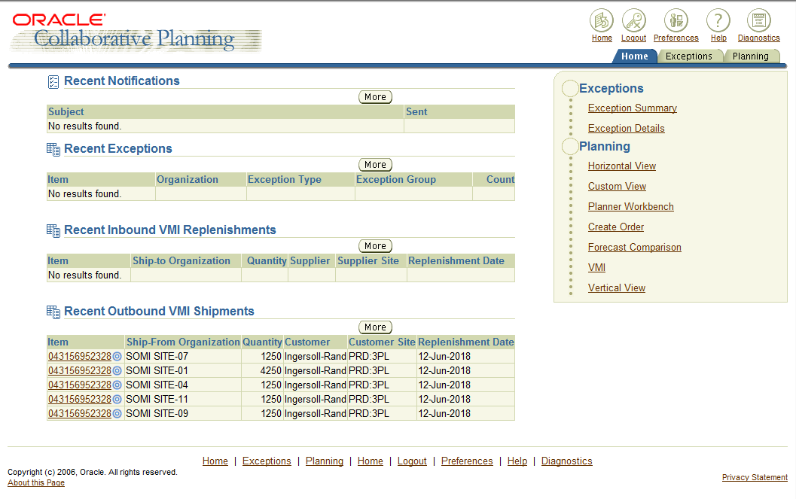

1

1. Select the **Vertical View** link on the home page
2. Here you will be able to review the status of each one fo the different release lines that were affected by your current actions
3. It will describe the status of the line you release, which can be a Requisition, Purchase order, Allocated Onhand. Either document will be provided for you to review in the iSupplier portal as shown later on this document.
4. You could export into an Excel Spreadsheet file the information for you to analyze it. Just click the Export all Button.

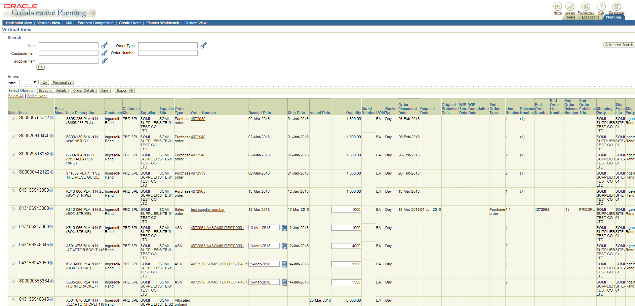

1

### Reference Documents

1. NA

# Chapter *2* Oracle iSupplier Portal

T

his Chapter contains information on how to use Oracle iSupplier Portal application along with Allegion’s SOMI Process. This guide assumes you have a working knowledge of the principles and customary practices of your business area.

1. Use this section to divide your document into chapters.   
     
   The chapter number above is a Word Sequence field that automatically updates to reflect the correct chapter number when you have multiple chapters in your document.   
     
   Also consider dividing your document into sections by inserting a section break before each chapter. You can also include the current chapter number in captions and page numbers using by inserting a field (Insert->Field…) with the contents:  
     
    Seq Chapter \c  
     
   For more information, search for “Sequence” in Word for Windows help.

## Overview of Oracle iSupplier Portal

Oracle iSupplier Portal is a collaborative application enabling secure transaction between buyes and suppliers using the Internet. Using Oracle iSupplier Portal, suppliers can monitor and respond to events in the procure-to-pay cycle.

Oracle iSupplier Portal enables a buying company to communicate key procure-to-pay information with suppliers. As a supplier using Oracle iSupplier Portal, you can view and acknowledge purchase orders, submit change requests, create advance shipment notices, view receipts, view inventory levels, view invoices, and view payments. As a buyer using Oracle iSupplier Portal, you can view order, shipment, receipt, invoice, and payment information. Although Oracle iSupplier poses great functionality this guide will focus on Allegions SOMI Process functionality and the use Oracle iSupplier Portal to accomplish the required tasks of such process.

### Chapter Topics

#### Topics

This chapter covers the following functional areas:

1. Navigating the iSupplier Portal
2. Reviewing Purchase Orders
3. Purchase Order Changes
4. Create an ASN for a Purchase Order Shipment
5. View Purchase Order Receipts

### Navigating the iSuppliers Portal

###### Login to Supplier Collaborative Planning portal

Description of the login process.

1

2

3

1. Click in the **username** field and enter your unique user name
2. Click in the **password** field and enter the password provided to you
3. Click the **Login** Button

If it is the first time you log in to Oracle Collaborative portal you may be asked to change your password.



1. Click in the **Current Password** field and enter your current Password.
2. Click in the **New Password** field and enter your new password
3. Click in the **Re-enter New Password** field and enter your new password again
4. Click the **Apply** button.

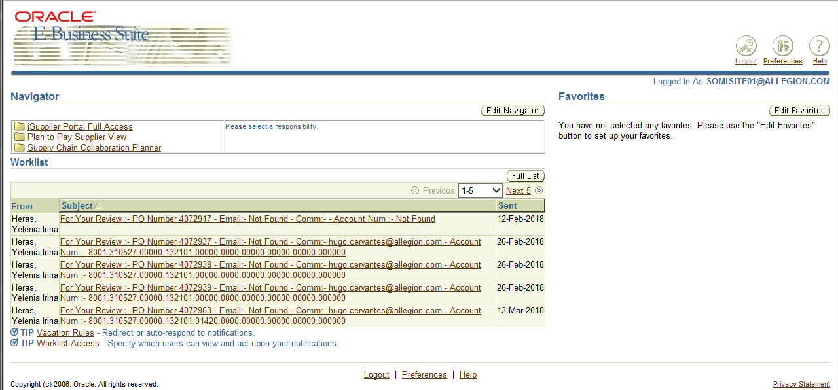

8

Note: Once youo have signed into the portal, there will be different reposnibilities on the home page. Youo will chose the responsibility based on what information you want to view.

Below a brief description of the possible responsibilities that will be assigned to your username.

* **iSupplier Portal Full Access:** Use this responsibility to see all purchase order information (current and history); view Delivery schedules, Overdue Receipts, and enter ASNs, view Receipts, Returns, Invoices and Payments, view Consigned Inventory (CI) information and transactions.
* **Supply Chain Collaboration Planner:** Use this responsibility to see vendor Managed Inventory (VMI). Item Forecast may also be viewed here as well. NOT all functionality is being use for the time being.
* **Plan to Pay:** This responsibility covers all iSupplier and Collaboration Planner functionalities in one responsibilities with the limitation of the local Supply Chain Collaboration planner Functionality.

For what it concerns to our process we will only focus on **iSupplier Portal Full Access**

1. Click in the **iSupplier Portal Full Access** link

Please review the attached video for more information on the steps to follow.



 **TIP**: On Your initial login to the system, you will be prompted to change your password. This step will only be performed on the initial login and will not need to be performed again. Please use 8 characters, use one Capital leter, no repeating characters allowed (i.e. aa, 11, 22, etc).

#### iSupplier Main Page Description

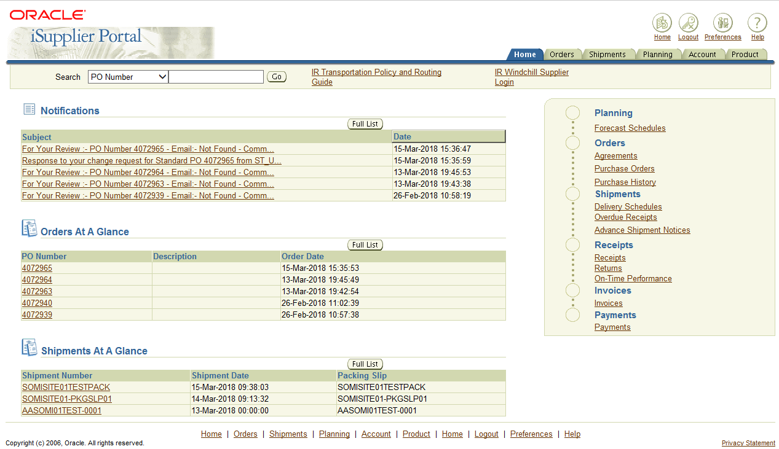

This is the iSupplier Main Page.

Tabs and Quick links allow you to navigate around the portal.

### Reviewing Purchase Orders

***Navigation Path***

**iSupplier Portal Full Access -> Home Page**

You can view Purchase Orders in iSupplier Portal for content and accuracy.



2 

1 

1. On the home page, the **Notifications** section will display any new notifications for your review. You can click on **Full List** button to see al notifications and to filter on any notifications wich would require a response. Examples of notifications would include: PO acknowledgements, buyer changes, and new POs for you to review. Not all notifications will require an action.
2. The **Orders At A Glance** section will display a list of the five most recent purchase orders wich were sent to you. You may click on the **Full List** button for a complete list of the purchase orders.

3

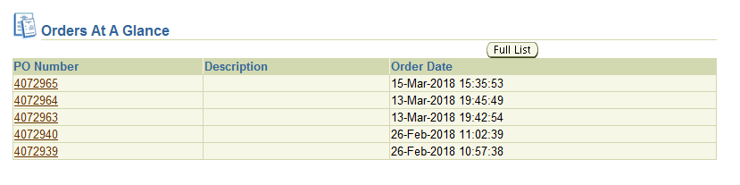

1. Click the **Purchase Order** link of a document to get to more information.

The first part of the screen displays the purchase order header information.

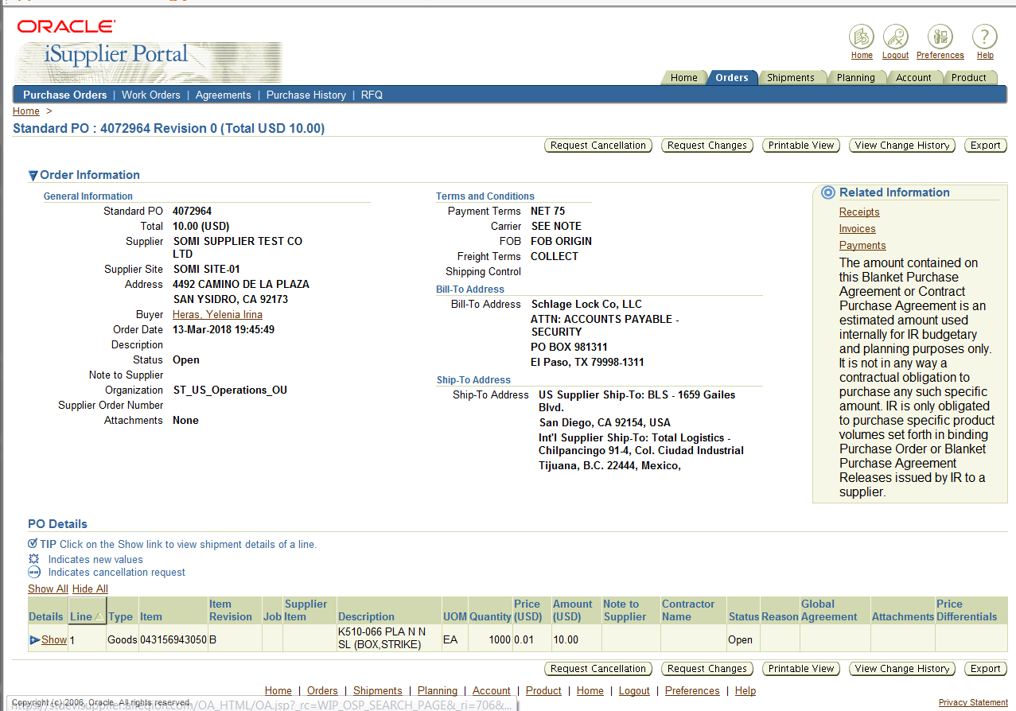

6

5

1. Scroll down to see purchase order line information
2. Click on the **Show All** link to see all line details or click on the **Show** link to show all the line information specifically for that line.
3. Click **Printable View** button to view the po in a printable PDF Format
4. The PO Detail is displayed in a PDF Format.

**Note:** A PDF viewer is required to view the PO PDF Format. If you need one, download a free version of Adobe Reader from [www.adobe.com](http://www.adobe.com)

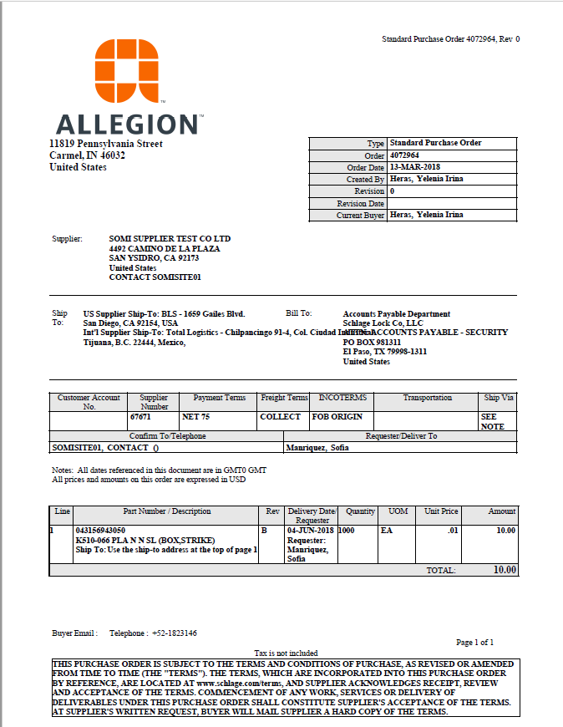

Please review the following video for refrence



### Purchase Order Changes

From the Orders tab, you may view the change history of a purchasing document, acknowledge a porchase order, request changes or request a cancellation. It is important to understand that your request for change or cancellation may be rejected by the buyer. The system will not update the promised dates until de buyer approves the requested changes.

You may request that a single line of a purchasing document or an entire document be changed or cancelled from this window.

PO acknowledgment functionality will be used for Blancket Purchase Agreements (BPA), BPA-Releases, and Standard Purchase Orders in iSupplier portal.

You may request a change on any purchasing document which needs to be changed.

***Navigation Path***

**iSupplier Portal Full Access -> Home Page-> Orders**

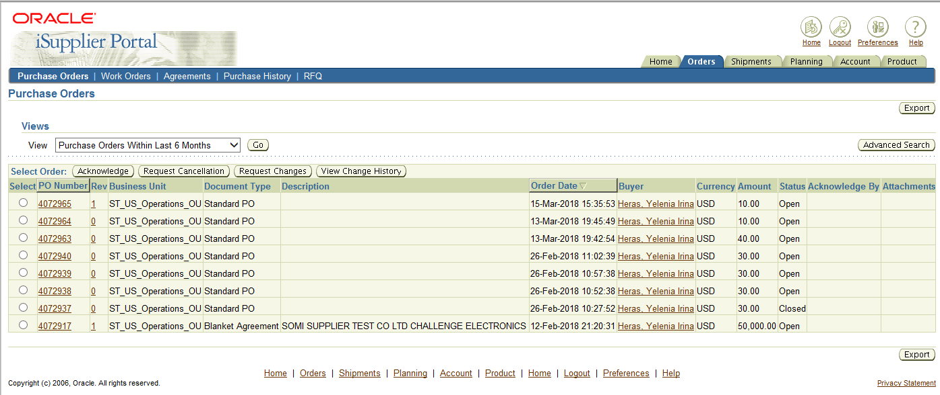

1

2

1. To perform a desired action, click the **Select** radio button of the document(s).
2. Click the button for the desired action.
3. Available actions are:
   * Acknowledge
   * Request Cancellation
   * Request Changes
   * View Change History

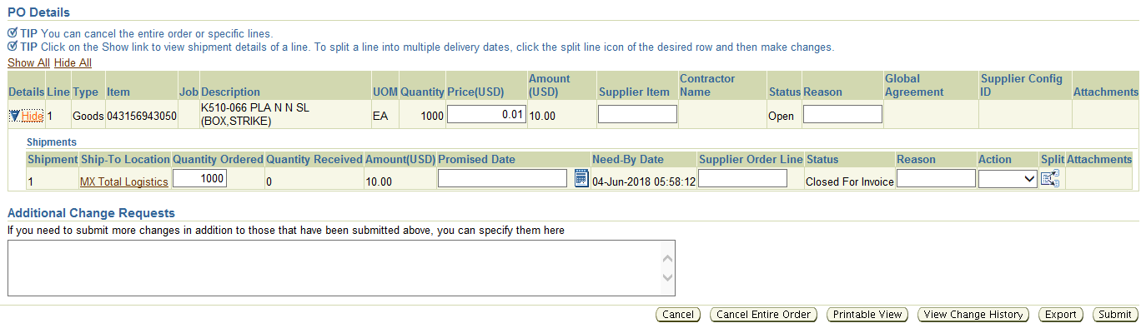

1. Once you select the action to perform the po information will be shown. Do not forget to click on the Show All / Show links to show detailed line information. This is where quantity and Delivery Dates may be updated.

Update the desired information.

Example:

* + Update Quantity Ordered to change the PO quantity.
  + Update Promised Date toupdate your delivery date.
  + The Need-By Date can not be changed and is the date that Allegion needs the parts in house.
  + Click in the Reason field an add a reason for the changes
  + Click in the Action field and select Change action.
  + Click the Submit button to submit changes.

Remember that PO Changes must be approved by the buyer.

Please review the following video for further information.



### Create an ASN for a Purchase Order Shipment

Advanced Shipment Notice (ASN) is an important feature in the portal. By creating an ASN, you are providing Allegion with confirmation of shipment, this information decreases the risk of data entry error, and ensure full, on-time payment.

Advance Shimpent Number (ASN) is also displayed as “Shipment Number” in Oracle.

***Navigation Path***

**iSupplier Portal Full Access -> Shipments-> Shipment Notices**

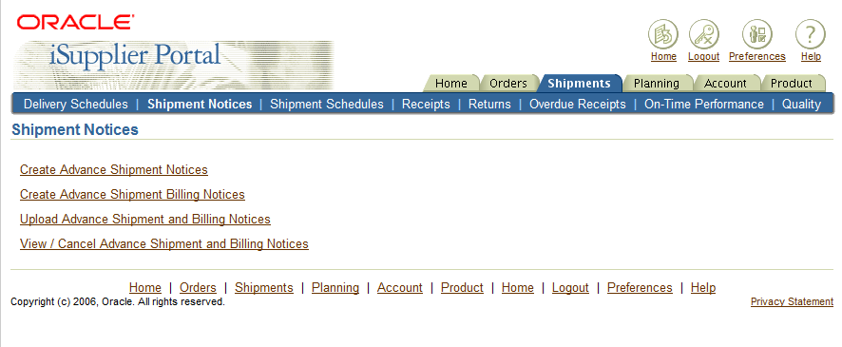

1

1. Click the Create Advanced Shipping Notices link

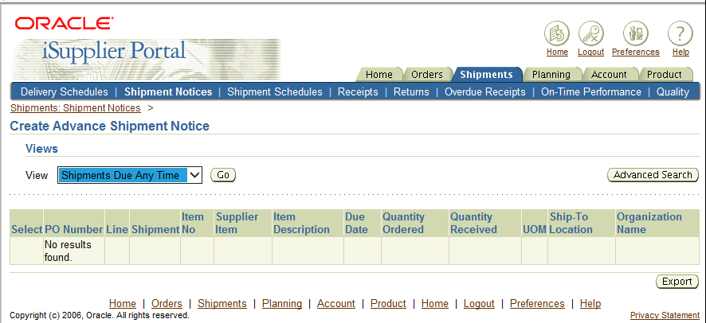

2

1. Click the View drop down list
2. Select the view of either Shipments Due This Week or Shipment Due Any Time from the list
3. Click the Go button

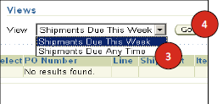

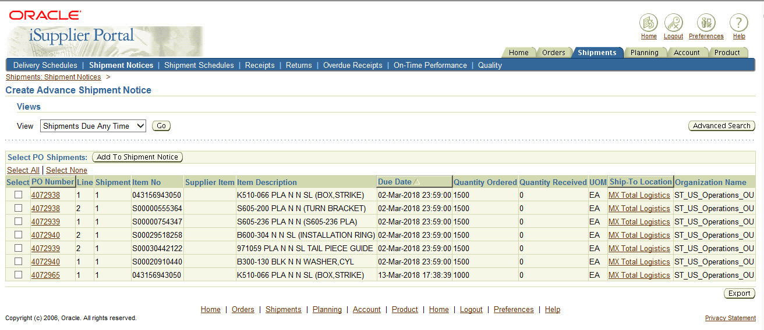

6

5

1. Click the Select check box of the line(s) to add to the shipment notice

Multiple lines can be selected.

1. Click the Add to Shipment Notice button, this form will allow you to enter Shimpent deafults for all lines or specific lines.

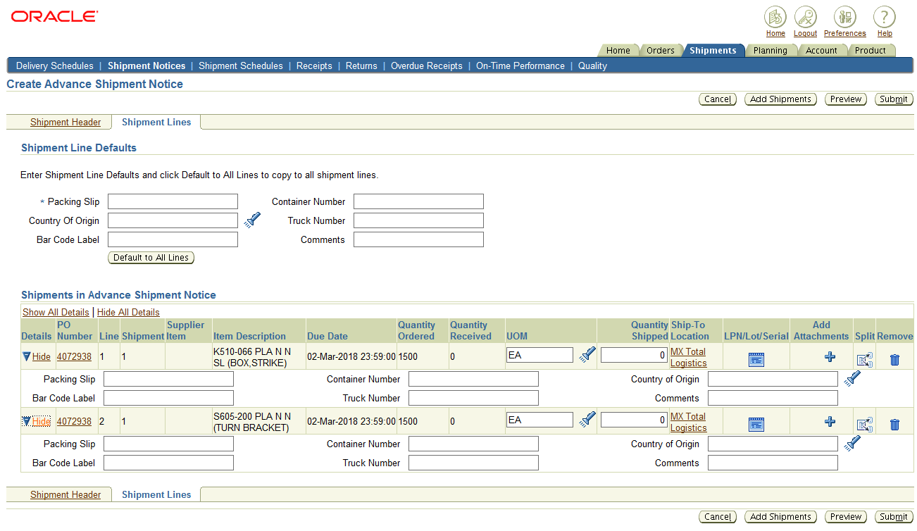

77

9

8

1. To add defaults to a specific line, click on Show link next to the line. Do not forget to review the quantities shipped. If all lines will have the same packing slip information, proceed to step 8.
2. Enter the Packing Slip number in the Packing Slip field.
3. Click the Shipment Header link.

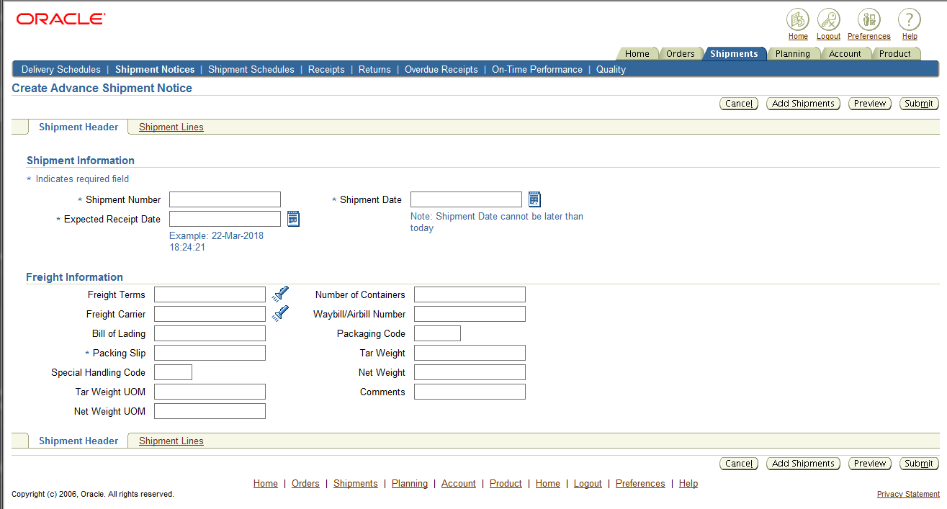

11

10

1. Fill all required fields marked with an asterisk (*). The Shipment Date must be today’s date, and the Expected Receipt date must be later than the shipment date by the time, if not by the day. Please consider that system time is in the EST Time Zone.
2. Click the Submit button.

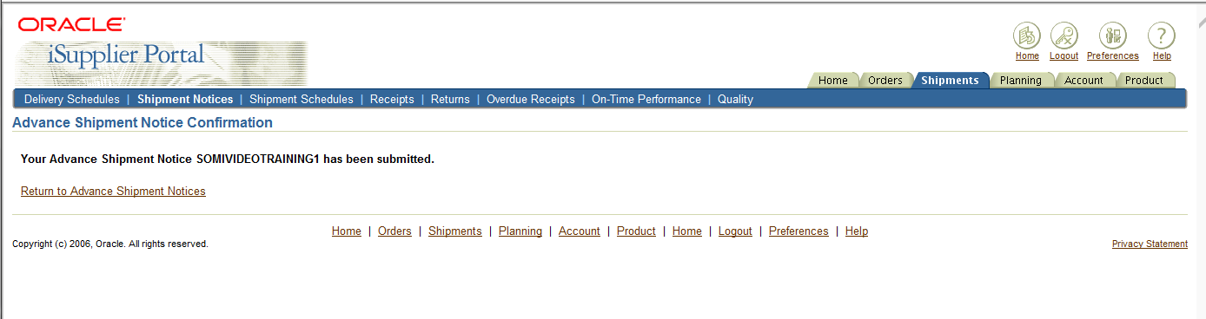

12

1. The confirmation for the ASN displays.

Please review the attached video for more information on how to create an ASN.



### View Purchase Order Receipts

You can view Purchase Order Receipts in iSupplier Portal.

***Navigation Path***

**iSupplier Portal Full Access -> Shipments-> Receipts**

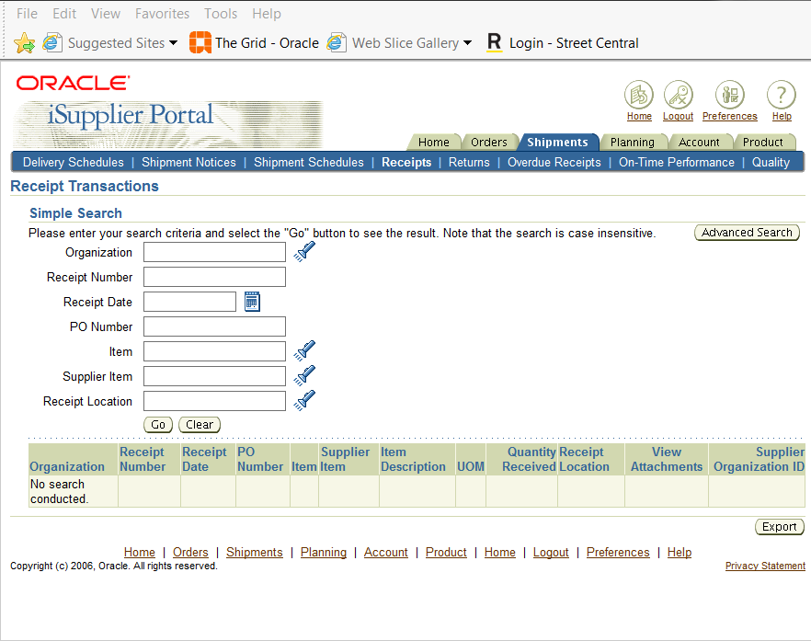

1

1. Enter your Receipt search criteria in any of the available fields in the Simple Search and click the Go button.

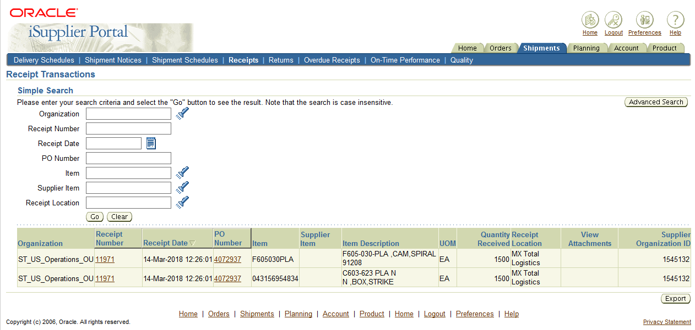

2

1. Click on the link to a PO Number or a Receipt Number for more information on the transaction.

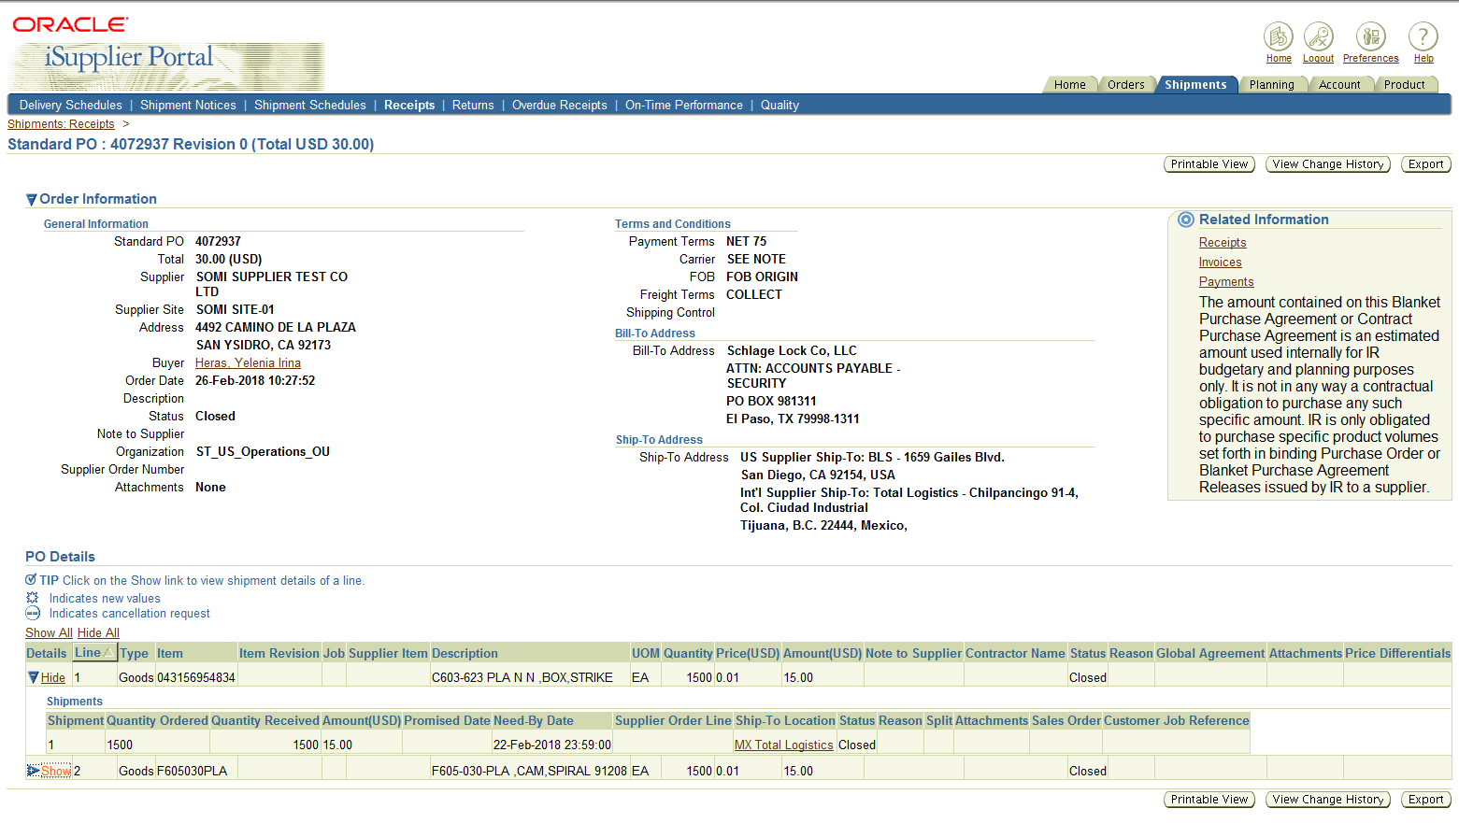

3

1. Selecting the PO Number displays the Order Information screen

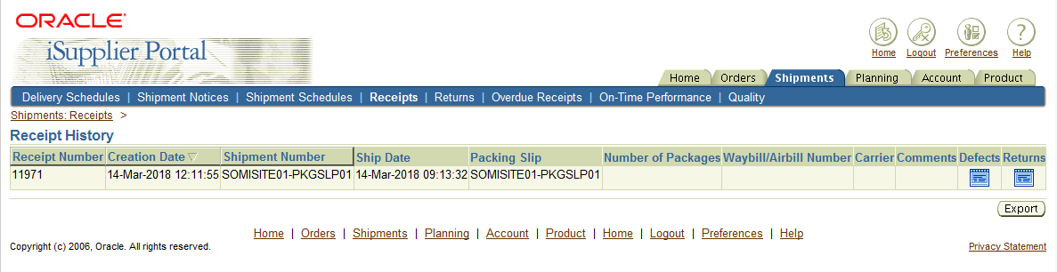

4

1. Selecting the Receipt Number displays any receipt detail information, such as the packing slip, if recorded at the time of the receipt.

Please review the attached video for further information.

