TABLE OF CONTENTS Page

- Corporate Policy 2

- Purpose 2

- Scope 3

- Importer Security Filing (ISF) 3

- Freight Forwarders 3-4

- Documentation Requirements 4-8

- Customs Trade Partnership Against Terrorism (CTPAT) 9-10

  - Container Inspection Checklist
  - Seals

- Country of Origin Marking 10

- Wood Packaging Materials 10
- Freight Plans 11

- Responsibilities 11-16

- Penalties for non-compliance 16

- Allegion Contacts 17

Exhibit 1: Tracking Your Shipments 18

Exhibit 2: Freight Carrier Contacts
- Ocean Vessel: Kuehne + Nagel (KN) 21-23
- Small Package: DHL Express (DHL) 24
- Air Cargo: UPS Supply Chain Solutions (UPS-SCS) 25-26

Exhibit 3: CTPAT Container Inspection Checklist 27

Exhibit 4: Receiving Discrepancy Report 28

Exhibit 5: External Agent Contacts 29

I. Corporate Policy | It is the policy of Schlage Lock Company, LLC to ensure compliance with US and MX government regulations on importing and exporting. This policy and procedure applies to raw materials, parts, components or other goods transported thru the US for final destination of Schlage de Mexico from any foreign (non-US) supplier:  - Supplier Documentation: All supplier documentation shall be prepared in accordance with the Documentation requirements shown in the “At A Glance INBOND Shipments to Schlage de Mexico” file. Suppliers must pay special attention to the Packing List requirements for Inbond shipments.  - Southbound Form: Planner/Buyer (Initiators) must submit a Southbound Form at time of Purchase Order release for all new items to ensure registration in the Mexico Customs system  - Receiving Controls: Each facility is required to conduct an inspection of all goods received to identify any overages or shortages. All quantity discrepancies identified by Receiving must be communicated to the Schlage de Mexico Customs team IMMEDIATELY.  - Offloading within 24 Hours: To avoid extremely high ‘per diem’ charges assessed by the ocean carriers ($80 daily), all trailers must be offloaded by the facilities and returned to the US within 24 hours or sooner.
II. Purpose | Goods are moved “Inbond” thru the US to avoid the unnecessary payment of US Customs duties. In-bond movements must have a “Transportation and Exportation” entry (T&E) prepared by a US Customs Broker. Once the T&E is filed, the cargo moves via a ‘bonded carrier’ to the border. This procedure sets forth the requirements to facilitate the transportation thru and exportation from the US.  The purpose of this Policy & Procedure is to:  ensure Schlage, its manufacturing plants, and its foreign Suppliers comply with US and MX Customs requirements.  prevent the assessment of customs penalties for failure to comply with MX Customs import and discharge requirements.  prevent the added expenses of warehousing and steamship line fees associated with delays associated to lack of information from the suppliers or Planner/Buyers.  - provide instructions to the Suppliers regarding documentation instructions.  - provide instructions to the freight forwarder to facilitate cargo movement and tracing.  provide instructions to the bonded warehouse (IAB) for creation of the “Schlage Manifest” to support the MX Import Invoice.  provide instructions to the bonded carrier (LAX Freight) to facilitate movement of cargo to the Schlage de Mexico plants.
III. Scope | This policy and procedure applies to raw materials, parts, components or other goods transported through the US for immediate exportation to Schlage de Mexico from any foreign (non-US) supplier.  This SOP does not cover SOMI Inbond shipments to Mexico (see SOMI Import SOP for instructions on SOMI Inbond shipments to Mexico).
IV. Importer Security  Filing (ISF) | Under US Customs law, an Importer Security Filing (ISF) must be transmitted to US Customs at least 24 hours prior to loading any vessel bound for the US. Failure to file the ISF will result in $5K penalty per violation.  For all vessel shipments, Suppliers must obtain an Importer Security Filing transaction number prior to physically turning cargo over to the freight forwarder.  Procedure for Supplier to obtain ISF Transaction Number:  - Obtain bill of lading number from the freight forwarder. Complete Importer Security Filing (ISF) template, using below template applicable to the type of shipment: “ISF TEMPLATE – INBOND to Schlage de Mexico”.  - Email completed ISF template to the designated filing agent at least 72 hours in advance of sailing.  NOTE: The ISF Filing Agent for Inbond shipments to MX is:  isf@iab-sd.com  The ISF contact is Steve Goding.  - Obtain ISF transaction number from filing agent (must be documented on the ISF template). The ISF filing agent is required to return the ISF transaction number within 24 hours.  - Deliver cargo to freight forwarder, and provide copy of final ISF template (reflecting ‘ISF Transaction Number’) with shipment documentation.
V. Freight Forwarders | INBOND SHIPMENTS:  - VESSEL SHIPMENTS:  - For ocean shipments moving Inbond to Mexico, Kuehne + Nagel (KN) is the designated freight forwarder. KN will be booking on behalf of Allegion on GSA endorsed steamship lines.  - AIR SHIPMENTS:  - Shipments under 65kgs: Air shipments that weigh less than 65kgs should be forwarded through DHL Express (DHL).  - Shipments greater than 65kgs: Air shipments that weigh more than 65kgs should be forwarded through UPS Supply Chain Solutions (UPS-SCS).  - Please refer to Exhibit 2 for a listing of freight forwarder contacts.  - Please refer to the “At A Glance – Inbond Shipments to Schlage de Mexico” below for additional instructions.
VI. Documentation | - Documentation required from Schlage de Mexico PLANNER / BUYER (INITIATOR):  - Southbound Form: Southbound Forms must be completed for all new Oracle part numbers. This form provides key data for registration of new parts into the MX Customs system. It is the responsibility of the Planner/Buyer to provide this form to Customs at the time of, or prior to, creation of the Purchase Order. Please refer to the “Parts and Raw Materials Exported to Schlage de Mexico Procedure – Import/Export Policy 16”.  - The Form must be sent to the Schlage de Mexico Customs team and the US Customs team for review.  - Documentation required from SUPPLIER:  - Documents Required from Supplier: The following documents are required at time of entry into the US.  - Importer Security Filing (ISF)  - Commercial Invoice (see requirements below)  - Packing List (see requirements below)  - Bill of Lading, Truck Bill or Airway Bill  - For MOLDS and MACHINERY please include a picture of the serial number and model number (as it appears affixed to the item).  - KEY POINT: PLEASE EMAIL THE INVOICE, PACKING LIST AND BILL OF LADING OR AIRWAY BILL TO THE PLANNER BUYER.  - Invoice Requirements: The invoice should contain the following information in English:  - Consignee Name and Address  - Delivery Address of MX Plant  - The date of export  - The place of export (i.e., origin port);  - The exporter’s name, address, telephone number and name of person with knowledge of the shipment;  - Place where goods will be imported (Port of Entry);  - The bill to name and address;  - The ship to/sold to name and address;  - Terms of sale (i.e., FOB, CIF, etc.);  - Invoice number;  - Invoice date;  - Buyer’s PO and release number should be identified at the top of the invoice;  - Buyer’s part number/item number;  - Payment terms;  - Blanket order line item;  - Detailed description of the merchandise (this includes the grade or quality, the marks, numbers and symbols of the merchandise);  - Quantities and unit of measure;  - Unit price of each item;  - Total value of each item;  - Total numeric and written value of shipment (i.e., $1000 – one thousand US dollars);  - Associated charges in the currency of purchase (i.e., material surcharges, freight costs, other fees, as applicable and not already included in the invoice price per item);  - The currency of transaction;  - The country of origin of the goods;  - US Harmonized Tariff Code (see note below); If you do not have the US Harmonized Tariff Code for a product, please contact the Customs and International Trade Compliance team  - Packing list number associated with the shipment should be referenced;  - Page numbers.  - Add the Inbond Statement in accordance with the value thresholds established on the AT A GLANCE.  - FOR MOLDS and MACHINERY: include serial numbers and model numbers  - Packing List Requirements:  - Supplier must create a separate packing list for each Mexico facility destination (ENS, TEC, TIJ or SAU). Do not consolidate goods destined for different Mexico facilities onto 1 packing list.  - The Packing list must be attached to a pallet or carton. The packing lists should contain the following information in English:  - Packing list number;  - Shipping marks (i.e., marks, numbers and symbols of the packages in which the merchandise is packed);  - Pallet numbers;  - Country of Origin  - Carton Numbers;  - Planner/Buyer’s Oracle part number;  - Product description;  - Quantity (quantity per carton and total number of cartons should both be listed); Total Quantity per Oracle Part Number  - Gross weight and unit of measure;  - Net Weight and unit of measure.  - PO Number and Release Number  - Final Destination, indicate:  - Schlage de Mexico – XXX  (replace XXX with applicable Plant Code listed below):  - ENS (for ENSENADA PLANT - ENS Residential)  - TEC (for TECATE PLANT)  - TIJ (for TIJUANA PLANT)  - SAU (for EL SAUZAL PLANT – ENS Commercial)  - Documentation Instructions  - Complete all documents following instructions shown in “At-A-Glance Inbond to Schlage de Mexico Shipping Instructions”. The “AT A GLANCE” document below contains instructions for 3 types of shipments, as follows:  - Vessel Shipments to Schlage de Mexico  - Air Shipments (under 65 kgs) to Schlage de Mexico  - Air Shipments (greater than 65 kgs) to Schlage de Mexico  - The “At-A-Glance INBOND Shipments to Schlage de Mexico” provides specific instructions on the following:  - Sold To Party  - Deliver To address  - Final Destination address  - Notify Party  - Special Requirements  - ISF filing agent  It is critical the correct Final Destination address is shown on all documents. If unsure of final destination, contact the Buyer Planner.  - Documentation required from US CUSTOMS BROKER (port of arrival):  - Transportation & Exportation (T&E) – This US Customs Form, the CBP 7512, must be prepared by an Allegion designated broker. The T&E allows for the movement of cargo under an Inbond status to avoid assessment of US duties.  - Transportation & Exportation (T&E) Log – The Vessel Freight Forwarder prepares and distributes this log. The distribution list includes Planner/Buyers so that they can link the bill of lading or house bill of lading number, for ocean shipments, to the T&E, for tracking purposes. (Refer to Exhibit 1).  - Documentation required from US BROKER/BONDED WAREHOUSE (IAB)  (port of export):  - “Schlage Manifest” – The bonded facility is responsible for creating the “Schlage Manifest” template for shipments to Schlage de Mexico.  - Create one “Schlage manifest” per Schlage de Mexico plant.  - By noon each day, begin creating “Schlage manifest”. By 2 pm, electronically send “Schlage manifest” to MX Customs team (MX Customs team will return commercial invoice to broker by 2:30 pm).  - Definitions related to each column header is provided below:  - Receipt Number: IAB creates this number thru their warehouse management system. This number is the IAB Warehouse Entry Number.  - PO Number: This number can be obtained from the Packing List and relates to the Planner/Buyer’s Purchase Order Number.  - Packing Slip: This number is the Packing List number.  - Vendor Name: This name is from the Packing List and is the name of the shipper/manufacturer.  - Part Number: This number will be pulled from the IXPORT catalog once the Oracle Part number is typed.  - Oracle Part Number: This number is located on the Packing List and must be typed in the worksheet. As a result of typing in the Oracle part number, the fields for Unit of Measure, Country of Origin and Weight in kilograms will be populated.  - Quantity: This number is located on the Packing List and must be typed in the worksheet.  - No Ctns: This is the carton count and must be typed based on the information that is on the Packing List.  - No Bulks: Type in the number of bulks from the packing list.  - Unit Measure: This number will be pulled from the IXPORT catalog once the Oracle Part number is typed.  - Vendor Number: Oracle Number assigned to the Vendor. This number will be pulled from the IXPORT catalog once the Vendor Name is typed.  - Price: This value is located on the Invoice and must be typed in the worksheet  - Country of Origin: The Country of manufacture will be pulled from the IXPORT catalog once the Oracle Part number is typed.  Note: The clerk can change it if different information is provided on the documentation.  - Weight KGS: This number will be pulled from the IXPORT catalog once the Oracle Part number is typed.  - Active Yes/No: This field validates/confirms that the Oracle number exist in IXport.  - Comments: Use this field to type the T&E number and the name of the Carrier. If there are any issues that you have identified, please also use this field.  - See Schlage Manifest example attached:  - Documentation required from Schlage de Mexico Customs team  - Commercial Invoice for Schlage de Mexico – For shipments to Schlage de MX, the Mexico Commercial Invoice is generated based on the key data provided on the “Schlage Manifest”. This document must be sent electronically to the MX Customs Broker in order to review and add the bar code for the cross border movement.
VII.  Customs Trade  Partnership  Against Terrorism  (CTPAT) |  | As part of US Customs’ CTPAT program (Customs Trade Partnership Against Terrorism), Allegion requires our foreign suppliers to (A) conduct and document container inspections and (B) apply high security seals to containers.  All suppliers must comply with C-TPAT requirements A and B listed immediately below:  A. Conduct a 9-point Container Inspection prior to loading cargo, as well as:  - check the reliability of the locking mechanisms of the container doors,  - document the inspection (using the “Container Inspection Checklist” (attached to this document), and  - assign documentation accountability (someone from your company must be assigned the responsibility for container inspections).  NOTE: Container integrity is critical to protect against the introduction into the US of unauthorized material and/or persons.  - The required 9-point container inspection process covers:  - Container cleanliness (not filthy; no weeds or seeds)  - Pallet cleanliness (not filthy; no weeds or seeds)  - Underside of Trailer  - Left Wall  - Right Wall  - Front Wall  - Floor  - Ceiling  - Inside and Outside Door / Hinges  (i.e., Ensure Locking mechanisms are secure)  - Container Inspection Checklist  Complete the Container Inspection Checklist (attached below). Suppliers must complete sections I, II, and III for shipments bound for the US, and include the completed form sent on the inside door of the container.  B. Apply a high security Seal to all shipping containers bound for the U.S.  US law requires all containers bound for the U.S. to be secured with a high security SEAL which meets PAS/ISO 17712:2013 standards, as follows:  - seals must meet or exceed certain standards for strength and durability to prevent accidental breakage, early deterioration (due to weather conditions, chemical action, etc.) or undetectable tampering under normal usage. An 18MM MINIMUM WIDTH DIAMETER for bolt seals is required.  - seals must be clearly and legibly marked with a unique identification number.  - The seal is classified as an “H” – High Security Seal  Unused seals must be stored in a secure place and controlled.  Less than container loads must use a secured padlock or similar locking device. Only a limited number of individuals should have access to open this padlock. Once freight is consolidated for shipment to the US, the containers must be sealed with a high security seal.  US Customs Border Protection will assess civil penalties for violations of the container sealing requirement. For additional information/specifications related to the seal requirement, or for any questions on C-TPAT, please contact the Trade Compliance group.
VIII. Country of Origin  Marking  IX. Wood Packaging Materials  X. Freight Plans  XI. Responsibilities |  | All products capable of being marked must be marked with their country of origin. All packaging MUST BE MARKED with country of origin.  U.S. Customs laws require each imported article of foreign origin to be marked with the English name of the country of origin. The country of origin marking must be permanent and conspicuous. The origin marking must be permanent so as to remain on the article (or its container) until it reaches the ultimate purchaser. The size of the marking statement should be readily visible by normal handling of the article.  Suppliers must ensure all Wood Packaging Materials (WPM) comply with US and international phytosanitary standards as follows:  - all WPM must be properly marked to indicate it has been either heat treated or treated with methyl bromide,  - all WPM must contain the internationally recognized IPPC mark which certifies treatment,  - All WPM must also be free of timber pests.  Note: The marking must be on at least two opposite sides of the article, with a legible and permanent mark approved by the IPPC.  Wood Packaging Material (WPM) is defined as wood or wood products (excluding paper products, such as corrugated paper cartons) used in supporting, protecting or carrying a commodity (includes tonnage). Wooden packaging materials include:  - pallets,  - crates,  - boxes,  - packing blocks,  - drums,  - cases,  - skids, and  - pieces of wood used to support or brace cargo.  OCEAN VESSEL and AIR CARGO Shipments ONLY:  Supplier must ensure the “Bill To” portion of the Bill of Lading reflects KORBER, our Third- Party Payment Provider, and the appropriate address below:  ALLEGION c/o Körber Supply Chain  Freight Plan XXXXX (replace XXXXX with applicable 5-digit number listed below  11555 N Meridian St., STE 200  Carmel IN, 46032 USA  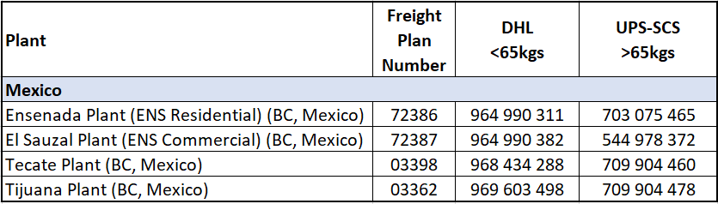  * DHL (<65 kgs), no reference to KORBER or Freight Plan Number is necessary. The account number will be entered upon shipment creation by the supplier under the 3rd Party Billing field.  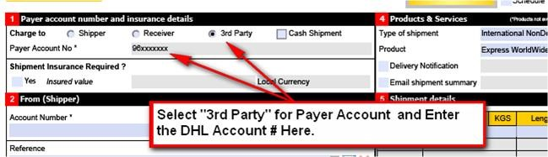  A. Schlage de Mexico PLANNER / BUYER (INITIATOR):  (1) Southbound Form  It is the Planner/Buyer’s responsibility for completing the Southbound Form for any new SKUs to ensure registration in the Mexico Customs system at time of Purchase Order release.  (2) Purchase Orders  The Planner/Buyer is responsible for ensuring that the Purchase Order includes the following PACKING LIST instructions:  ALL PACKING LISTS must include the following information:  (a) Final Destination  Schlage de Mexico – XXX  (replace XXX with applicable Plant Code listed below)  - ENS (for ENSENADA PLANT)  - TEC (for TECATE PLANT)  - TIJ (for TIJUANA PLANT)  - SAU (for EL SAUZAL PLANT)  (b) Oracle Part Numbers  (c) Quantity per Oracle Part Numbers  (d) Descriptions  (e) PO Number and Release Number  Supplier must provide a separate Packing List for each MX facility.  It is the Planner/Buyer’s responsibility to ensure the supplier is complying with the above described requirement. This requirement is listed to facilitate the movement and clearance of the product. Failure to provide a packing list or providing incomplete or consolidated packing lists, will result in delays, and the Planner/Buyer having to resolve the issue with the supplier.  (3) Tracking Shipments –Master Bill of Lading, House Bill of Lading, and T&E Numbers  OCEAN VESSEL SHIPMENTS: The Planner/Buyer will be responsible for obtaining the Master Bill of Lading and House Bill of Lading numbers and tying it to the T&E number on the Kuehne + Nagel T&E log, for ocean shipments. The Planner/Buyer can use the Master Bill of Lading, House Bill of Lading number, and Supplier Name, to locate the T&E number on the log. It is the T&E number that will allow the Planner/Buyer to track their shipments.  Questions regarding the shipment can be discussed with the freight forwarder if the shipment has not yet been dispatched to the truck carrier (LAX Freight). If the freight forwarder/broker already sent documents to the truck carrier the Planner/Buyer can contact the plant Receiving Supervisor for the status of the shipment. (Planner/Buyer should consider waiting, at a minimum, 1 full day from the date the freight forwarder sent documents to the truck carrier before asking the Receiving Supervisor about the shipment).  AIR SHIPMENTS: The Planner/Buyer must obtain the Airway Bill number to track the shipment in the UPS online tracking system. The UPS online tracking system will allow the Planner/Buyer to track up until the delivery is made to the bonded facility (IAB).  (4) Quantity Discrepancies  It is the Planner/Buyer responsibility to research the reasons for any quantity discrepancies and advise the MX Import Supervisor regarding all discrepancies immediately. The Planner/Buyer will complete the Receiving Discrepancy Report - Exhibit 4. Failure to do so jeopardizes the Maquiladora permit and Schlage de Mexico’s right to import.  B. SUPPLIER:  (1) Importer Security Filing (ISF) Template  For all vessel shipments, Suppliers must obtain an Importer Security Filing transaction number prior to physically turning cargo over to the freight forwarder.  (2) Documentation  Ensure all documentation provided to Kuehne + Nagel (KN) (for vessel shipments), UPS or DHL (for air shipments) complies with this Inbond SOP:  - Importer Security Filing (ISF) for Inbond vessel shipments  - Commercial invoice  - Packing List  - Bill of Lading, Truck Bill or Airway Bill  - Certificates of Origin  (3) Master Bill of Lading / House Bill of Lading Numbers  Foreign Supplier is to send, via email, the master bill of lading number and house bill of lading number to the Schlage de Mexico Planner/Buyer. This information is used to track the shipment and link to the T&E (where applicable).  C. FREIGHT FORWARDER / BROKER (KN):  (1) Transportation & Exportation (T&E)  It is the freight forwarder’s responsibility to process T&Es prior to vessel arrival, and to coordinate the delivery order and related documentations with the truck carrier, steamship line and/or CFS station timely. Please also include IAB personnel in the email distribution list associated to T&E releases.  (2) Transportation & Exportation (T&E) Log  The freight forwarder is responsible for maintaining and distributing the T&E log when updates occur.  The broker shall serve as the liaison between the Importer and US Customs for any issues related to Inbond shipment delays.
E. SCHLAGE DE MEXICO CUSTOMS:

(1) Revise Macro with updated Catalog
On a weekly basis, the MX Customs will send to IAB a revised Manifest with Macros linked to the updated MX Customs System database.

(2) Commercial Invoice
The Schlage de Mexico Customs team will create a commercial invoice based on the data elements provided on the Manifests. If the shipment is combined with material from Ensenada and El Sauzal, the MX Customs team will create a commercial invoice for each plant.

If IAB contacts the Schlage de Mexico Customs team to advise them that the Macro on the Manifests resulted in a blank return, the MX Customs team will notify the Planner/Buyer Supervisor that the shipment is on hold until a Southbound Form is received and registered. The MX Customs team will interface with the MX Customs broker to process the import pedimento.

The MX Customs team will provide a commercial invoice to IAB within 30 minutes of receiving a completed manifest. They will also copy in the Planner Buyers when the email is sent.

F. TRUCK CARRIER (LAX FREIGHT):

(1) Shipments to Schlage de Mexico
- LAX Freight will include a copy of the packing list, T&E and manifest with each shipment sent to Schlage de Mexico.

- LAX freight must create and submit the Digital Tax Receipt plus the Complement of the Waybill (Complemento Carta Porte), and share these 2 documents (PDF file + CFDI) via e-mail to Schlage de Mexico's Customs Team prior to dispatching the southbound shipment.

- For any full container loads, LAX Freight will advise IAB as soon as they plan to pick up merchandise from the port. This advance notification to IAB, done via email, will allow IAB to commence creation of the Manifest associated to the container and T&E.

- The truck carrier must go to BLS, to pick up the commercial invoice that has the MX Customs bar code on it, before crossing the border.

(2) Closing the T&E
It is LAX Freight’s responsibility to close the T&E number in CBP’s system.
LAX Freight keeps the T&E for recordkeeping purposes.

G. SCHLAGE DE MEXICO PLANTS (WAREHOUSE):

(1) ON LINE TRACKING TOOL FOR SCHLAGE DE MX
It is the responsibility of the MX Receiving Supervisor to review IAB’s online tool for IAB warehouse receipts associated to the Schlage de Mexico inventory. This tool allows him to determine anticipated volumes expected to arrive in MX or to determine the status of shipments if the Planner/Buyer has inquired on the status.

(2) OFFLOADING WITHIN 24 HOURS OF PLANT ARRIVAL FOR FCL
The Receiving Department must ensure Inbond FCL cargo is offloaded within 24 hours of arrival at the plant. For LCL, an immediate offload is required with a 2 hour cap.

(3) REPORTING QUANTITY DISCREPANCIES
The MX Receiving Supervisor is to notify the Planner/Buyer when quantity discrepancies are identified at time of receiving. It is CRITICAL that quantity discrepancies are reported in order to ensure correct declarations are made to MX Customs. Failure to do so may lead to revocation of Schlage de Mexico’s maquiladora permit.

(4) RECEIVING IN ORACLE
The MX Receiving Supervisor is responsible for receiving parts as per the plants Receiving Procedure.

H. SCHLAGE DE MEXICO PLANTS (SHIPPING):

(1) RETURNING INBOND CONTAINERS WITHIN 24 HOURS OF ARRIVAL
The Traffic Department ensures Inbond containers are returned to LAX Freight within 24 hours to avoid per diem charges.

XII. PENALTIES For Non-Compliance  XIII. Allegion Contacts |  | Penalties for Quantity Discrepancies: Mexico Customs will issue penalties against Schlage de Mexico for failure to declare the correct quantities on its import pedimento. Failure to declare the correct quantities may be perceived by the MX Customs authorities as fraudulent behavior.  Materials imported into Schlage de Mexico’s Maquiladora must be “discharged” or exported. Accurate quantities are therefore also required to ensure correct discharge of inventory.  Receiving must notify the Schlage de Mexico Customs team when discrepancies are identified.  For questions, please contact the following:  TRADE COMPLIANCE  Yesenia Gallegos, Trade Compliance Manager (619) 778-2127 Yesenia.Gallegos@allegion.com  Fernanda Velarde Trade Compliance Analyst (619) 210-2207 Laura.Velarde@allegion.com  Kelly Guzman Trade Compliance Director (619) 778-4137 Kelly.Guzman@allegion.com  MEXICO TRADE COMPLIANCE  Milton Rangel MX Trade Compliance Manager +52 (665) 845 2246 Milton.Rangel@allegion.com  Tomas Hernandez MX Customs Supervisor +52 (646) 182 3157 Tomas.Hernandez@allegion.com  Monica Cobian MX Compliance Supervisor +52 (665) 103 6188 Monica.Cobian@alllegion.com  GLOBAL LOGISTICS  Patrick Bowman Americas Region Logistics Manager (317) 617-4068 Patrick.Bowman@allegion.com  Doug Pasquale Global Distribution and Logistics (317) 420-6300 Doug.Pasquale@allegion.com  SCHLAGE DE MEXICO WAREHOUSE  Ensenada Plant (ENS/SAU) Silvia Cardenas Regional Materials Control Manager +52 (646) 182 3151 Silvia.Cardenas@allegion.com  Raul Sanchez Supervisor, ENS/SAU Receiving +52 (646) 116 2121 Raul.Sanchez@allegion.com  Tecate Plant (TEC) Luis Pinto Materials Team Leader +52 (655) 118 3468 Luis.Pinto@allegion.com  Lucia Leal Inventory Control Supervisor +52 665 3915620 Lucia.Leal@allegion.com  Tijuana Plant (TIJ) Alfonso Valentin Warehouse Leader +52 664 386 0355 Alfonso.Valentin@allegion.com  Julio Cervantes Warehouse Supervisor +52 664 188 4529 Julio.Cervantes@allegion.com

Exhibit 1

TRACKING SHIPMENTS / T&E LOG

1. Tracking Shipments:

- Ask Supplier for Master Bill of Lading Number, House Bill of Lading Number or Tracking number

  - KN*: http://www.kn-portal.com/

  - UPS-SCS: http://www.ups.com/

  - DHL: http://www.dhl.com/

2. T&E Log:

- Estimated Time of Arrival (ETA) Port: View this column to determine if the shipment arrived at the Port.

- T&E # transmitted/accepted: Confirm the date is before or on the same day as ETA Port. (This information indicates the Broker transmitted the information timely to US Customs. If the date is AFTER ETA, the broker may not be transmitting timely).

- LAX FRT dispatched & confirmed: This column indicates the delivery order was issued to the truck carrier and that he confirmed he has the documents to pick up the cargo. This column should have a date within a day or two of the “Available CFS” date for LCL shipments or the “ETA Port” date for FCL. Note, sometimes it will take more than 2 days for the container to be available for pickup at the Port

- Less than Container Load (LCL):

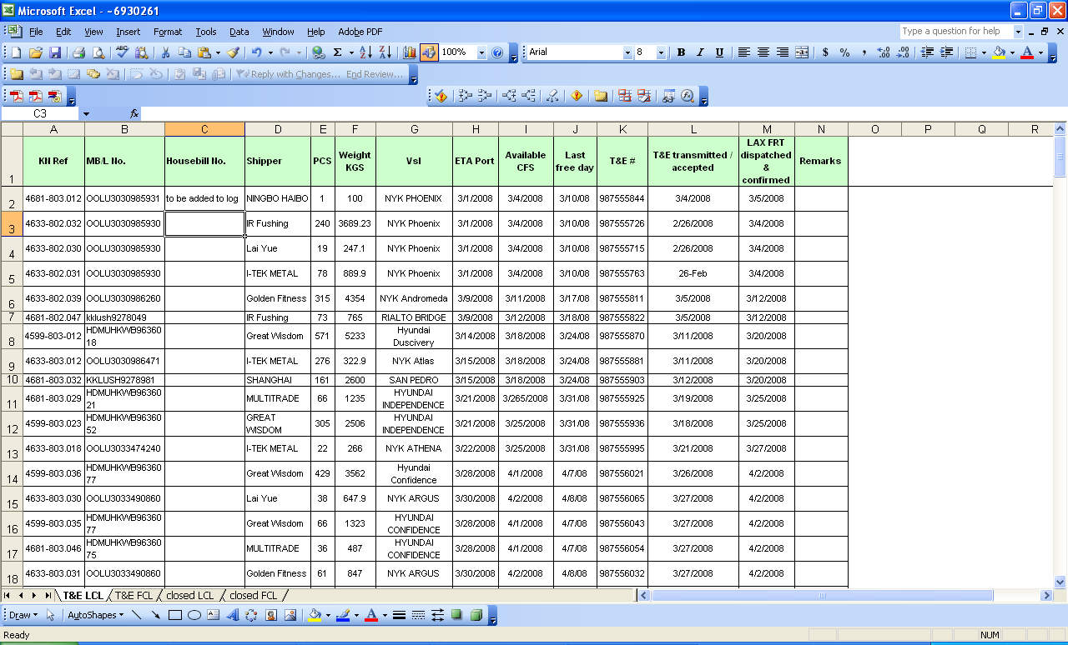

- Full Container Load (FCL):

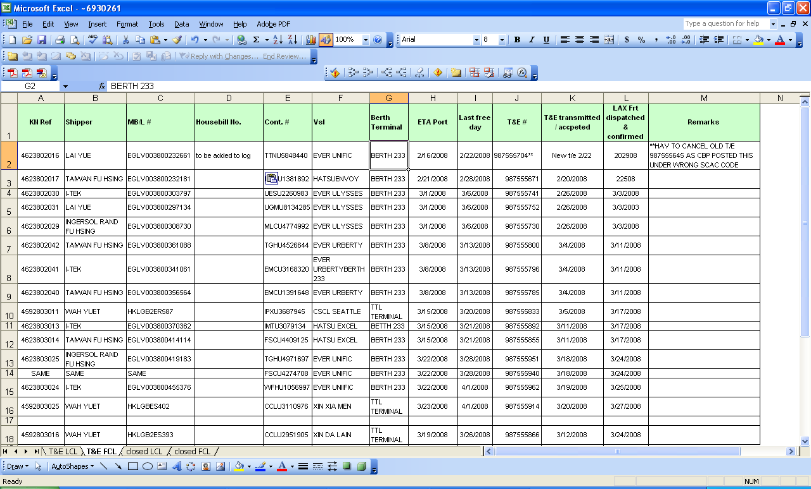

    - Contact MX Logistics Supervisor (for shipments to Schlage de Mexico):

- If Delivery Order was issued, and merchandise was moved as an Inbond shipment, contact the MX Logistics Supervisor to confirm whether shipment was delivered to the IAB bonded facility. (The MX Logistics Supervisor has access to the IAB warehouse system).

- If cargo arrived at the IAB bonded facility before noon, expect a delivery to the MX Plant the same day. Contact the MX Receiving Supervisor for the plant to confirm the status.

OCEAN VESSEL: KUEHNE+ NAGEL (KN)

Exhibit 2

Jiangmen
Jiangmen Branch Office
20-21/F Center Plaza North Tower

- Carol Yi – FCL & LCL
PH: 0086-20-2238-6944 | carol.yi@kuehne-nagel.com

Ningbo
Ningbo Branch Office
6F(south) Howard Johnson Office, Building 230,
Liuting Street, Ningbo

- Sylvia Fei - FCL
PH: 0086-574-2790 9533 | Sylvia.Fei@kuehne-nagel.com

- Florence Wang - LCL
PH: 0086-574-2790 9658 | Florence.Wang@kuehne-nagel.com

Shanghai
Shanghai Branch Office
Life Hub at Daning
Office Tower Block 1, 11-16F
1868 Gong He Xin Road
Zhabei District
200072, Shanghai

- Nicola Cai – Key Account Manager
PH:0086-21-2602 8425 | nicola.cai@kuehne-nagel.com

- Anson Wang - FCL
PH:0086-21-2602 8083 | Anson.Wang@kuehne-nagel.com

- Phoenix Wu - LCL
PH: 0086-21-2602 8085 | Phoenix.Wu@kuehne-nagel.com

Shenzhen
Shenzhen Branch Office
Unit A/B/D/D, 28/F Block A World Finance Center
4003 ShenNan Dong Road Shenzhen 518001

- Chaya Luo - LCL
PH: 0086-755-8269 2429 | chaya.luo@kuehne-nagel.com

Hong Kong + Yantian
Hong Kong Branch Office
Kuehne + Nagel, Inc.
32/F Manhattan Place
23 Want Tai Road
Kowloon, Hong Kong

- Charlie Kok - FCL
PH:0085-2-2866 5260 | Charlie.Kok@kuehne-nagel.com

- Jessie Hou - LCL
0085-757-8163 2343 | Jessie.Hou@kuehne-nagel.com

Kaohsiung
Kaohsiung Branch Office
Kuehne + Nagel, Inc.
A-2 6th Floor
8 Min Chuan 2nd Road
806 Kaohsiung – Taiwan R.O.C.

- Diane Tsao – FCL + LCL
PH: 00886-7-339 1085 ext. 122 | Diane.Tsao@kuehne-nagel.com

Taipei + Keelung
Taipei Branch Office
Kuehne + Nagel, Inc.
4th F, 219 Nanking East Rd,
Section 3, Taipei

- Ashlee Su - FCL
PH: 00886-2-2544 5150 | ashlee.su@kuehne-nagel.com

- Joyce Shih - LCL
PH: 00886-4-2320 0907 | joyce.shih@kuehne-nagel.com

Delhi
Delhi Branch Office
70, Udyog Vihar Phase IV
Gugaon, India 122017

- Siddhartha Chaudhury - FCL
PH: 0091-124-459 5838 | Siddhartha.chaudhury@kuehne-nagel.com
- Pardeep Saini - LCL
PH: 0091-124-459-5959 | pardeep.saini@kuehne-nagel.com

Tijuana
Tijuana Branch Office
Paseo de los Heroes SN, Esquina
Diego Rivera, Plaza Lincoln Int 209, Zona Rio
Tijuana, B.C. MX 22010

- Joaquin Castillo – Ocean Freight Manager
PH:0052-664-972 9470 | Joaquin.Castillo@kuehne-nagel.com
- Brenda Razo (FCL) & Francisco Saavedra (LCL_
PH: 0052-664-972 9470 | Brenda.Razo@kuehne-nagel.com  Francisco.Saavedra@kuehne-nagel.com

Minneapolis
Minneapolis Brand Office
1675 Meadow View Road
Suite 100
Eagin, MN 55122

- Andrea Birkeland – Operational Account Manager
PH: 001-651-234-4266 | andrea.birkeland@kuehne-nagel.com
- Stephanie Klinckman – Ocean Freight Import Manager
PH: 001-651-234-4208 | Stephanie.Klinckman@kuehne-nagel.com
- Jenna Yentsch – Ocean Freight Import Supervisor
PH: 001-651-234-4296 | Jenna.Yentsch@kuehne-nagel.com
- Kyle Lock – Ocean Freight Import Operator FCL
PH: 001-651-234-4251 | Kyle.Lock@kuehne-nagel.com
- Gavin Gates – Ocean Freight Import Operator LCL
PH: 001-651-234-4250 | Gavin.Gates@kuehne-nagel.com

allegion.support@kuehne-nagel.com Escalation Purposes only. Contact regional contacts above for booking and tracking requests.

SMALL PACKAGE: DHL Express (DHL)

Customer Service Team – Lead: Chris Johnson
Email: allegion.customercare@dhl.com

Phone (Within US): 1-877-873-2521 x 53553

If outside of the US, please work with your local DHL office for assistance. You can use the links below as well:

- To find the nearest Service Point and its hours of operation, please visit:
http://www.dhl.com/en/express/shipping/find_dhl_locations.html

- For more details on E-Shipping tools, please visit:
http://www.dhl.com/en/express/resource_center/advanced_shipping.html

- To obtain DHL eMailShip in the language of your choice, please visit:
http://www.dhl.com/en/express/resource_center/emailship.html

- To order Supplies: please visit:
http://www.dhl.com/en/express/shipping/order_supplies.html

- Contact DHL if you need assistance with your first Express shipment—please visit:
http://www.dhl.com/en/contact_center.html

  - AIR CARGO: UPS SUPPLY CHAIN SOLUTIONS (UPS-SCS):

Strategic Support Desk / Pickups
Phone: 800-648-9333 or 913-693-6300 from outside the US
Email: AllegionGFF@ups.com
Expected Coverage- 24/6 Monday 0700cst – Saturday 2359cst.

Local Offices Identified.

Ningbo
Phone: 86 574 2766-1600
UPS SCS Air Export Mailbox
Email: UPSNGB-Export-Operations-Air@ups.com (DL List)
Phoebe Cen – Supervisor
phoebe.cen@ups.com
Cora Zheng – Assistant Supervisor
corazheng@ups.com
Jasmine Yuan - Manager
jamine.yuan@ups.com

Shanghai
Phone: 86 21 3855 3000
UPS SCS Air Export Mailbox
UPSFFSHAEXPCSRSHATEAM@ups.com (DL List)
Zhao Lauren (aao1npp) Senior Manager Work: 86-21-61057888 Mobile: 13-81887-9327 Email: lauren.zhao@ups.com
Stephanie Hu - Manager
Stephanie.hu@ups.com

Hong Kong
Phone: 852-2738-5000
UPS SCS Air Export Mailbox
hkgairexport@ups.com (DL List)
Billy Chow Manager
billy.chow@ups.com
Fung Brenda Supervisor
Supervisor
Email: bfung@ups.com
Yantian (Shenzhen)
Phone: 86 755 83160688
UPS SCS Air Export Mailbox
Email: upsupsszxairexport@ups.com
Joy Hu – Supervisor - (Included on DL)
Kenny Mok - Manager - (Included on DL)

Kaohsiung
Phone: 0800-291-300 / 886 7 586 8800
UPS SCS Air Export Mailbox
UPSKHHAIR@ups.com (DL List)

Hsieh Pony – Air Coordinator (included on DL)

Grace Wang – Manager
grace.wang@ups.com

Keelung / Taipei
Imports
Email: UPSTWAIRIMPORT@ups.com (DL List)
Exports
Email: UPSTWAIREXPORT@ups.com (DL List)
Phone: 886 2 6611-7676
Frances Hsu – Asst Manager Exports (Included on DL list)
Grace Wang – Manager
grace.wang@ups.com

Mumbai (Bombay) Nava Sheva
UPSUPSBOMAIREXPORTS@ups.com (DL List)
Phone: 91 022 71726200
Kumar Gupta Vinod – Executive Exports
Zubin Bhagalia – Manager zubin.bhagalia@ups.com

Exhibit 3

Container Inspection Checklist (CIC)
This example is shown for illustration only; please use Word version attached within this SOP in Section VII.
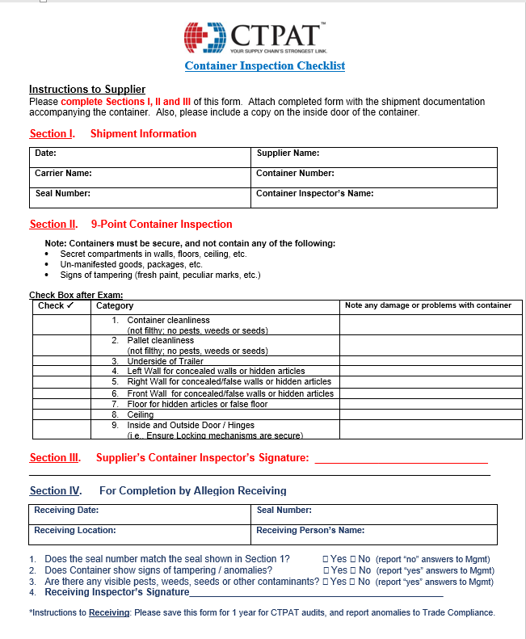

Exhibit 4
Receiving Discrepancy Report

Instructions to Planner/Buyer: Please complete Sections I below. Forward the completed checklist to the Schlage de Mexico Customs team for any quantity discrepancies for Inbond shipments.

Please note: This report should be sent to the Schlage de Mexico Customs team within 2 days of receiving the merchandise so that they may modify the MX Import Pedimento timely.

Section I.

Date ________________________________________________________________

Invoice Number ________________________________________________________________

Warehouse Control # ______________________________________________________________

Truck # ______________________________________________________________

Oracle Part # ______________________________________________________________

Quantity Declared _____________________________________________________________

Quantity Received ______________________________________________________________

Planner/Buyer ______________________________________________________________

Name of Person who detected the issue: ___________________________________________

Exhibit 5

External Agent Contacts

I. External Contacts

US BONDED WAREHOUSE /  US BROKER: | International Automated Brokers (“IAB”)
 | Steve Goding | 619-661-6464 Ext: 3111  sgoding@iab-sd.com
 | Edgar Cortes | 619-661-6464 Ext: 3105  edgar.cortes@iab-sd.com
 | Jose Lopez | 619-661-6464 Ext: 3120  jlopez@iab-sd.com
BONDED CARRIER: | LAX Freight
 | Isaac Rivas | 619-661-9463 Ext. 3133  irivas@iab-sd.com
 | Luis Arrequin | 619-661-9463 or  619-661-6464 Ext: 3134  luis@iab-sd.com

