TABLE OF CONTENTS Page

- Corporate Policy 2

- Purpose 2

- Scope 2

- Designated Freight Forwarders 2-3

- Importer Security Filing (ISF) 3

- Customs Documentation 4

    - US Customs Documentation Requirements 4-5
    - Returned Goods Documentation Requirements 5
    - Documentation Distribution 6-7

VII. Customs Trade Partnership Against Terrorism (CTPAT) 8-9

- Container Inspection Checklist 8
- Seals 9

VIII. Country of Origin Marking 9

IX. Wood Packaging Material (WPM) 10

X. Freight Plans 11

XI. Responsibilities 12-15

XII. Allegion Contacts 15

Exhibit 1: CTPAT Container Security – Inspection Checklist 16

Exhibit 2: Freight Carrier Contacts

- Ocean Vessel: Kuehne + Nagel (KN) 17-21
- Small Package: UPS Parcel (UPS) 21
- Air Cargo: UPS Supply Chain Solutions (UPS-SCS) 21-22

Exhibit 3: Receiving Discrepancy Report 23
I. Corporate Policy: | It is the policy of Allegion, plc to ensure compliance with all US Customs and other government agency regulations. This Import SOP is written in accordance with US Customs regulatory requirements. Allegion, plc is the parent company of Schlage Lock Company, LLC, AD Solutions, Elatec Inc (USA), Triangle Brass Mfg Co, Inc DBA TRIMCO, and Allegion Access Technologies LLC. “Allegion” will be referenced periodically in this SOP.
II. Purpose: | The purpose of this SOP is to ensure all Allegion suppliers are aware of and adhere to US Customs and other government agency import requirements. All current revisions of this Import SOP can be found on the Allegion Supplier Portal (www.allegion.com/suppliers).
III. Scope:  IV. Designated  Freight  Forwarders:  V. Importer Security Filing (ISF):  VI. Customs Documentation:  VII. Customs Trade Partnership Against Terrorism (CTPAT):  VIII. Country of Origin Marking:  IX. Wood Packaging Materials:  X. Freight Plans:  XI. Responsibilities:  XII.  Allegion Contacts: | This policy and procedure provide instructions for shipments to the US for Schlage Lock Company, LLC, AD Solutions, Inc., Elatec Inc (USA), Triangle Brass Mfg Co, Inc DBA TRIMCO, and Allegion Access Technologies LLC.  This SOP does not cover SOMI shipments to the US or Mexico. See “SOMI Import Standard Operating Procedure (SOP)” for instructions on SOMI shipments.  This SOP does not cover INBOND shipments to Mexico. See “INBOND Standard Operating Procedure (SOP) for Schlage de Mexico” for instructions on INBOND shipments.  Allegion has designated freight forwarders depending on the mode of transportation and type of shipment. Please refer to the guide below when shipping product to any of Allegion’s US sites.  Note: This section only applies to designated freight forwarders and not to US Customs brokers.  VESSEL SHIPMENTS:  - For all vessel shipments our designated freight forwarder is Kuehne + Nagel (KN). KN will be booking on behalf of Allegion on GSA-endorsed steamship lines.  - Please refer to Exhibit 2 for contact information by country/city.  AIR SHIPMENTS:  Shipments under 65kgs: Air shipments that weigh less than 65kgs should be forwarded through UPS Parcel (UPS Small Package).  Note: UPS is to be used in certain circumstances when noted specifically.  - Shipments greater than 65kgs: Air shipments that weigh more than 65kgs and destined for facilities in the US should be forwarded through UPS Supply Chain Solutions (UPS-SCS).  - Please refer to Exhibit 2 for contact information by country/city  INBOND SHIPMENTS:  - Please refer to the separate procedure for INBOND SHIPMENTS. Please find all procedures on the Allegion Supplier Portal (http://www.allegion.com/suppliers).  SOMI SHIPMENTS:  - Please refer to the separate procedure for SOMI SHIPMENTS. Please find all procedures on our Allegion Supplier Portal (http://www.allegion.com/suppliers).  Under US Customs law, an Importer Security Filing (ISF) must be transmitted to US Customs at least 24 hours prior to loading any vessel bound for the US. Failure to file the ISF will result in a $5K customs penalty per violation.  For all vessel shipments, Suppliers must obtain an Importer Security Filing transaction number prior to physically turning cargo over to the freight forwarder.  Procedure for Supplier to obtain ISF Transaction Number:  - Obtain bill of lading number from the freight forwarder  2. Complete Importer Security Filing (ISF) template, using template entitled: “ISF Template US Imports 2025”  Note: the Excel version of the ISF template will be distributed with this SOP but can also be obtained from Trade Compliance.  - Email completed ISF template and estimated time of vessel departure to the designated filing agent at least 72 hours in advance of sailing.  For Schlage, AD Solutions, Elatec Inc (USA), and Triangle Brass Mfg Co, Inc DBA TRIMCO, the ISF Filing Agent for US Importations is:  isf@iab-sd.com. The ISF contact is Steve Goding.  For Allegion Access Technologies LLC, the ISF Filing Agent for US Importations is: isf@kuehne-nagel.com  - Obtain ISF transaction number from filing agent (must be documented on the ISF template). The ISF filing agent is required to return the ISF transaction number within 24 hours.  - Deliver cargo to freight forwarder and provide copy of final ISF template (reflecting ‘ISF Transaction Number’) with shipment documentation.  US CUSTOMS DOCUMENTATION REQUIREMENTS:  - Documents Required: The following documents are required for importation into the US.  - Importer Security Filing for vessel shipments  - Commercial Invoice  - Packing List  - Express Bill of Lading, Truck Bill or Airway Bill  - CTPAT Container Inspection Checklist (CIC) for FCL  - Shipping and Documentation instructions are reflected in the attached “At-A-Glance US Imports 2025 rev 12.05.2025”, and includes requirements for the following types of import shipments:  - Ocean Vessel: KN  - Small Package: UPS Parcel (Small Package)  - Air Cargo: UPS-SCS  These matrices provide the instructions for:  - Sold To Party  - Destination / Final Delivery  - Notify Party  - Special Requirements  - ISF filing agent  - Invoice Requirements: The invoice should contain the following information in English:  - The date of export  - The place of export (i.e., origin port);  - The exporter’s name, address, telephone number and name of person with knowledge of the shipment;  - Place where goods will be imported (Port of Entry);  - The bill to name and address;  - The ship to/sold to name and address;  - Terms of sale (i.e., FOB, CIF, etc.);  - Invoice number;  - Invoice date;  - Buyer’s PO and release number should be identified at the top of the invoice;  - Buyer’s part number/item number;  - Payment terms;  - Blanket order line item;  - Detailed description of the merchandise (this includes the grade or quality, the marks, numbers and symbols of the merchandise);  - Quantities and unit of measure;  - Unit price of each item; NOTE: this must be the selling price (price to be paid or payable).  - Total value of each item;  - Total numeric and written value of shipment (i.e., $1000 – one thousand US dollars);  - Associated charges in the currency of purchase (i.e., material surcharges, freight costs, other applicable fees not already included in the invoice price per item);  - The currency of transaction;  - The country of origin of the goods;  - US Harmonized Tariff Code (see note below);  - If you do not have the US Harmonized Tariff Code for a product, please contact the Trade Compliance team prior to export.  - Packing list number associated with the shipment should be referenced;  - Page numbers.  - Packing List Requirements: The packing lists should contain the following information in English:  - Packing list number;  - Shipping marks (i.e., marks, numbers and symbols of the packages in which the merchandise is packed);  - Pallet numbers;  - Carton Numbers;  - Buyer’s part number/item number;  - Product description;  - Quantity (quantity per carton and total number of cartons should both be listed);  - Gross weight and unit of measure;  - Net Weight and unit of measure.  RETURNED or REJECTED GOODS DOCUMENTATION REQUIREMENTS:  - Documentation requirements for returned or rejected merchandise is the same as described above.  - Indicate on the commercial invoice if the shipment is being returned or rejected and the reason for return (i.e., “Shipment being returned for repairs and re-export” (if applicable)).  - The invoice value shown on the invoice must be the actual value of the goods at the time they were purchased.  DOCUMENTATION DISTRIBUTION  Copies of the following documents should be emailed to the NOTIFY parties instructed in the below attached “At-A-Glance US Imports 2025 rev 12.05.2025.” The Primary Notify Parties are also included further below for reference.  - Importer Security Filing (for Vessel Shipments only)  - Commercial invoice;  - Packing list;  - Express Bill of Lading/Airway Bill/Truck Bill  - CTPAT Container Inspection Checklist (CIC) for FCL shipments  Each document should be a separately scanned attachment (i.e., for example, all pages of the commercial invoice should be in one attachment, and all pages of the packing list should be in a separate attachment).  For Vessel Shipments:  For Schlage, AD Solutions, Elatec Inc (USA), and Triangle Brass Mfg Co, Inc DBA TRIMCO  Primary Notify Party:  International Automated Brokers (IAB)  Steve Goding, James Goding  Email the following:  sgoding@iab-sd.com  jamesg@iab-sd.com  Phone: (619) 671-3186  Phone: (619) 671-3185  For Allegion Access Technologies LLC  Primary Notify Party:  Kuehne+Nagel Inc (KN)  Elizabeth Yarns  Email the following: USBRKMSPHUB@KUEHNE-NAGEL.COM  Direct Phone: (651) 234-4259  For UPS Parcel (Small Package) Shipments under 65kgs:  For Schlage, AD Solutions, Elatec Inc (USA), and Triangle Brass Mfg Co, Inc DBA TRIMCO  Primary Notify Party:  UPS US Allegion  Email the following:  UPSUSALLEGION@ups.com  For Allegion Access Technologies LLC  Primary Notify Party:  UPS Supply Chain Solutions  Christina Kemp  Email the following: Christinakemp@ups.com  Direct Phone: (502) 362-6657  For UPS-SCS Air Shipments greater than 65kgs:  For Schlage, AD Solutions, Elatec Inc (USA), and Triangle Brass Mfg Co, Inc DBA TRIMCO  Primary Notify Party:  International Automated Brokers (IAB)  Steve Goding, James Goding  Email the following:  sgoding@iab-sd.com  jamesg@iab-sd.com  Phone: (619) 671-3186  Phone: (619) 671-3185  For Allegion Access Technologies LLC  Primary Notify Party:  Kuehne+Nagel Inc (KN)  Elizabeth Yarns  Email the following: USBRKMSPHUB@KUEHNE-NAGEL.COM  Direct Phone: (651) 234-4259  ***Important: These instructions pertain solely to the distribution of IMPORT DOCUMENTATION for Customs clearance. For payment instructions, the commercial invoices should also be sent to the appropriate entities as instructed on your PURCHASE ORDERS. NOTE: The EXACT SAME invoice must be used for BILLING AND CUSTOMS PURPOSES.  As part of US Customs’ CTPAT program (Customs Trade Partnership Against Terrorism), foreign suppliers are required to comply with the Minimum-Security Criteria for Foreign Manufacturers (attached below).  Allegion requires our foreign suppliers to (A) conduct and document container inspections and (B) apply high security seals to containers.  All suppliers must comply with CTPAT requirements A and B listed immediately below:  A. Conduct a 9-point Container Inspection prior to loading cargo, as well as:  - check the reliability of the locking mechanisms of the container doors,  - document the inspection using the “Container Inspection Checklist” (attached to this document), and  - assign documentation accountability (someone from your company must be assigned the responsibility for container inspections).  NOTE:  Container integrity is critical to protect against the introduction of unauthorized material, persons and agricultural pests into the US.  The required 9-point container inspection process covers:  - Container cleanliness (no visible signs of pest contamination, including weeds, seeds, insects, fungi, etc.)  - Pallet cleanliness (no visible signs of pest contamination, including weeds, seeds, insects, fungi, etc.)  - Underside of Trailer  - Left Wall  - Right Wall  - Front Wall  - Floor  - Ceiling  - Inside and Outside Door / Hinges  (i.e., Ensure Locking mechanisms are secure)  Container Inspection Checklist  Complete the Container Inspection Checklist (attached to this SOP). Suppliers must complete sections I, II, and III for shipments bound for the US and include the completed hardcopy form on the inside door of the container.  B. Apply a high security Seal to all shipping containers bound for the U.S.  US law requires all containers bound for the U.S. to be secured with a high security SEAL which meets PAS/ISO 17712:2013 standards, as follows:  (1) seals must meet or exceed certain standards for strength and durability to prevent accidental breakage, early deterioration (due to weather conditions, chemical action, etc.) or undetectable tampering under normal usage. An 18MM MINIMUM WIDTH DIAMETER for bolt seals is required.  (2) seals must be clearly and legibly marked with a unique identification number.  (3) The seal is classified as an “H” – High Security Seal  Unused seals must be stored in a secure place and controlled.  Less than container loads must use a secured padlock or similar locking device. Only a limited number of individuals should have access to open this padlock. Once freight is consolidated for shipping to the US, the containers must be sealed with a high security seal.  US Customs and Border Protection will assess civil penalties for violations of the container sealing requirement.  For additional information/specifications related to the seal requirement and for questions on CTPAT, please contact the Trade Compliance group.  To receive the Container Inspection Checklist via email as a Word document, contact the Trade Compliance group.  U.S. Customs laws require each imported article of foreign origin to be marked with the English name of the country of origin. The country of origin marking must be permanent and conspicuous.  The origin marking must be permanent so as to remain on the article (or its container) until it reaches the ultimate purchaser. The size of the marking statement should be readily visible by normal handling of the article.  Suppliers must ensure all Wood Packaging Materials (WPM) comply with US and international phytosanitary standards as follows:  - All WPM must be properly marked to indicate they have been either heat treated or treated with methyl bromide.  - All WPM must contain the internationally recognized IPPC mark, which certifies treatment. See example of IPPC mark below.  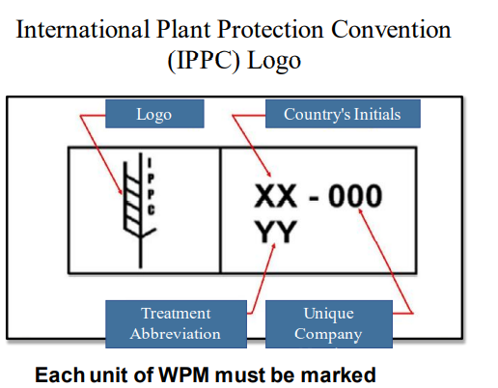  - All WPM must also be free of timber pests.  - All WPM must be very clean and cannot have any signs of weeds or seeds on them (free from organic plant life).  WPM should not be stored outside. Suppliers must regularly inspect their cargo areas to ensure they remain free of visible pest contamination.  Wood Packaging Material (WPM) is defined as wood or wood products (excluding paper products, such as corrugated paper cartons) used in supporting, protecting or carrying a commodity. Wood packaging materials include:  - pallets,  - crates,  - boxes,  - packing blocks,  - drums,  - cases,  - skids, and  - pieces of wood used to support or brace cargo.  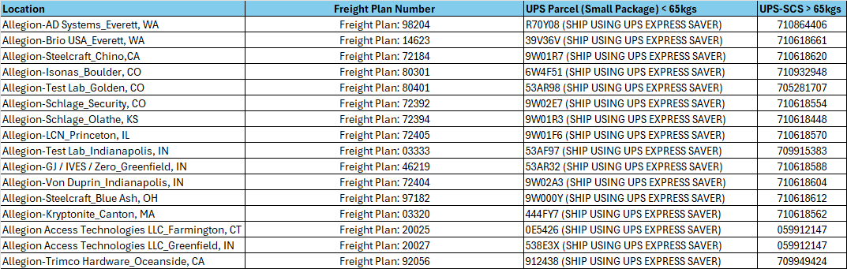  OCEAN VESSEL and AIR CARGO Shipments ONLY:  Supplier must ensure the “Bill To” portion of the Bill of Lading reflects KORBER, our Third-Party Payment Provider, and the appropriate address below:  ALLEGION c/o Körber Supply Chain  Freight Plan XXXXX (replace XXXXX with applicable 5-digit number listed above)  11555 N Meridian St., STE - 200  Carmel IN, 46032  * UPS Parcel (Small Package) (<65 kgs), no reference to KORBER or Freight Plan Number is necessary. The account number will be entered upon shipment creation by the supplier in the UPS Account Number field. This is also used for Bill Transportation and Duty/Tax. Screenshot example below.  Important instructions when shipping UPS Parcel (Small Package):  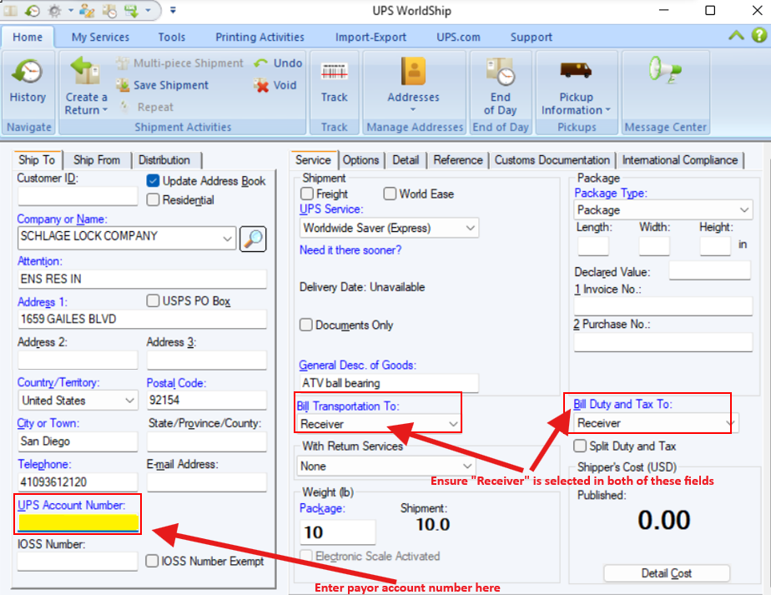  A. PLANNER/BUYER (INITIATOR):  (1) Purchase Orders for New Product – NOTIFY TRADE COMPLIANCE  The Planner/Buyer is responsible for advising Trade Compliance when new articles will be purchased. The Planner/Buyer will complete the “US Import Classification Form” (attached below). Planner/Buyer must email this completed form to the Trade Compliance Analyst. This step will allow the Trade Compliance Analyst to review the new parts in order to assign a US HTS Classification and identify any other government agency requirements.  (2) Quantity Discrepancies  It is the responsibility of the Planner/Buyer to research the reasons for any quantity discrepancies and advise the Trade Compliance Manager regarding all discrepancies. The Planner/Buyer will complete the Receiving Discrepancy Report - Exhibit 3. This information is then used to make corrections with US Customs. The US Customs entry quantities must match the quantity that was received. The values on the invoice must also match what the supplier will be paid for the shipment. Failure to report quantity and value discrepancies jeopardizes the company’s compliance efforts and places the company at risk of receiving a penalty.  B. FOREIGN SUPPLIER:  (1) Importer Security Filing  Suppliers cannot release any vessel cargo to the freight forwarders until they have obtained an ISF transaction number (see ISF instructions under section V of this SOP).  (2) Documentation  Ensure all documentation is provided to the freight forwarder and US Customs Broker, and complies with this Import SOP:  - Importer Security Filing for vessel shipments  - CTPAT Container Inspection Checklist (CIC)  - Commercial invoice (with required data, including HTS classification)  - Packing List  - Seaway bill of lading and / or Automated Manifest System (AMS) bill, Truck Bill or Airway Bill (House bill)  (3) Bill of Lading/House bill of Lading Numbers  Supplier is to send, via email, the master bill of lading number and house bill of lading number to the Planner/Buyer. This information is used to track the shipment.  (4) Transportation Issues/Delays  The Americas Logistics Manager along with the Buyer/Planner must be immediately notified in the event of delays, cancellations and/or rescheduling of freight that causes airline/port delays, mechanical problems, traffic congestion, embargoes, Customs audits/holds, or any other type of transportation delay/failure.  (5) Freight Bill Audit/Payment  Any questions surrounding the usage of freight plan numbers, invoice payment cycles or other freight bill audit and payment issues should be brought to the immediate attention of the Americas Logistics Manager.  C. FREIGHT FORWARDER:  - Documentation at Origin  The Freight Forwarder is responsible for ensuring that he/she has copies of documentation at origin. Next, the Freight Forwarder scans and uploads the documentation into the freight forwarding system to support recordkeeping efforts.  The Freight Forwarder should NOT allow a shipment to depart origin without the required documentation.  The Freight Forwarder is responsible for ensuring that the arrival notice with the supplier documents is turned over to the designated Broker.  - Freight Bills (OCEAN VESSEL and AIR CARGO Shipments Only)  Bills of lading and supporting documents for any freight, drayage, terminal fees, etc. must be sent with the freight invoice to KORBER (the freight payment service provider) for payment processing. It is extremely important that the freight plan number be included on the Bill of Lading. Allegion will not be responsible for the payment of freight invoices sent to KORBER with missing or incorrect freight plan numbers. In addition, it is important for suppliers and freight forwarders to note that only freight related charges are to be billed to KORBER. Under no circumstances should KORBER be billed for any direct material costs.  It is imperative that the “Bill To” block of the Bill of Lading be filled out to reflect KORBER, Allegion’s Third-Party freight payment provider. In addition to the KORBER reference, a unique freight plan number must also accompany the KORBER address. Each Allegion facility has a specific freight plan number, as outlined in Section X, and the following information is required to be placed in the Bill of Lading “Bill To” block:  ALLEGION c/o Körber Supply Chain  Freight Plan XXXXX (replace with correct 5 digit # from p.10)  11555 N Meridian St., STE - 200  Carmel IN, 46032  D. US CUSTOMS BROKER:  - Documentation  The US Customs Broker is responsible for reviewing all supplier import documentation and ensuring it meets the US Customs requirements for entry and compliance purposes. The US Customs Broker is also responsible for reviewing the entry file in accordance with Allegion’s “US Customs Broker Guidelines.” These Guidelines include Billing requirements.  - Recordkeeping  The US Customs Broker is responsible for mailing a Data Stick or CD of all entry records for the month to the Trade Compliance Manager.  Copies of the entry packets should be sent with the billing invoice to KORBER, the freight payment service provider, for payment processing. The Freight Plans must be included.  (3) Missing Data  The US Customs Broker is responsible for coordinating further with the US Customs Team for any missing data, such as country of origin or classifications.  E. ALLEGION TRADE COMPLIANCE:  (1) US HTS Classification  The Trade Compliance Analyst is responsible for reviewing the US IMPORT Classification Form that the Buyer/Planner sends. The Trade Compliance Analyst will determine the correct US HTS Classification. The Trade Compliance Analyst will maintain records of supporting documentation used for determination of the US HTS. The classification will be provided to the Buyer/Planner within 2 days. The Trade Compliance Analyst will also update the Broker Master with the new part and compliance details.  (2) Audits  The Trade Compliance Analyst is responsible for performing periodic entry audits to ensure suppliers, Planner/Buyers and Brokers are following this US Import SOP, as well as following the compliance requirements of the US Customs and Border Protection agency.  (3) Quantity Discrepancies  The Trade Compliance Manager will review the Receiving Discrepancy Report that the Planner/Buyer sends. The Trade Compliance Manager will communicate the required entry changes to the US Customs Broker. Please refer to Exhibit 3.  F. ALLEGION LOGISTICS:  (1) Logistics Support / Contracts  The Americas Logistics Manager is responsible for providing logistics support, including operational crisis management support, when requested by the US plants, factories, and distribution centers. In addition, the Americas Logistics Manager will ensure that the designated freight forwarder/carrier is consistent with the Allegion endorsed transportation base, as well as making sure that logistical movements are conducted in accordance with established contracted rates and service levels established by Allegion.  G. ALLEGION RECEIVING:  The US Receiving Supervisor is to notify the Planner/Buyer when quantity discrepancies are identified at time of receiving. It is CRITICAL that quantity discrepancies are reported to ensure correct declarations are made to US Customs. Failure to do so may lead to serious penalties against Allegion.  For questions, please contact the following:
  TRADE COMPLIANCE | Maria Serratos  Supervisor, US Imports and Classification | (619) 210-2205
   | Brandon Pak  Senior Trade Compliance Analyst | brandon.pak@allegion.com
   | Yesenia Gallegos,  Trade Compliance Manager | (619) 778-2127
   | Kelly Guzman,  Trade Compliance Director | (619) 778-4137
  LOGISTICS | James Hirsch  Logistics Manager | (317) 719-7210
   | Patrick Bowman  Sr. Manager Americas Logistics | (317) 617-4068
   | Doug Pasquale  Global Logistics and Distribution Director | (317) 420-6300

Container Inspection Checklist (CIC)

Exhibit 1

This example is shown for illustration only. Please use the Word version available below and on the Allegion Supplier Portal.
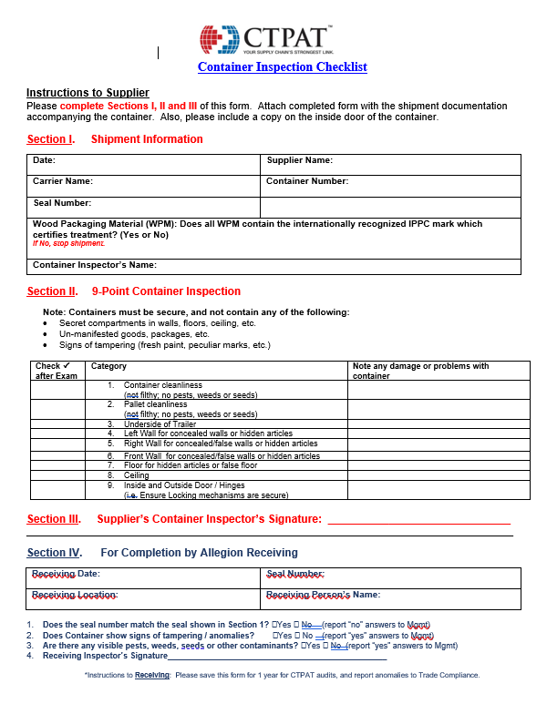

Freight Carrier Contacts

Exhibit 2
  - OCEAN VESSEL: KUEHNE+ NAGEL (KN)
Bangkok
Bangkok Branch Office

- Narisarawan Nandvan– FCL & LCL
PH: TBD | narisarawan.nandavan@kuehne-nagel.com

Hanoi
Hanoi Branch Office

- Gioi Pham – FCL & LCL
PH: TBD | Gioi.pham@kuehne-nagel.com

Osaka
Osaka Branch Office

- Kohei Nakanishi; Sayaka Takahashi – FCL & LCL
PH: TBD | kohei.nakanishi@kuehne-nagel.com; sayaka.takahashi@kuehne-nagel.com

Zhongshan
Zhongshan Branch Office

- Summer Zhang – FCL & LCL
PH: TBD | summer.zhang@kuehne-nagel.com

Jiangmen
Jiangmen Branch Office
20-21/F Center Plaza North Tower

- Carol Yi – FCL & LCL
PH: 0086-20-2238-6944 | carol.yi@kuehne-nagel.com

Ningbo
Ningbo Branch Office
6F(south) Howard Johnson Office, Building 230,
Liuting Street, Ningbo

- Sylvia Fei – FCL + LCL
PH: 0086-574-2790 9702 | sylvia.fei@kuehne-nagel.com

Shanghai
Shanghai Branch Office
Life Hub at Daning
Office Tower Block 1, 11-16F
1868 Gong He Xin Road
Zhabei District
200072, Shanghai

- Tracy You – FCL & LCL
PH:0086-21-2602 8083 | tracy.you@kuehne-nagel.com

Shenzhen
Shenzhen Branch Office
Unit A/B/D/D, 28/F Block A World Finance Center
4003 ShenNan Dong Road Shenzhen 518001

- Alice Lin; Julie Wu - FCL & LCL
PH: 0086-755-8269 2429 | alice.lin@kuehne-nagel.com; julie.wu@kuehne-nagel.com

Hong Kong + Yantian
Hong Kong Branch Office
Kuehne + Nagel, Inc.
32/F Manhattan Place
23 Want Tai Road
Kowloon, Hong Kong

- Summer Zhang – FCL & LCL
PH:0085-2-2866 5260 | Summer.jx.Zhang@kuehne-nagel.com

Kaohsiung
Kaohsiung Branch Office
Kuehne + Nagel, Inc.
A-2 6th Floor
8 Min Chuan 2nd Road
806 Kaohsiung – Taiwan (R.O.C.)

- Cyril Chung; Kimi Chang – FCL + LCL
PH: 00886-7-3391085 | cyril.chung@kuehne-nagel.com; kimi_chang@kuehne-nagel.com

Taipei + Keelung
Taipei Branch Office
Kuehne + Nagel, Inc.
10F, No.246, Sec. 1, Neihu Rd, Neihu Dist,
Taipei City, 114661 – Taiwan (R.O.C)

Cyril Chung; Kimi Chang – FCL + LCL
PH: 00886-2-2544 5150 | cyril.chung@kuehne-nagel.com; kimi_chang@kuehne-nagel.com

INDIA
Delhi Branch Office
70, Udyog Vihar Phase IV
Gurgaon, India 122017

- Siddhartha Chaudhury - FCL
PH: 0091-124-459 5838 | Siddhartha.chaudhury@kuehne-nagel.com
- Pardeep Saini - LCL
PH: 0091-124-459-5959 | pardeep.saini@kuehne-nagel.com

Tuticorin Branch Office

- Balakumar Periyasamy – FCL + LCL
PH: TBD | Balakumar.periyasamy@kuehne-nagel.com

301-302, Buliding 637
Opp. Sears Tower & CII Building
Near Panchwati Cross Roads
Gulbai Tekra Road
Ellisbridge, Ahmedabad 380006

- Biju Nair - LCL
PH: 0091-79-4024-6428  Mobile: 0091-99 2575 7778 | biju.nair@kuehne-nagel.com

Tijuana
Tijuana Branch Office
Paseo de los Heroes SN, Esquina
Diego Rivera, Plaza Lincoln Int 209, Zona Rio
Tijuana, B.C. MX 22010

General Contact: info.tijuana@kuehne-nagel.com
Elsa Escalante / Ocean Freight Supervisor
Esla.Escalante@kuehne-nagel.com
Diego Navarro / FCL Coordinator
Diego.Navarro@kuehne-nagel.com
Victor Rochin / LCL Coordinator
External.Victor.Rochin@kuehne-nagel.com

Minneapolis
Minneapolis Branch Office
1440 Northland Drive, Suite 300
Mendota Heights, MN 55120, USA

- Andrea Birkeland – Operational Account Manager
PH: 001-651-234-4266 | andrea.birkeland@kuehne-nagel.com
- Stephanie Klinckman – Ocean Freight Import Manager
PH: 001-651-234-4208 | Stephanie.Klinckman@kuehne-nagel.com
- Jenna Yentsch – Ocean Freight Import Operator FCL
PH: 001-651-234-4296 | jenna.yentsch@kuehne-nagel.com

allegion.support@kuehne-nagel.com
Escalation Purposes only. Contact regional contacts above for booking and tracking requests.

  - SMALL PACKAGE: UPS Parcel

International Help Desk
Email: goglobal@ups.com

Phone (Within US): 1-800-782-7892

  - AIR CARGO: UPS SUPPLY CHAIN SOLUTIONS (UPS-SCS):

Strategic Support Desk / Pickups
Phone: 800-648-9333 or 913-693-6300 from outside the US
Email: ed.arquilla@ups.com
Expected Coverage- 24/6 Monday 0700cst – Saturday 2359cst.

Local Offices Identified.

Ningbo
Phone: 86 574 2766-1600
UPS SCS Air Export Mailbox
Email: UPSNGB-Export-Operations-Air@ups.com (DL List)
Phoebe Cen – Supervisor
phoebe.cen@ups.com
Jasmine Yuan - Manager
jasmine.yuan@ups.com

Shanghai
Phone: 86 21 3855 3000
UPS SCS Air Export Mailbox
UPSFFSHAEXPCSRSHATEAM@ups.com (DL List)
Zhao Lauren (aao1npp) Senior Manager Work: 86-21-61057888 Mobile: 13-81887-9327 Email: lauren.zhao@ups.com
Stephanie Hu - Manager
Stephanie.hu@ups.com

Hong Kong
Phone: 852-2738-5000
UPS SCS Air Export Mailbox
hkgairexport@ups.com (DL List)
Billy Chow Manager
billy.chow@ups.com
Fung Brenda Supervisor
Supervisor
Email: bfung@ups.com
Yantian (Shenzhen)
Phone: 86 755 83160688
UPS SCS Air Export Mailbox
Email: upsupsszxairexport@ups.com
Joy Hu – Supervisor - (Included on DL)
Kenny Mok - Manager - (Included on DL)

Kaohsiung
Phone: 0800-291-300 / 886 7 586 8800
UPS SCS Air Export Mailbox
UPSKHHAIR@ups.com (DL List)

Hsieh Pony – Air Coordinator (included on DL)

Grace Wang – Manager
grace.wang@ups.com

Keelung / Taipei
Imports
Email: UPSTWAIRIMPORT@ups.com (DL List)
Exports
Email: UPSTWAIREXPORT@ups.com (DL List)
Phone: 886 2 6611-7676
Frances Hsu – Asst Manager Exports (Included on DL list)
Grace Wang – Manager
grace.wang@ups.com

Mumbai (Bombay) Nava Sheva
UPSUPSBOMAIREXPORTS@ups.com (DL List)
Phone: 91 022 71726200
Kumar Gupta Vinod – Executive Exports
Zubin Bhagalia – Manager zubin.bhagalia@ups.com

Exhibit 3

Receiving Discrepancy Report

Instructions to Planner/Buyer: Please complete Section I below. Forward the completed checklist to Allegion US Trade Compliance for any quantity discrepancies.

Please note: This report should be sent to the Allegion team within 2 days of receiving the merchandise, so that they may modify the US Customs Entry timely.

Section I.

Date

Entry Number (if known)

Invoice Number and Invoice Date

Supplier Name

Container #

Bill of Lading Number and House Bill of Lading Number

Oracle Part # or Part # (where Oracle is not used)

Quantity Declared

Quantity Received

Full Value that will be paid for the invoice

Planner/Buyer Name

Name of Person who detected the issue:

Our designated US Customs Brokers are provided within the “At-A-Glance US Imports 2025 rev 12.05.2025.”

