INDEX Page

- Policy 2

- Purpose 2

- Scope 2

- Definitions 3

- Background 3

- Requirements 3

- Exceptions 6

- Responsibilities 7

- US Penalties for Non-Compliance 8

- Procedures for Returning WPM 9

- Contacts 10

- History of Revisions 11

- POLICY:

  - It is the policy of Allegion plc to ensure compliance with US and foreign government regulations on importing and exporting. This Import/Export Policy on Wood Packaging Material (WPM) is written in accordance with US Customs and Border Protection (CBP) and US Department of Agriculture regulatory requirements.

  - This policy requires that all Wood Packaging Materials (WPM) comply with US and international phytosanitary rules as follows:

- all WPM must be properly marked to indicate it has been either Heat treated or treated with Methyl bromide,

all WPM must contain the internationally recognized International Plant Protection Convention (IPPC) mark which certifies treatment.

- All WPM must also be free of timber pests.

- Pallets must be free of all weeds and seeds and should not be stored outside.

- PURPOSE:

  - To ensure Allegion plc complies with US and international Wood Packaging
Material (WPM) requirements.

  - To prevent the assessment of customs penalties for failure to comply with WPM
requirements.

  - To prevent the added time and expense of having to immediately export violating goods.

- SCOPE:

  - This policy applies to all Allegion plc business units, including manufacturing facilities and distribution centers which import or export to/from the US.

  - This policy also applies to all foreign suppliers shipping goods to the US (even if for immediate transportation and exportation from the US, i.e., ‘in-bond’).

  - This policy applies to all suppliers of goods bound for the IPPC signatory countries which includes the United States and Mexico. For a complete listing of the IPPC contracting parties, go to https://www.ippc.int/en/countries/all/list-countries/.

- DEFINITIONS:

  - Wood Packaging Material (WPM) - wood or wood products (excluding paper products, such as corrugated paper cartons) used in supporting, protecting or carrying a commodity (includes dunnage). Wood packaging materials include:
- pallets,
- crates,
- boxes,
- packing blocks,
- drums,
- cases,
- skids, and
- pieces of wood used to support or brace cargo

  - International Plant Protection Convention (IPPC) - “a 1951 multilateral treaty overseen by the United Nations Food and Agriculture Organization that aims to secure coordinated, effective action to prevent and to control the introduction and spread of pests of plants and plant products.”

- BACKGROUND:

  - The purpose of these WPM rules is to prevent the introduction of wood-boring tree pests into the United States and other participatory countries.

- REQUIREMENTS:

  - WPM Treatment and Marking Requirements:

- All WPM must be either Heat treated (HT) or fumigated with Methyl Bromide (MB) by an accredited agency. DH for Dielectric heating or SF for Sulphuryl fluoride treatment are also acceptable treatment codes.

- IPPC Mark: The official International Plant Protection Convention (IPPC) quality mark confirms the wood packaging material has been subjected to an approved treatment.

- The IPPC marking must be permanent, legible and visible.
- It must be marked/stamped on two opposite sides of all WPM.
- RED AND ORANGE INK SHOULD NOT BE USED.

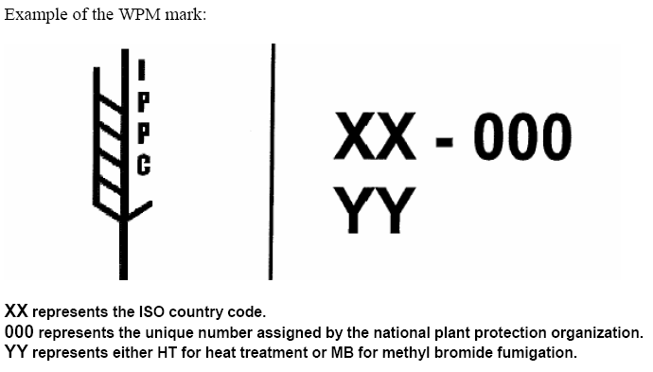

- Treatment Options: There are two primary treatment options, Heat treatment or fumigation with Methyl bromide. For Heat treatment, WPM must be heat treated to achieve a minimum wood core temperature of 56°C for a minimum of 30 continuous minutes. For fumigation, the WPM must be fumigated with Methyl bromide in an enclosed area for at least 16 hours at the regulated dosage and then must be aerated to reduce the concentration of fumigant below hazardous exposure levels.

- The quality mark will include the following information (example of a quality mark can be found further below):

- The approved international symbol for compliant WPM;

- The two letter ISO country code for the country where the WPM originated, followed by the unique number assigned by an accredited inspection agency to the treatment facility;

- The MB abbreviation for WPM treated using Methyl bromide, an HT abbreviation for WPM treated using Heat treatment, DH for Dielectric heating or SF for Sulphuryl fluoride treatment;

- The identifying symbol, logo or name of the accredited agency.

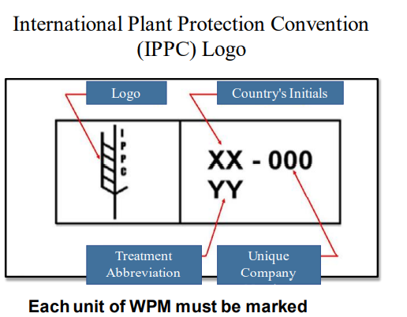

Example: Logo rotated 90 degrees to the left. Right-side elements in one line.
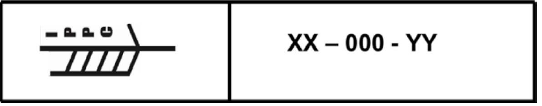

- Once the WPM is properly treated and marked by an approved facility in any country, the mark will be accepted as proof of compliance for the life of the WPM.

- If the WPM has been repaired or recycled, the WPM is required to be either fumigated or heat treated again. The old mark must be obliterated with a new mark applied by one of the inspection agencies.

- Treatment Facilities Outside the US: Contact information for treatment facilities may be requested from the appropriate country’s plant protection agency.

- Treatment Facilities Inside the US: The US Department of Agriculture has designated two entities to manage the treatment programs in the US. The National Wooden Pallet & Container Association (NWPCA) manages the fumigation program and the American Lumber Standards Committee (ALSC) manages the heat treatment program.

- Recommendations from the ALSC, including approved US Heat treatment
facilities and US fumigators, may be found at the link below:
http://www.alsc.org/WPM_facsimile_mod.htm

  - Pallet Charges included on Invoices:

- Pallet Charges: If our company has agreed to pay pallet charges tied to the
WPM treatment and/or value of pallets, then the supplier must include these charges on the commercial invoice as a separate line item (from the cost of goods). These charges are considered indirect payments to the seller and are considered dutiable by most customs authorities (thus they must be declared to upon importation).

- EXCEPTIONS:

  - The following items are considered low risk and are exempt from the ISPM 15 standard:

    - Purely domestic moves within the Continental US if there is no intention of
exporting the WPM out of the US. WPM sent to Otay Mesa, CA for export to Mexico would not be a purely US domestic move. WPM in this case must be compliant with the WPM requirements.

    - Wood packaging material made entirely from thin wood (6 millimeters or less in
thickness)

    - Wood packaging made wholly of processed wood material, such as plywood,
particle board, oriented strand board, or veneer that has been created using glue, heat, pressure, or a combination thereof

    - Sawdust, wood shavings, and wood wool
Exception: If these materials are combined with nonmanufactured wood packaging material, you must make sure the nonmanufactured wood packaging material is treated and properly marked.

- RESPONSIBILITIES:

  - Suppliers (Foreign or Domestic):

- Ensure all WPM has been either heat treated or treated with Methyl bromide.

- Ensure all WPM contains the internationally recognized IPPC mark which certifies treatment.

- Ensure all WPM is free of timber pests.

- If our company has agreed to pay pallet charges tied to the WPM treatment and/or value of pallets, then the supplier must include these charges on the commercial invoice as a separate line item (from the cost of goods).

  - US Receiving Departments:

- Receiving Departments must physically inspect all import shipments for compliance with WPM requirements.

        - Title 7 CFR §319.40-3(b)(3) provides for immediate export of WPM that does not contain the required mark. As of November 1, 2016, USDA-APHIS has provided allowances for secure disposal (under compliance agreement) of violative maritime dunnage if the pest risk is not excessively high and an incinerator facility approved by APHIS to burn wood is available.”

Please notify the Trade Compliance team for additional support.

  - US Shipping Departments:

- Shipping Departments must physically inspect all export shipments prior to loading onto conveyances to ensure non-compliant WPM is not used.

        - If any non-compliant WPM is found for an export shipment, THEN DO NOT SHIP. Goods shipped using non-compliant WPM will be RETURNED by the importing country.

        - Goods may only be shipped on compliant WPM.

- US PENALTIES for Non-Compliance:

  - Any WPM imported into the US in violation of the requirements will be subject to the following consequences:

    - Penalties: US Customs and Border Protection may issue penalties against
importers, carriers or bonded custodians for importing wood packaging material
(WPM) in violation of the regulations.
          - When violations occur, penalties will be assessed on the value of the merchandise, which is considered the value of the WPM plus the value of the commodities listed on the entry documentation. The penalty may be assessed at the total entered value of the merchandise.

    - Exportation: If US Customs and Border Protection discovers any WPM not
properly marked (that is, lacking the proper IPPC logo) while examining cargo, the shipment will be considered in violation of the WPM rule. The shipment will be held until the non-compliant WPM is separated from the remainder of the goods or the entire shipment is exported from the US.

Please note that separation of the non-compliant WPM is at the discretion of the CBP Port Director. A user fee will be assessed for supervising the separation of the WPM from the cargo. If separation is not permitted by the Port Director, shipments are not authorized to move in bond to another port for separation under the WPM program. The non-compliant WPM must be exported.

- PROCEDURES FOR RETURNING WPM:

  - US IMPORT SHIPMENTS:

If Separation of Violative WPM is feasible and approved by the Port Director:

        - Cargo will be separated at the importer’s expense at a time and place determined by the Port Director.

        - Violative WPM is to be exported and the importer or party of interest (working in conjunction with the exporting carrier) must supply evidence sufficient to Port Director’s satisfaction that the non-compliant WPM will be removed from the US This proof may include, but is not limited to, a bill of lading, a statement on carrier letterhead, US export or foreign entry documents, etc.

- If Separation of the Violative WPM is not feasible or Separation is not requested:

        - The entire shipment (violative WPM, compliant WPM, and merchandise) shall be ordered exported from the US in accordance with the rule at the importer’s or party of interest’s expense. It is irrelevant if the shipment contains a mixture of compliant and violative WPM.

If Country of Export or Country of Origin will not take it back:

        - Regulation does not state that violative WPM must be returned to any particular country. It will be the responsibility of the importer to determine an alternate destination that will accept the untreated WPM.

Actions to take if Non-Compliant WPM is encountered at your facility:

        - Follow the SIN principle SECURE, ISOLATE and NOTIFY

S= Secure
If there are pests or evidence of a pest, cover the shipment with tarp or shrink wrap. If possible, return the shipment to a container and seal the container door.

I = Isolate
Separate the shipment or container from compliant shipments.

N = Notify

Contact your local US Department of Agriculture Plant Protection and Quarantine office to advise of the non-compliant WPM.

  - US EXPORT SHIPMENTS:

Returns from Canada and Mexico:
        - Fumigation is allowed in Mexico and phytosanitary certificates are allowed in Canada in certain circumstances.

Returns from all other countries:

        - If CBP Officers or Agriculture Specialists encounter a shipment of returned US merchandise that contains non-compliant WPM, CBP will provide a sectional release for the merchandise and WPM upon reasonable submission of proof that the merchandise did not enter the commerce of any other country.

- CONTACTS:

For questions, please contact Allegion plc’s Trade Compliance department:

Kelly Guzman (619) 778-4137 Kelly.Guzman@allegion.com
Yesenia Gallegos (619) 778-2127 Yesenia.Gallegos@allegion.com

- HISTORY OF REVISIONS:

Date | Rev | Description of Change | Modified by:
6/30/2021 | 7 | Formatting changes  Replaced the word “packing” with “packaging”  Added link for IPPC contracting parties  Removed the requirements for invoice certifications  Added Definitions section  Updated regulations throughout the document  Removed WPM Supplier Certification | Yesenia Gallegos
5/9/2022 | 8 | Updated sources /footnotes to reference latest publications.  Introduced DH for Dielectric heating or SF for Sulphuryl fluoride as additional acceptable forms of WPM treatment. | Yesenia Gallegos
5/10/2024 | 9 | Updated footnotes to reference latest publications  Removed references to Canada.  Updated fumigation requirements. | Yesenia Gallegos

https://en.wikipedia.org/wiki/International_Plant_Protection_Convention
Wood Packaging Materials | U.S. Customs and Border Protection (cbp.gov)
ISPM_15_2018_En_WoodPackaging_Post-CPM13_Rev_Annex1and2_Fixed_2019-02-01.pdf (ippc.int) Guide to regulation of wood packaging material (fao.org), p.13
Wood Packaging Material | Animal and Plant Health Inspection Service (usda.gov)
https://www.cbp.gov/sites/default/files/assets/documents/2018-Oct/20180725_GUIDELINES%20FOR%20LIQUIDATED%20DAMAGES%20AND%20PENALTIES%20FOR%20NC%20WPM.pdf Additional source: https://assets.ippc.int/static/media/files/publication/en/2019/02/ISPM_15_2018_En_WoodPackaging_Post-CPM13_Rev_Annex1and2_Fixed_2019-02-01.pdf
US Customs CSMS #17-000609

