1. Purpose:

To clearly define global packaging and labeling requirements to Allegion Suppliers.

1. Application:

This standard applies to all material items shipped to Allegion’s global facilities.

Execution of this work instruction requires the cooperation and participation from various cross-functional groups. Packaging development requires a partnership. It can only function as intended when both supplier and customer work together from proposal through implementation. And then it is absolutely crucial that both parties adhere to authorized packaging. The key is open, two-way communication.

1. References:

* Import and Export Requirements for Wood Packaging Material (WPM) into the U.S. - <https://help.cbp.gov/app/answers/detail/a_id/720/~/import-and-export-requirements-for-wood-packaging-material-(wpm)-into-the-u.s>.
* U.S. Electronic Code of Federal Regulations (7 CFR 319.40) - <http://www.ecfr.gov/cgi-bin/text-idx?SID=2c6f8333fbb7e26822b41636dc14b6b8&mc=true&node=sp7.5.319.xx10&rgn=div6>
* ISPM15 <http://www.ispm15.com/ISPM15_Revised_2009.pdf>
* American National Standards Institute (ANSI) standard MH10.8M-1983 - <http://www.ansi.org/>

1. Definitions:

* ISPM15 – International standards for Phytosanitary Measures no 15; Regulation of Wood Packaging Material in International Trade.
* Grade A Pallet - A grade pallets have a like new fresh appearance with no stringer repairs. Broken stringers may have been replaced or repaired. All damaged deck boards are replaced. This is a fairly clean pallet that is structurally sound. A grade pallets have 7 top deck boards & 5 bottom deck boards.
* IPPC - International Plant Protection Convention
* SWPM – Solid Wood Packaging Material
* 3 of 9 barcode (Code 39) - Code 39 is defined in American National Standards Institute (ANSI) standard MH10.8M-1983, and is also known as USD-3 and 3 of 9.
* GCMI – a standard for color used in package printing developed by the Glass Packaging Institute (formerly known as the Glass Container Manufacturers Institute).

1. Supplier Responsibility:
   1. Standard Packaging: It is the suppliers responsibility that all products utilize a standard quantity for each part number supplied in a single container, package and/or pallet.
   2. Damage free parts: It is the responsibility of the supplier to define the packaging to insure that parts arrive at Allegion without damage, corrosion, rust or dirt.
   3. Deviations from Standards: Deviations from this specification or modifications to packaging must have proper approval.
   4. Sample Shipments: A sample shipment may be required to test and prove that the packaging is able to withstand delivery conditions during the FA process.
2. Packaging Requirements:
   1. **Shipping containers:** Products packed in containers designated as shipping containers will be cushioned, blocked, braced, or anchored as necessary to prevent movement and damage during handling and transit.
   2. **Pallets:**
      1. All pallets used should be designed with flush, partial 4-way and non-reversible. Pallet assembly, fastener quality and fastening schedule must comply with the uniform standard. All criteria are consistent with Grade A pallets.
      2. To minimize damage to pallet loads, pallets should not be loaded with overhang beyond the pallet dimensions.
      3. Pallets with broken or sagging stringers should not be used.
      4. Wood pallets should be of solid wood construction. The wood must be sound (no decay) and spare edged. Wood in classes 7 and 14 in the Uniform Standard for Wood Pallets, as published by the National Wooden Pallet and Container Association are not acceptable.
         1. Knots must not be larger than 1/3 of the board.
      5. Plastic pallets are a viable alternative to wood pallets. The plastic surface is often slippery, which makes fastening or blocking products to prevent movement more difficult. Products must be securely attached to plastic pallets
      6. No serious cracks, protruding splinters, protruding nail heads or points are allowed.
      7. Plywood, manufactured wood, paper or corrugated pallets are prohibited.
      8. The use of corner and edge boards is required for unitized loads. These corner and edge boards will be non-laminated and can be made of recycled fiberboard.
   3. **Strapping and Shrink-Wrap:**
      1. Metal Strapping/Banding should not be used.
      2. All products must be secured to pallets by applying non-conductive, non-metallic strapping or suitable shrink-wrap material. When strapping is used, a minimum of two straps will be required. The strapping and the manner employed will be of sufficient quantity, quality, width and thickness to preclude failure during transit and handling.
      3. Four full wraps of shrink wrap per pallet overlapping top of product and pallet are required.
      4. Protection and security of the load and the safety of personnel will the primary considerations.
      5. The non-metallic strapping will be of a material that will resist stretching and continue to hold the load properly at high temperatures.
      6. Clear shrink-wrap or stretch film may be used to secure the load to the pallet. However, when strapping is required, the film will be applied over the required strapping. The film will be applied so as to allow a minimum opening of 2ft x 2ft (0.6m x 0.6m) on the top of the load.
      7. Bands and shrink-wrap should not be used on individual cartons.
   4. **Oversized Containers:**
      1. Containers that exceed standard pallet size may be shipped on larger pallets as necessary, upon approval.
      2. Containers of any type that are too large or too heavy to be palletized will be shipped in their own containers, crates, etc. When practical, these containers will be skidded to facilitate forklift handling.
   5. **Packing for Pallet Loading:**
      1. Packages may be stacked on pallets, provided that the bottom container is strong enough, when fully packed (including protective packing for the contents), to support the weight of the loaded containers stacked on top of it without being crushed.
      2. Acceptable measures to protect breakable products include: fiberboard inserts cut and folded to fit tightly around the contents of the package and prevent movement inside the package, custom-fitted molded and/or cut foam inserts, and others.
      3. Bubble packing or other space fillers may be used if packed tightly enough to produce the necessary loaded package strength.
      4. Items that are packed with packaging peanuts or shredded paper are not acceptable.
      5. Reasonably dry, unheated quarters are also non-air conditioned, and high humidity may prevail. Package materials must be able to retain sufficient strength when stored in such conditions for significant lengths of time.
      6. Empty containers used as space fillers must be clearly marked “EMPTY”
      7. Interlocking stacking provides the most stability and is preferred.
      8. When stacking patterns are not interlocking, slip sheets are required between layers.
      9. When stacking product on a pallet that is going to result in empty space. The empty space must be positioned to the center of pallet
      10. Products should not be mixed on a pallet unless the order quantity dictates otherwise. A single tier per product is acceptable.
      11. Palletized cartons shall be oriented so that the maximum number of carton labels is visible.
      12. Unless otherwise specified, packaging shall be of sufficient strength to allow double stacking of palletized loads of similar dimensions and gross weight without causing visible damage during handling and transportation.
      13. Pallets that are unable to to be double stacked require labeling notating “DO NOT STACK” clearly on all four sides of the pallet and the top of the pallet.
      14. Pallets shall not be crated.
   6. **Environmentally Friendly Packaging:** 
      1. Packaging must be environmentally friendly.
      2. No free standing oil shall be present in the bottom of the container.
      3. No oil soaked cardboard is permissible. All cardboard must be recyclable.
      4. Recyclable and/or recycled materials (plastics) are to be used.
      5. Plastic liners shall be used to contain excess fluids, odors and to maintain part cleanliness.
   7. **Solid Wood Packaging Mark:** 
      1. All Solid Wood Packaging Materials (SWPM) designed for export must be treated in accordance with 7 CFR 319.40, ISPM15 and/or the government regulations of the country of import. Domestic shipments do not require treatment, but it is recommended that all domestic SWPM should be marked with “Do Not Export”.
      2. IPPC (ISPM 15) Stamp – IPPC (ISPM 15) Stamp is required as treatment marking for SWPM. The stamp must be applied immediately after the treatment and at the same location as that of the treatment. We will not allow for the SWPM to be moved to another location for marking (chopping) after treatment has been applied.

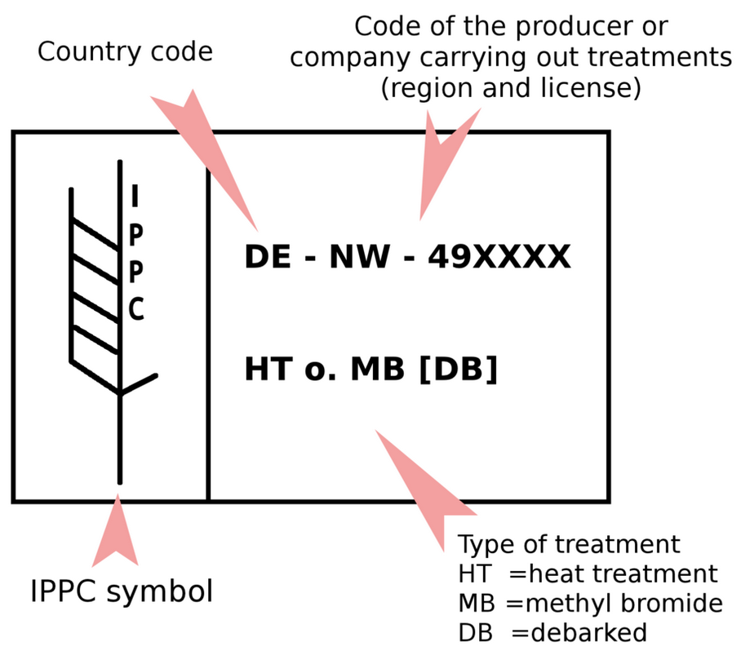

Examples of stamps on wooden pallets used in shipping that indicate ISPM 15 complainces

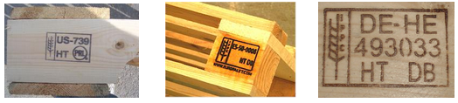

* + 1. It is supplier/factory’s sole responsibility to insure they are in compliance with the most updated government procedures, restrictions, and/or regulations governing SWPM and its treatment, not limited to what listed in this document.
  1. **Shipping Cartons:**
     1. Cartons must use properly sized carton for product and carton quantity.
     2. Items should fit firmly in shipping carton to minimize damage during transit.
     3. Carton quality guidelines include:
        1. Minimum Mullen Burst Test of 175-200 pounds corrugated fiberboard.
        2. Minimum Edge Crush Test factor of 29-32.
        3. May need to be stronger for heavier cartons or fragile products.
     4. Cartons must be sealed with tape or glue.
     5. Ensure carton will remain sealed through changes in the climate (temperature, humidity, etc.) and multiple handlings.
     6. Do not use bands or staples.
     7. No stretch wrap on individual cartons.
     8. Pack fragile items with adequate protection. Retail packaging must arrive undamaged without denting, punctures, breaks or tears. Case pack must provide adequate protection.

1. Labeling Requirements:
   1. Packing Slip: Each product shipment will have a packing slip securely attached to the outside of one of the containers and under the stretch or shrink film wrapping when applied. For multiple box shipments the boxes in the shipment of n boxes will each be labeled “1 of n,” “2 of n”, etc with the packing slip inserted into the number one box. The number one box will be labeled “Packing slip inside.”
   2. The product package is also known as a unit package. All products, including kits, enclosed in a unit/product package will be identical.
   3. The part numbers, descriptions product identification and descriptive codes that are displayed on the exterior of these containers must be the same as those listed in the contract.
   4. Product/Unit packages will have the following information displayed on the bar code:
      * Purchase order number, purchase order line, purchase order release (bar coded)
      * Quantity (bar coded)
      * Part number or Item number (bar coded)
      * Item description (or drawing number)
      * Consignment material Yes or No (if applicable)
      * Lot number or manufacturing date
      * Drawing Revision
      * UPC barcode (if applicable) (bar coded)
      * Quantity (bar coded)
      * Country of Origin
      * Box weight

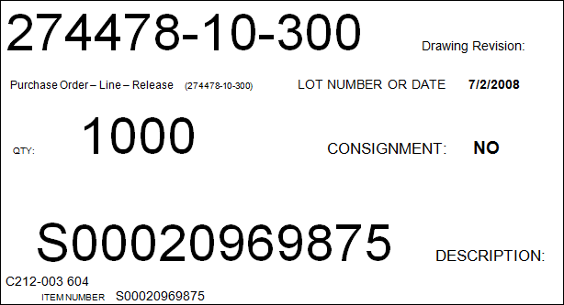

* 1. Master Carton packages will have the following:
     + Supplier Name
     + Purchase order number, purchase order line, purchase order release (bar coded)
     + Quantity (bar coded)
     + Part number or Item number (bar coded)
     + Part revision
     + Item description (or drawing number)
     + Lot number or manufacturing date
     + Drawing Revision
     + UPC barcode (if applicable) (bar coded)
     + Quantity per box (bar coded)
     + Master Carton weight

**Sample Retail Master Case**

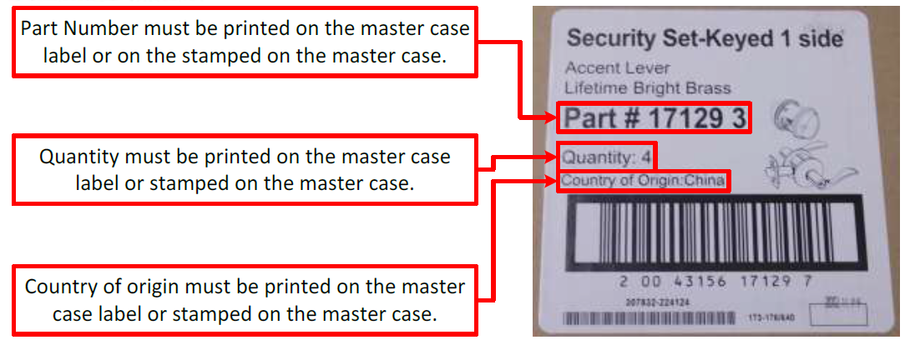

* 1. Product label should be located in the upper left hand corner of the small face of the carton.
  2. Unitized loads require a label reading “SAME” in charcters not less than ¾ of an inch in height will be affixed on each for lift entry side of the pallet.
  3. Mixed loads require a label reading “MIXED LOADS” in charcters not less than ¾ of an inch in height will be affixed on each for lift entry side of the pallet.
  4. UPC
     1. Single units sold at the merchant level require the bar code type “UPC-A”. This is a standard 12 digit bar code that must be applied at the single unit level.
     2. Scanable UPC is required to be visible on each sellable unit.
     3. One UPC corresponds to one unique product including assortments.
     4. UPC barcode is to be printed black on white non reflective material. The minimum size requirements are as follows:

|  |  |
| --- | --- |
|  | GS1 Standard Range |
| Narrow Bar | From 10 to 26 mil (0.010 to0.026”) |
| Wide Bar | Variable – See GS1 Guidelines at www.gs1us.org |
| Quiet Zone | Nominal size .117” (scalable from 80% to 200%**)** |
| Total Height | From 0.816” to 2.04” |
| ANSI Print Quality | ANSI “C” |
| Print Method | Thermal Transfer |

* + 1. UPC barcode with dimensions in millimeters. Not to scale.

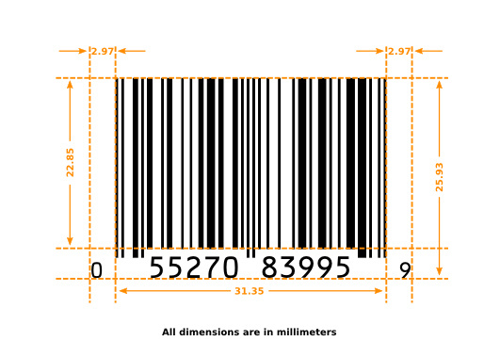

* 1. ITF-14-Shippping Container Code:
     1. Master cases that are shipped between warehousing require an “Interleave two of five” (ITF-14) barcode. This is a standard 14 digit bar code that must be applied to each master case. When this barcode is printed on corrugate there must be barrier bars on all side of the barcode with at minimum a quarter inch of quiet space on the left, and right hand side of the bars to preserve scan-ability. When this barcode is printed on white label paper barrier bars are only required at the top, and bottom of the barcode. For additional information visit the GS1 website at <http://www.gs1.org/>
     2. Can only be used when cartons are shipped on a stretch-wrapped pallet and the pallet has a SSCC-18/UCC128 barcode label.
     3. All human readable information and the GTIN-14 must appear on 2 adjacent sides when printed on the carton.

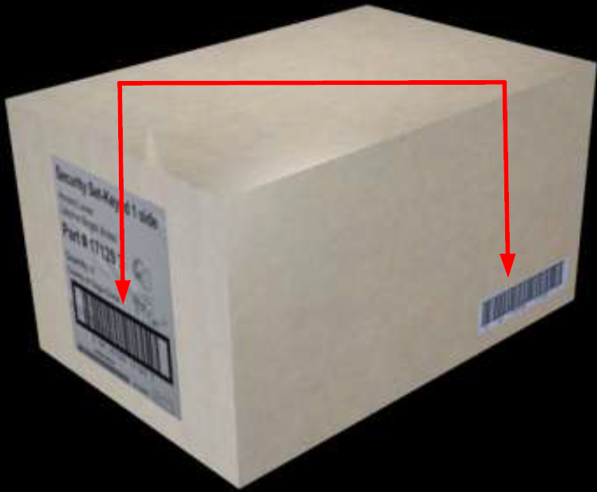



* + 1. For ITF-14 barcodes printed directly on corrugate cardboard the minimum size requirements are:

|  |  |
| --- | --- |
|  | GS1 Standard Range |
| Narrow Bar | From 19.5 to 40 mil (.0195" to .04") |
| Wide Bar | 2.5 times the width of the narrow bar |
| Quiet Zone | 10X the narrow bar width |
| Total Height | 1.25" |
| ANSI Print Quality | ANSI “C” |
| Print Method | Various |

* + 1. For ITF-14 barcodes printed black on a white background the minimum size requirements are:

|  |  |
| --- | --- |
|  | GS1 Standard Range |
| Narrow Bar | From 24 to 40 mil (.024" to .04") |
| Wide Bar | 2.5 times the width of the narrow bar |
| Quiet Zone | 10X the narrow bar width |
| Total Height | 1.00" |
| ANSI Print Quality | ANSI “C” |
| Print Method | Thermal Transfer |

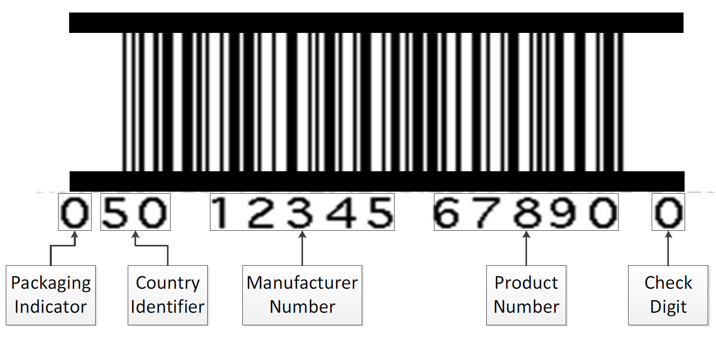

* + 1. Barrier bars will ensure the quality of each scan of the barcode as it helps the scanner to read and interpret the barcode.

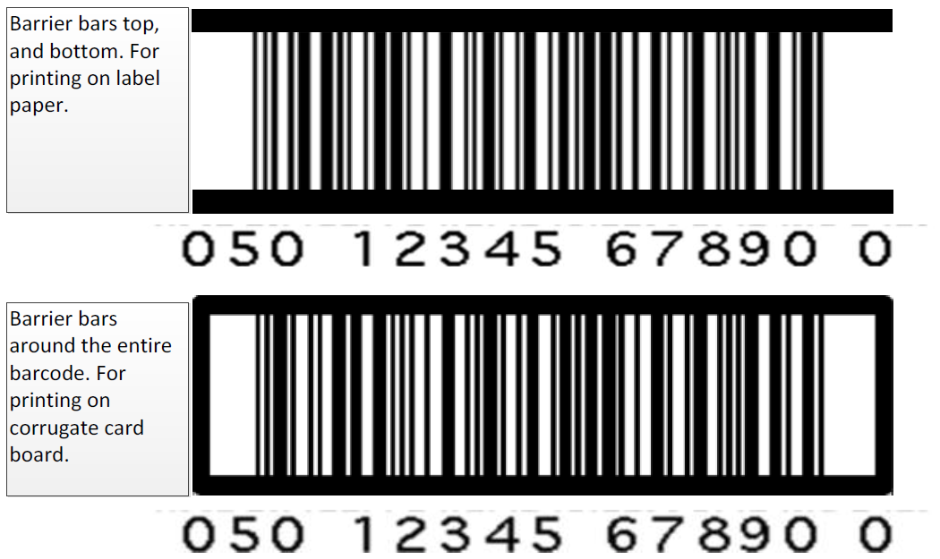

* + 1. ITF-14/I2of5 versus UPC-A – An ITF-14/I2of5 barcode should NOT be used in cases where the secondary package is also the retail (UPC and ITF-14/I2of5 barcode CANNOT be on the same carton). IFT-14/I2of5 barcodes will not be printed on case packs of one (1).
    2. UPC-A versus ITF-14/I2of5 – Individual product UPC should NOT appear on the master carton or be visible through the master carton.

1. Master Carton
   1. Master cartons require the Allegion Logo in the lower right corner.
   2. A master carton should be printed in one color.
   3. Allegion Orange (GCMI 80) and Allegion Gray (GCMI 9002) are both acceptable colorways for a master carton.

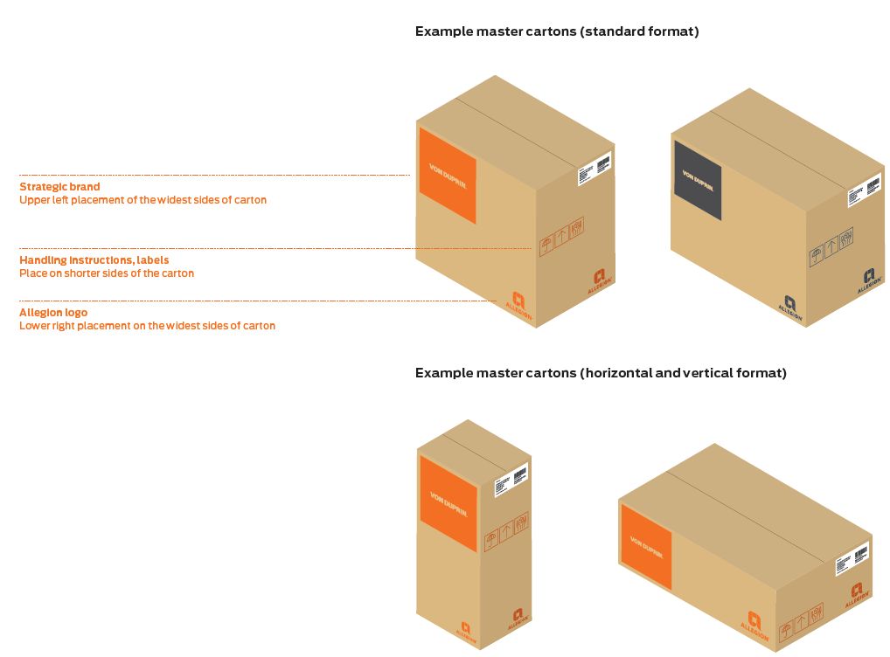

* 1. Mastor Carton Layout
     1. The block should be placed on the upper left, on the widest sides of the box.
     2. Standard format block sizing:
        1. Take the box dimensions, divide in quarters, allow for margins show in the below drawings.
        2. Use the shorter dimension of the upper left quarter of the box – that will be the size of the block

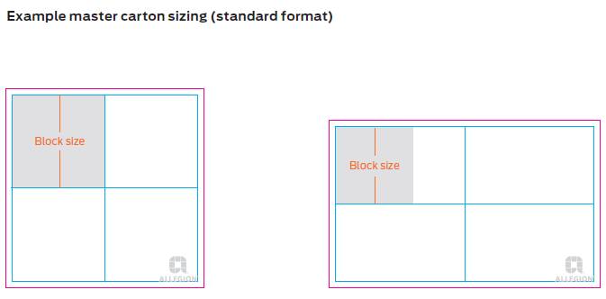

* + 1. Horizontal and verticle format: For boxes that have an extreme horizontal or vertical shape, follow these instructions:
       1. Use the shorter dimension of the top (verticle layouts) or left (horizontal layouts to size the block. Allow for margins as shown on the right.

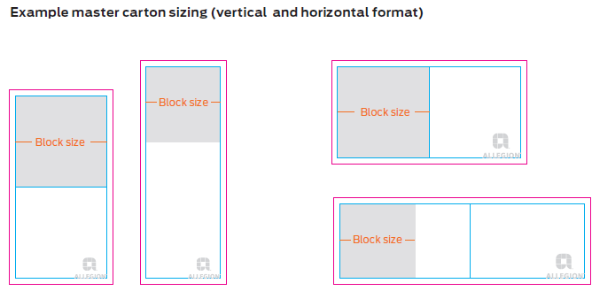

* 1. General Product Packages
     1. For product pagages that are used for general product types, use the following layout direction.

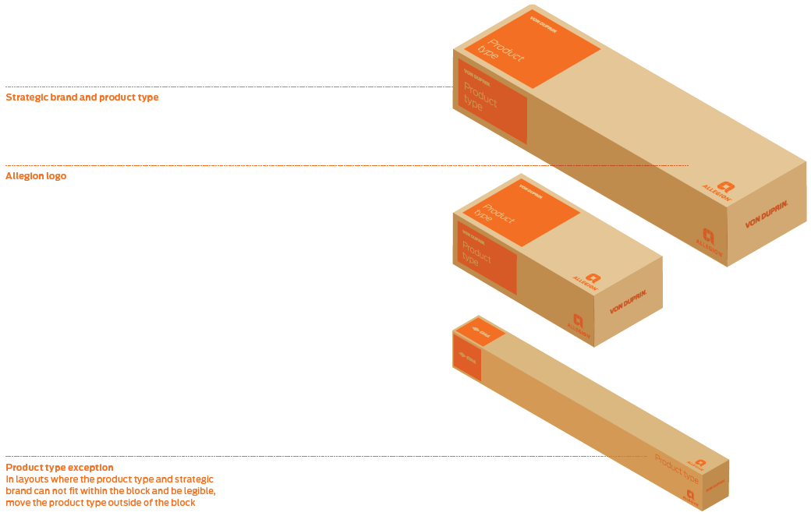

Revision History:

|  |  |  |
| --- | --- | --- |
| Revision | Date | Description of Change |
| 0 | 09/25/15 | New document release |
|  |  |  |
|  |  |  |
|  |  |  |
|  |  |  |

**Appendix A**

**Pallet Requirements by Facility**

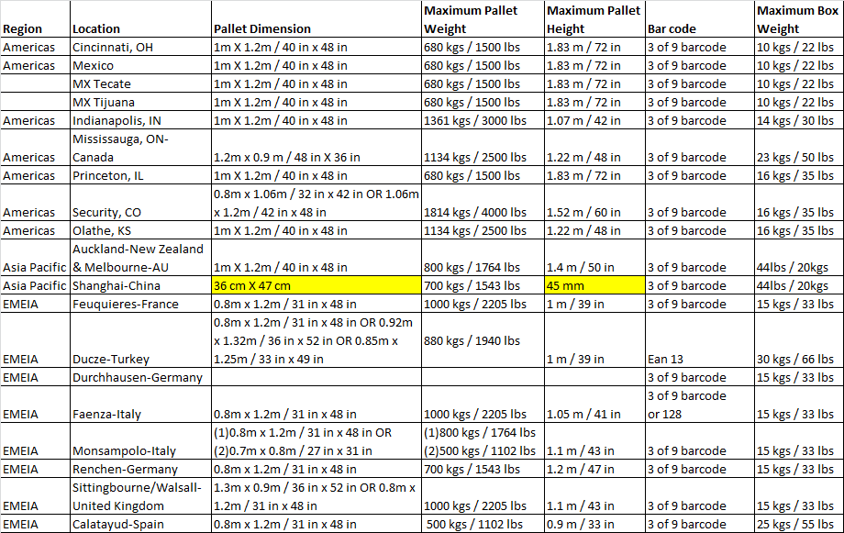

**Appendix B**

**Pallet Stacking Patterns**

**Interlocking Patterns: These type of patterns provide the most stability.**

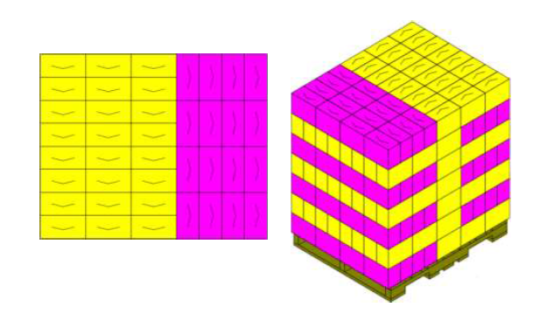

**Slip Sheets are required between layers when patterns are not interlocking.**

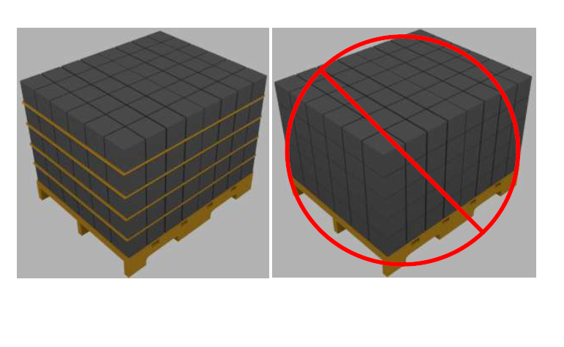

**Empty space must be positioned to the center of the pallet.**

