Title: | Supply Chain Security for US Imports  Standard Operating Procedure (SOP) |  |  | No. Control: |  |  | Import/Export Policy 41
Date of Issue: | October 2012 |  |  |  | Revision: | 20

TABLE OF CONTENTS Page
- Corporate Policy 3

- Purpose 3

- Scope 3

- CTPAT Carriers Only 3

V. Responsibilities 3
A. Foreign Suppliers 3 - 10
- Shipping Requirements
- Importer Security Filing
- Container Security: Inspection and Container Inspection Checklist (CIC)
- High Security Seals
- Shipping FCL – Security Controls via Email
- Security Procedures / Annual Survey
- Shrink Wrap
- Report Anomalies and Incidents

B. Freight Forwarders/ Carriers 10 - 12
- CTPAT Carrier
- Status Verification Interface (SVI)
- Importer Security Filing (ISF)
- High Security Seals
- Annual Survey
- Report Anomalies, Incidents and Exams

C. US Customs Broker 12-13
- Importer Security Filing (ISF)
- Annual Survey
- Report Anomalies, Incidents and Exams

TABLE OF CONTENTS (continued) Page

D. Receiving 13-14
- Container Inspection Checklist (CIC)
- Digital Photograph Validation
- Cargo Discrepancies Log and Analysis
- Seals
- Report Anomalies and Incidents

E. Trade Compliance 14-15
- High Security Seals
- Annual Survey Audit
- CTPAT Security Profile
- Periodic Internal Testing
- Report Anomalies and Incidents
VI. Contacts 15-16
Exhibit 1 Container Inspection Checklist 17
Exhibit 2 ISF TEMPLATE – US IMPORTS 17
Exhibit 3 ISF TEMPLATE – INBONDS TO MEXICO 17
Exhibit 4 Annual Survey for Freight Forwarders 17

Exhibit 5 Annual Survey for Brokers 17

Revision History 18-19

Corporate Policy: |  |  | It is the policy of Schlage Lock Company, LLC to ensure compliance with all US Customs and other government agency regulations. This Supply Chain Security Import SOP is written in accordance with the security requirements of the US Customs-Trade Partnership against Terrorism (CTPAT) program.
Purpose: |  |  |  | The purpose of this SOP is to ensure compliance with our CTPAT obligations, and to protect Schlage’s shipments TO or THRU the United States from infiltration of narcotics, weapons, theft or human trafficking.
Scope: |  |  |  | The scope of this policy relates to all shipments TO or THRU the United States (‘thru the US” refers to ‘inbond’ shipments sent thru the US for immediate export to Mexico). The policy is intended to cover shipments to the US where Schlage Lock Co., LLC is the Importer of Record.
CTPAT Carriers Only |  |  |  | As required by CTPAT, this policy requires our business partners (freight forwarders and foreign suppliers) to ONLY use CTPAT certified carriers or freight forwarders, or carriers and freight forwarders who meet the CTPAT minimum security criteria. All carriers, including rail and land carriers, handling the movement of Schlage shipments, must be CTPAT compliant. Failure to do so may result in the carrier’s removal from future Schlage Lock Company, LLC carrier bids.
- Responsibilities: Foreign Suppliers  - Responsibilities: Foreign Suppliers  - Responsibilities: Foreign Suppliers  - Responsibilities:  Foreign Suppliers  - Responsibilities: Foreign Suppliers  - Responsibilities: Foreign Suppliers  - Responsibilities:  Foreign Suppliers  - Responsibilities: Freight Forwarders  - Responsibilities:  US CUSTOMS BROKER  - Responsibilities: RECEIVING  - Responsibilities: TRADE COMPLIANCE |  |  |  | - Foreign Suppliers  - Shipping Verification and Tracking Requirements  - All cargo should be accurately described, and the weights, labels, marks and piece count indicated and verified against the cargo manifest.  - Departing cargo should be verified against purchase or delivery orders.  - Drivers delivering or receiving cargo must be positively identified before cargo is received or released.  - Procedures should be established to track the timely movement of incoming and outgoing goods.  - Importer Security Filing (ISF)  - Under US Customs law, an Importer Security Filing (ISF) must be transmitted to US Customs at least 24 hours prior to loading any vessel bound for the US.  - Failure to file the ISF will result in $5K customs penalty per violation.  - For all vessel shipments, Suppliers must obtain an Importer Security Filing transaction number prior to physically turning cargo over to the freight forwarder.  - Procedure for Supplier to obtain ISF Transaction Number:  - Obtain bill of lading number from the freight forwarder.  - Complete the Importer Security Filing (ISF) template, using the template applicable to the type of shipment. All foreign suppliers should have the ISF templates in Excel already, but if not, please contact Yesenia.Gallegos@allegion.com.  “ISF TEMPLATE – US IMPORTS” (Exhibit 2)  Or  “ISF TEMPLATE – INBONDS TO MEXICO” (Exhibit 3)  - Email the completed ISF template to the ISF filing agent at least 72 hours in advance of sailing.  NOTE: the ISF Filing Agent for the US or MX Importations is:  isf@iab-sd.com  The ISF contact is Steve Goding.  - Obtain ISF transaction number from filing agent (must be documented on the ISF template). The ISF filing agent is required to return the ISF transaction number within 24 hours.  - Deliver cargo to freight forwarder and provide copy of final ISF template (containing ISF transaction number) with the shipment documentation.  - Container Security  - Container integrity is critical to protect against the introduction into the US of unauthorized material and/or persons.  - Foreign suppliers must conduct and document a container inspection.  - Container Inspections  Procedures must be in place to verify the physical integrity of the container structure prior to stuffing, to include the reliability of the locking mechanisms of the doors. If containers do not meet the 9-point inspection, then they must be rejected in place of a compliant container.  A 9-point inspection process is recommended for all containers:  - Container cleanliness (must not be filthy; no pests, weeds or seeds allowed)  - Pallet cleanliness (must not be filthy; no pests, weeds or seeds allowed)  - Outside/Underside of Trailer  - Left Wall  - Right Wall  - Front Wall  - Floor  - Ceiling  - Inside and Outside Door / Hinges (i.e., Ensure Locking mechanisms are secure)  - Container Inspection Checklist (CIC)  - Document the inspection of the container using the “Container Inspection Checklist” (See Exhibit I).  - Suppliers must complete sections I, II, and III for shipments bound for the US or MX and include the completed form with paperwork sent with container.  - Suppliers must assign documentation accountability (someone must be assigned responsibility for the container inspections).  - Include a copy of the Container Inspection Checklist on the inside of the container, on one container door.  - Agricultural Requirements  - The cargo staging areas, and surrounding areas, must be inspected on a regular basis to ensure these areas remain free of visible pest contamination.  - If visible pest contamination is found, then the areas must be cleaned and vacuumed immediately.  - Containers must also be inspected for signs of visible pest contamination. The Container Inspection Checklist contains 2 fields to certify the inspection for pests, weeds or seeds (see Category 1 and 2 in Section II).  - If containers show signs of pest contamination, then you have 2 options:  - reject the container and notify the carrier or  - wash and vacuum the container.  - Wood Packaging Material (WPM)  - Wood Packaging Material (WPM) must comply with US and international phytosanitary rules as follows:  - All WPM must be properly marked to indicate it has been either heat treated or treated with methyl bromide.  - All WPM must contain the internationally recognized IPPC mark which certifies treatment.  - All WPM must also be free of timber pests.  - Pallets must be free of all weeds, seeds and pests.  - Pallets should not be stored outside.  - More details can be found on the Wood Packaging Material SOP located under Global Shipping Compliance on the Supplier Portal:  https://www.allegion.com/suppliers  - High Security Seals  - Foreign suppliers must apply high security seals to containers  bound for the U.S.  - US law requires all containers bound for the U.S. to be secured with a high security SEAL which meets ISO standard-- ISO 17712:2013.  Ensure the following:  - Seals must meet or exceed certain standards for strength and durability to prevent accidental breakage, early deterioration (due to weather conditions, chemical action, etc.) or undetectable tampering under normal usage. A 18MM MINIMUM WIDTH DIAMETER for bolt seals is required.  - Seals must be clearly and legibly marked with a unique identification number.  - The seal is classified as an “H” – High Security Seal  - Please comply with key points below:  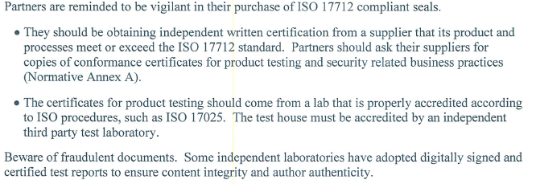  - Unused seals must be stored in a secure place and controlled.  - Less than container loads must use a secured padlock or similar locking device. Only a limited number of individuals should have access to open this padlock.  - Once freight is consolidated for shipping to the US, the containers must be sealed with a high security seal.  - US Customs Border Protection will assess civil penalties for violations of the container sealing requirement.  For additional information/specifications related to the seal requirement, or for any questions on CTPAT, please contact the Trade Compliance group. Below are instructions on how to apply the seal.  - Application of the Seal:  - Apply a high security seal to the cargo door of the container.  - The Shipping Coordinator must ensure seals are applied to container doors as shown below.  - STEPS:  - Seal Placement: The seal is inserted from top to bottom through the slot on the right-side door handle (see picture).  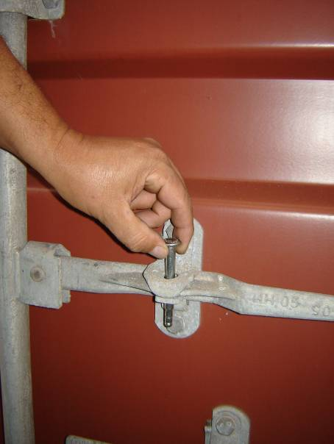  - Lock Seal: Insert the plastic piece on the bottom part of the bolt. When the seal has been properly locked, you will hear a “click” sound.  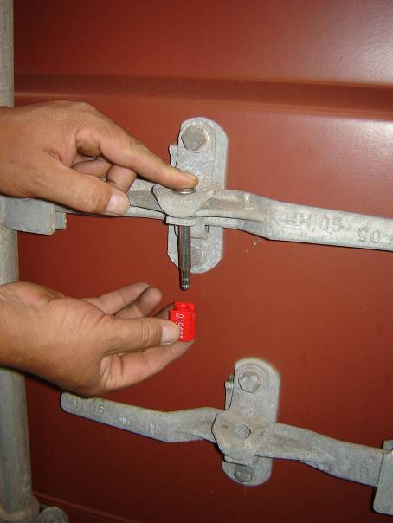  - Test Seal: Pull firmly downwards on the plastic piece to confirm that the seal has been properly locked.  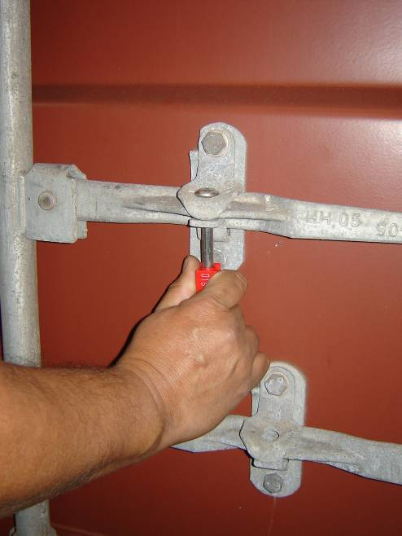  - Shipping FCL – Additional Requirements  - Foreign suppliers who ship full container loads (FCL) should ensure the following is sent via email to the US or MX Receiving facility (see contacts in “3” immediately below), prior to destination arrival of the conveyance:  - Copy of the “Container Inspection checklist” (CIC) and  - Digital photographs showing the condition of the cargo and container/trailer at time of shipping. Include a picture of the placement of the palletized cargo as well as the locked seal to allow viewing of the seal number.  - Please send email to the persons identified below, based on plant or site destination:  DSC at Olathe, Kansas USA  John.Perez@allegion.com  Bruce.Webster@allegion.com  Michael.Hooker@allegion.com  Von Duprin at Indiana USA  Dimo.Vckov@allegion.com  Donnie.Miller@allegion.com  LCN at Princeton, Illinois USA  Roger.DeBrock@allegion.com  Chelby.Thompson@allegion.com  Charles.Hundley@allegion.com  Kasey.Considine@allegion.com  SEC at Security, Colorado USA  George.Keith@allegion.com  Amber.Mcintyre@allegion.com  Walter.Butler@Allegion.com  Jacquelyn.Mall@allegion.com  Schlage de Mexico – Tijuana, MX Plant  Alfonso.Valentin@allegion.com  Sergiodaniel.Platero@allegion.com  Schlage de Mexico – Tecate, MX Plant  JorgeEnrique.Godinez@allegion.com  Jose.Abundez@allegion.com  Raymundo.Cruz@allegion.com  Omar.Urrea@Allegion.com  Schlage de Mexico - Ensenada/SAU, MX Plant  Cesar.Lopez@allegion.com  Raul.Sanchez@allegion.com  Yanira.DeLosReyes@allegion.com  Hector.Perez@allegion.com  Juan.Leon@allegion.com  For Inbond shipments thru the Port of Los Angeles or  Long Beach, California USA (including SOMI shipments)  sgoding@iab-sd.com  jortiz@iab-sd.com  - Security Procedures / Annual Survey  - For suppliers not eligible for CTPAT certification, the foreign manufacturer must require that their business partners demonstrate that they are meeting CTPAT security criteria via written/electronic confirmation (e.g., contractual obligations; via a letter from a senior business partner officer attesting to compliance; a written statement from the business partner demonstrating their compliance with CTPAT security criteria or an equivalent World Customs Organization (WCO) accredited security program administered by a foreign customs authority; or, by providing a completed foreign manufacturer security questionnaire).  - At a minimum, on a yearly basis, or as circumstances dictate such as during periods of heightened alert, security breach or an incident, foreign manufacturers should conduct a comprehensive assessment of their international supply chains based upon the CTPAT security criteria outlined in the “Minimum-Security Criteria for CTPAT Foreign Manufacturers.” Suppliers are responsible for completing the Annual Survey on Minimum-Security Criteria for CTPAT Foreign Manufacturers. The Trade Compliance team will issue an annual survey to suppliers by the end of September, and suppliers are required to certify by the end of October. Suppliers who have obtained a certification in a supply chain security program being administered by a foreign Customs Administration must advise Schlage of their status of participation.  - Shrink Wrap  - Vendors should ensure all pallets are completely shrink-wrapped to prevent the introduction of contraband without leaving evidence of tampering. Vendors that ship from high-risk areas, such as India and Mexico, should use branded shrink-wrap on shipments or tamper-evident security tape on individual boxes.  - REPORT ANOMOLIES and INCIDENTS  - Foreign Suppliers are expected to report any security breaches. Management must decide whether the security breach requires involvement of the local Police. For incidents of terrorism, narcotic smuggling or human trafficking, the Trade Compliance Director for Schlage must be informed.  Trade Compliance Director (619) 778-4137 kelly.guzman@allegion.com  B. Freight Forwarders  - CTPAT Carrier  - Freight forwarders who select ocean and air carriers must use only  CTPAT certified carriers, or those meeting the CTPAT minimum security criteria.  - All carriers handling the movement of Schlage shipments must be  CTPAT compliant.  - Suppliers who have obtained a certification in a supply chain security program being administered by a foreign Customs Administration must advise Schlage of their status of participation.  - Status Verification Interface  - CTPAT certification or the Status Verification Interface (SVI) number must be provided to the Trade Compliance team when logistics contracts are renewed.  - If a carrier’s CTPAT status changes, notify the Trade Compliance Director immediately.  - Importer Security Filing (ISF)  - Freight forwarders handling full container loads must verify, prior to accepting cargo from supplier, that an ISF was filed for the shipment.  - If the supplier is unable to supply evidence of filing, the Freight Forwarder must not accept the cargo.  - The Freight Forwarder must only accept the cargo once evidence of an ISF is provided.  - High Security Seals  - Freight forwarders are responsible for ensuring CTPAT high security seals are applied to all shipping containers bound for the U.S.  - Less than container loads must use a secured padlock or similar locking device.  - Only a limited number of individuals should have access to open this padlock.  - Once freight is consolidated for shipment to the US, the containers must be sealed with a high security seal.  - Annual Survey  - Freight Forwarders are responsible for completing an annual survey indicating key control requirements/minimum criteria are met for  CTPAT compliance.  - Freight Forwarder must advise if there are any significant changes to the supply chain security process. See Exhibit 4  - REPORT ANOMOLIES, INCIDENTS and Exams  - Vessel and Air  - Freight Forwarders involved with the carriage of international goods are expected to report any security breach or anomalies to Management. Management must decide whether the security breach requires escalation to the local Police and/or to the CTPAT Account Representative handling the account.  - For incidents of terrorism, narcotic smuggling or human trafficking, US Customs advises you should notify the following in this order:  - Local Police  - CTPAT Account Security Specialist  - Federal Bureau of Investigation (FBI) for US domestic affairs: (202) 324-3000  - Central Intelligence Agency (CIA) for foreign affairs: (703) 482-0623  - For any Exams required on Schlage imported merchandise, inform the following:  Trade Compliance Manager Yesenia.Gallegos@allegion.com  Trade Compliance Director Kelly.Guzman@allegion.com  - Land Carrier or Drayage Carrier  - If security deficiencies are identified in the supply chain, including but not limited to hijacking, internal conspiracies, hidden compartments on trailers, misuse, compromise, theft, tampering, altering or duplication of transponders, etc., then notify the following in this order:  Carrier’s Dispatcher; Carrier Dispatcher to notify Immediate Manager  CBP Los Angeles Security Watch (562) 366-5591  CTPAT Account Security Specialist for Carrier  Trade Compliance Director (619) 778-4137 Kelly Guzman  For any Exams required on Schlage merchandise, inform the following:  Trade Compliance Manager Yesenia.Gallegos@allegion.com  Trade Compliance Director Kelly.Guzman@allegion.com  C. US Customs Broker (IAB)  - Importer Security Filing (ISF)  - The US Customs Broker is responsible for transmitting and returning the Importer Security Filing transaction number within 24 hours of receiving a completed ISF from the supplier.  - Note: If the ISF is transmitted post vessel departure, the US Customs Broker must immediately inform the Trade Compliance Manager.  - The US Customs Broker is responsible for working with the Freight Forwarder and or Supplier when there are data mismatches, such as Bill of Lading number mismatches. If a resolution doesn’t occur, Filing Agent is to contact the Trade Compliance team.  - IAB must send the following Reports to the US Trade Compliance team on a quarterly basis:  - ISF Internal Log  - Detailed ISF reports  - ISF CBP Progress Reports  Dates to Issue reports:  January 2 April 1 July 1 October 1  - Annual Survey  - US Customs Brokers are responsible for completing an annual survey indicating key control requirements/minimum criteria are met for CTPAT compliance.  - US Customs Brokers must advise if there are any significant changes to their security process. See Exhibit 5  - REPORT ANOMOLIES, INCIDENTS and EXAMS  - US Customs Brokers are primarily involved with the handling of documentation and are often informed when there is an exam on the cargo. They are also often the first to identify anomalies with invoicing, manifests, packing lists, etc.  - US Customs Brokers must report any exams and/or anomalies such as quantity discrepancies or suspicious ISF data to the following:  Trade Compliance Manager (619) 778-2127 Yesenia Gallegos  Trade Compliance Director (619) 778-4137 Kelly Guzman  D. Receiving  - Container Inspection Checklist (CIC)  - The Receiving Team is responsible for completing Section IV of the CIC once the container arrives.  - The U.S. Receiving Supervisor will receive a copy of the conveyance inspection report or “Container Inspection checklist” (CIC) prior to the arrival of the conveyance.  - Digital Photographs validation  - The U.S. Receiving Supervisor will receive digital photographs of the condition of the cargo and container/trailer prior to the arrival of the conveyance.  - Both 1 and 2 will be forwarded electronically to the destination site before cargo arrives. These documents must be available at time of receiving the conveyance.  - Cargo Discrepancy Log and Analysis  - The CIC and the Digital Photographs must be reviewed and compared to actual documents and physical cargo to ensure consistency. Anomalies such as changes in seal numbers without an explanation of an exam, changes in configured layout of cargo, etc., must be reported to the immediate Manager, as well as the Trade Compliance Manager.  - Each U.S. receiving distribution center must implement the use of a macro or overview log for inbound trailers. They must document discrepancies and proactively analyze patterns to prevent recurrences. For example, identify wrong addresses, wrong Bill of Lading or no Bill of Lading for pallet, or mislabeling of commodity.  - The receiving distribution center leader must identify patterns such as same day occurrences, same person involved, etc.  - Seals  - Broken or used seals must be completely destroyed at the receiving facility. This task must be done under the Supervisor’s direction.  - REPORT ANOMOLIES and INCIDENTS  - The Receiving Supervisor must report any anomalies, including the below listed, to the Plant Manager.  - Un-manifested goods, packages, etc.  - Signs of tampering (fresh paint, peculiar marks, etc.)  - Secret compartments in walls, floors, ceiling, etc.  - Discrepancy between digital photos sent from origin against cargo layout received  The Local Leader will contact the Local Police depending on the severity of the situation.  The Plant Manager is responsible for obtaining a Police Report. He must also inform the following:  Kelly Guzman Director, Trade Compliance (619) 778-4137  Yesenia Gallegos Manager, Trade Compliance (619) 210-2204  E. Trade Compliance  - Notification/Escalation  The Trade Compliance Director is responsible for reporting all material security issues or anomalies to the Schlage CTPAT Security Specialist. A full report, including point of origin, conveyance details, dates, times, photographs, police filings, etc., will be included in the report.  - High Security Seals  The Trade Compliance Manager is responsible for obtaining a yearly independent laboratory testing certificate confirming that seals purchased for the MX plants, for use on exports to the US, meet the quality CTPAT standards. This certificate will be obtained from the seal supplier.  - Annual Survey Audit  The Trade Compliance Manager is responsible for reviewing the results of all annual surveys to ensure key control requirements/minimum criteria are met for CTPAT compliance. If issues or anomalies are identified, the Trade Compliance Manager will work with the Foreign Suppliers, Freight Forwarders and Brokers to confirm the estimated time to implement controls for compliance.  - CTPAT Company Profile and Security Profile  The Trade Compliance Manager is responsible for updating the CTPAT Company Profile and Security Profile for Schlage Lock Company, LLC. Updates will be made yearly on the CTPAT Portal. The US Customs deadline is 12/1 for Schlage Lock Company, LLC.  - Periodic Internal Testing  The Trade Compliance team will periodically conduct internal testing of documentation for shipments to the US (including from Schlage de MX and from Asia) to ensure CTPAT requirements are being carried out consistently and effectively. The audit includes a review of the ISF, Container Inspection Checklist, pictures (if provided), etc. Issues will be documented, and elevated for corrective action.  - REPORT ANOMOLIES and INCIDENTS  The Trade Compliance Manager or Trade Compliance Director is responsible for notifying the Schlage CTPAT Account Security Specialist of any issues related to security breach, including but not limited to those pertaining to theft, narcotics, human trafficking and terrorist activities.  US Customs and Border Protection 562-366-3275 (Christina Lin).
- CONTACTS

 | Schlage Lock Co, LLC - Trade Compliance
 | Kelly Guzman | Director, Trade Compliance |  |  | 619-778-4137 | Kelly.Guzman@allegion.com
 | Yesenia Gallegos | Manager, Trade Compliance |  |  | 619-210-2204 | Yesenia.Gallegos@allegion.com
 | Schlage de México - MX Customs Compliance
 | Monica Cobian | Manager, Trade Compliance Mexico |  |  | 011 52 665 103-6188 | Monica.Cobian@allegion.com
 | Tomas Hernandez | Supervisor, Customs |  |  | 011 52 646 182-3157 | Tomas.Hernandez@allegion.com
 | Schlage Lock Co, LLC - Distribution & Logistics
 | Americas Logistics |  |  |  |  | americas.logistics@allegion.com
 | Schlage de Mexico - Ensenada / Sauzal
 | Raul Sanchez | Warehouse Supervisor |  |  | 011 52 646 116-2121 | Raul.Sanchez@allegion.com
 | Andres Ruelas | Supervisor, ENS/SAU Receiving |  |  | 011 52 646 101 7432 | Andres.Ruelas@allegion.com
 | Marco Galindo | General Warehouse Supervisor |  |  | 011 52 646 136 2188 | MarcoAntonio.Galindo@allegion.com
 | Schlage de Mexico - Tecate
 | Raymundo Cruz | Warehouse Leader |  |  | 011 52 665 3937353 | Raymundo.Cruz@allegion.com
 | Cecilia Pina | Supervisor, Logistics |  |  | 011 52 646 185-5772 | Cecilia.Pina@allegion.com
 | Jorge Godinez Cota | Warehouse Supervisor |  |  | 011 52 6461905016 | JorgeEnrique.Godinez@allegion.com
 | Schlage de Mexico - Tijuana
 | Alfonso Valentin | Team Leader, Warehouse |  |  | n/a | Alfonso.Valentin@allegion.com
 | Julio Cervantes | Supervisor, Warehouse |  |  | 011 52 664-182-4529 | Julio.Cervantes@allegion.com
 | Cecilia Pina | Supervisor, Logistics |  |  | 011 52 646 185-5772 | Cecilia.Pina@allegion.com
 | U.S. Receiving Location - Everett, WA (AD Systems / Brio)
 | Mike Griess | Inventory/Ship/Req Manager |  |  | 425-309-8297 | Mike.Griess@allegion.com
 | Rene Crawford | Demand Planner |  |  | 425-297-0496 | Rene.Crawford@allegion.com
 | David George | Supply Chain Manager |  |  | 425-595-6000 | David.C.George@allegion.com
 | U.S. Receiving Location - San Diego, CA (Brokerage and Logistics Solutions)
 | Ruben Reyes | Warehouse Manager – Southbound |  |  | 619-573-2771 | rreyes@cd.jdgroup.net
 | Jorge Jacobo | General Manager |  |  | 619-755-7930 | jjacobo@cd.jdgroup.net
 | U.S. Receiving Location - Security, Colorado (Schlage)
 | Amber McIntyre | Receiving Team Lead |  |  | 719-390-5071 | Amber.Mcintyre@allegion.com
 | August Olgren | Materials Control Manager-Shipping/Warehouse |  |  | 719.896.3567 | August.Olgren@allegion.com
 | U.S. Receiving Location - Olathe, Kansas
 | Bruce Webster | Logistics Coordinator |  |  | 913-991-4344 | Bruce.Webster@allegion.com
 | John Perez | Warehouse Supervisor |  |  | 913-238-7131 | John.Perez@allegion.com
 | Michael Hooker | Frontline Leader 5 - Receiving Team Lead |  |  | 913-393-8600 | michael.hooker@allegion.com
 | U.S. Receiving Location – Princeton, Illinois (LCN)
 | Roger Debrock | Master Scheduler |  |  | 815 879-1460 | Roger.DeBrock@allegion.com
 | Kasey Considine | Materials Manager |  |  | 815 760-0261 | Kasey.Considine@allegion.com
 | U.S. Receiving Location – Indianapolis, Indiana (GJ / IVES / Zero)
 | Donnie Miller | Warehouse Supervisor |  |  | 317-503-8196 | Donnie.Miller@allegion.com
 | Dimo Vckov | Material Control Manager |  |  | 317-515-8763 | Dimo.Vckov@allegion.com
 | U.S. Receiving Location – Indianapolis, Indiana (Von Duprin)
 | Dan Arnold | Shipping/Receiving Manager |  |  | 317-410-8056 | Daniel.arnold@allegion.com
 | Jeff Olson | Purchasing Manager |  |  | 317-775-5443 | Jeff.Olson@allegion.com
U.S. Bonded Warehouse for INBOND shipments to Schlage de Mexico –
International Automated Brokers (IAB)
Otay Mesa, California
 | Steve Goding | VP Operations |  |  | 619-661-6464 X3111  Cell: 619-921-5824 | sgoding@iab-sd.com
 | Jesus Ortiz | Warehouse Supervisor |  |  | 619-661-6464  X3130 | jortiz@iab-sd.com

Exhibit 1 Container Inspection Checklist (CIC)

Exhibit 2 ISF TEMPLATE – US IMPORTS

Exhibit 3 ISF TEMPLATE – INBONDS TO MEXICO

Exhibit 4 Annual Survey for Freight Forwarders

Exhibit 5 Annual Survey for Brokers

Revision History:
Revision | Date | Description of Change
2 | 01/13/12 | New document release
3 | 02/9/12 | Updated BLS contacts and New ISO standard for seals--ISO 17712:2010
4 | 10/29/12 | Updated Leon Burns email address.
5 | 05/6/13 | Replaced IR logo with Schlage’s logo.  Replaced reference to Ingersoll Rand to show Schlage Lock Company LLC  Updated Titles
6 | 11/18/13 and 4/28/14 | Replaced reference to IR and irco email addresses  Updated seal requirements regarding ISO 17712:2013  Section V: Foreign suppliers: Updated contact names and addresses of recipients who will receive the CIC and digital photos (from the foreign suppliers.)
7 | 1/22/15 | Updated Container Inspection Checklist, including a change to a 9 point inspection list from a 7 point inspection list.  Embedded the CIC.  Updated contact information, as well as other changes
8 | 03/4/2016 | Updated Broker and Freight Forwarder responsibilities to require they inform Trade Compliance Manager and Trade Compliance Director of any EXAMS on cargo.  Updated several contact names and email addresses.
9 | 02/17/2017 | Added contacts for the LCN Receiving site and MX Receiving sites  Updated contacts for BLS
10 | 12/28/17 | Added contacts for Von Duprin Receiving site and updated Receiving site contacts.  Updated the phone number for the CBP Los Angeles Security Watch office.
11 | 02/02/15 | Updated US Imports SOP to reflect Schlage header
12 | 6/12/18 | Updated contact information for Von Duprin
13 | 03/12/2019 | Updated contacts throughout SOP
14 | 1/9/2020 | Updated contacts throughout SOP  Updated Annual Survey for Freight Forwarders and Brokers
15 | 6/9/2020 | Updated contacts
16 | 6/25/2020 | Added a Receiving site for IAB related to inbond shipments to Schlage de Mexico. Contacts were added.
17 | 3/18/2021 | Updated contacts and embedded exhibits
18 | 6/16/2021 | Added section on Agricultural Security and WPM  Replaced C-TPAT with CTPAT  Formatted throughout
19 | 3/6/2022 | Updating contacts throughout  Updated the Container Inspection Checklist for Agricultural Security
20 | 1/19/2023 | Updating contacts throughout  Updated Supplier Responsibilities section  Updated Annual Survey for Freight Forwarders and Brokers  Updated Container Inspection Checklist to address WPM compliance

